National Suicide Prevention Outcomes Framework

Overview


Acknowledgements

Acknowledgement of Country
The National Suicide Prevention Office (NSPO) acknowledges Aboriginal and Torres Strait Islander peoples as the Traditional Custodians of the lands and waters on which we live, work and learn.

Recognition of lived experience
The NSPO recognises the individual and collective contributions of those with lived and living experience of suicide. People who have survived suicide attempts, cared for a person in suicidal crisis, or have lost a loved one to suicide demonstrate tremendous generosity through providing their expertise and insights. Every person’s journey is unique and makes a valued contribution to Australia’s commitment to suicide prevention system reform.

Recognition of contributions
The NSPO works closely with stakeholders in the development of all our work, including the National Suicide Prevention Outcomes Framework. This includes members of the NSPO Lived Experience Partnership Group, the NSPO Advisory Board, the Jurisdictional Collaborative Forum, the Outcomes Framework Collaborative, the NSPO Scientific Advisors, Professors Jane Pirkis and Myfanwy Maple, sector and peak organisations, and Commonwealth portfolios. We acknowledge the work of the Australian Institute of Health and Welfare (AIHW), the Centre for Social Research in Health, and the Social Policy Research Centre, University of New South Wales in developing the data approach. We thank all those who share their time and expertise with us so generously.

Suggested citation
National Suicide Prevention Office. National Suicide Prevention Outcomes Framework Overview. Canberra: 2025.
ISBN: 978-1-7636173-7-7
© Australian Government, Department of Health, Disability and Ageing, November 2025.
Available at National Suicide Prevention Office:
www.mentalhealthcommission.gov.au/national-suicide-prevention-outcomes-framework

A note on language
The way we speak about suicide and self-harm has a major influence on how the community understands and responds to people who are experiencing suicidal thoughts and behaviours. It also impacts on the existence and degree of stigma and shame around suicide.
While there is ongoing debate on the words used in suicide prevention, the Outcomes Framework has drawn on the insights of people with lived and living experience of suicide, evidence-informed resources, research, and the knowledge of sector experts to guide the language used to describe aspects of suicide.

Sources of support
Please be aware the Outcomes Framework contains information about suicide that may be distressing. Please take care of yourself as you read it and ask for help if needed. Support is always available. Below are options for online and telephone information and support in Australia.
- Lifeline
13 11 14
Lifeline.org.au
- Suicide Call Back Service
1300 659 467
Suicidecallbackservice.org.au
- Defence Member and Family Helpline
1800 624 608
- MensLine Australia
1300 789 978
Mensline.org.au
- ReachOut
au.reachout.com
- 13YARN
13YARN (13 92 76)
- QLife
1800 184 527
Qlife.org.au
- Kids Helpline
1800 551 800
Kidshelpline.com.au
- Medicare Mental Health
Medicarementalhealth.gov.au
- Headspace
1800 650 890
headspace.org.au
- Open Arms
1800 011 046
openarms.gov.au
- Beyond Blue
1300 224 636
Beyondblue.org.au

Contents
The National Suicide Prevention Outcomes Framework 5
Aims 6
What is new about the Outcomes Framework 7
Relationship between the National Suicide Prevention Strategy and the Outcomes Framework 8
Development of the Outcomes Framework 9
Principles for the Outcomes Framework 10
Structure used by the Outcomes Framework 11
Components of the Outcomes Framework 13
Using the Outcomes Framework to improve suicide prevention efforts 15
Building on the evidence base 17
How the Outcomes Framework works 18
Appendix A 19
Theory of Change 19
References 22

The National Suicide Prevention Outcomes Framework
“The National Suicide Prevention Outcomes Framework is the next critical step to understanding how we can collectively make needed progress in suicide prevention. It will reinforce the intent, purpose and delivery of the National Suicide Prevention Strategy. As Co-Chair of the Lived Experience Partnership Group, it is a privilege and a pleasure to work alongside the National Suicide Prevention Office in developing the Outcomes Framework.”
– Imbi Pyman
NSPO Lived Experience Partnership Group
The National Suicide Prevention Outcomes Framework (Outcomes Framework) will markedly improve our understanding of whether suicide prevention efforts are safe and effective. In addition to focusing on the goal of reduced suicide deaths, the Outcomes Framework expands the goals for suicide prevention to include reduced suicide attempts and suicidal distress, as well as increased wellbeing to protect against suicide.
It identifies outcomes that reflect what matters to people about suicide prevention and that represent what is needed to improve the effectiveness of suicide prevention efforts. It measures these outcomes using quantitative and qualitative data to understand what change is happening from a statistical perspective and from people’s experiences. Finally, consultation with relevant stakeholders is used to help interpret and translate findings into meaningful recommendations to governments on how to improve suicide prevention efforts.

Aims

The Outcomes Framework aims to:
- improve collaboration by providing a shared understanding of what needs to be achieved and how everyone can contribute to a more effective suicide prevention system as described in the Strategy
- increase understanding by broadening measurement of suicide prevention beyond counting suicide deaths alone to include understanding the experience of suicide attempts, suicidal distress and bereavement by suicide
- make monitoring of suicide prevention more meaningful by measuring what the evidence indicates and what people impacted by suicide say matters
- increase effectiveness of national suicide prevention efforts by transparently reporting on what is working in suicide prevention, what is not working and what needs to be improved.

International examples of outcomes frameworks for suicide prevention
The World Health Organization recommends all countries have a national suicide prevention strategy to strengthen collective efforts.¹ Where this is most impactful is in those countries that monitor and report on their strategy,² for example:
- New Zealand’s Every Life Matters He Tapu te Oranga o ia tangata: Suicide Prevention Strategy 2019-2029 has a Suicide Prevention Plan 2025-2029 that includes specific outcomes for reducing the rates of suicide.³
- Scotland’s Creating Hope Together: Suicide Prevention Strategy 2022 to 2032 includes an Outcomes Framework for Creating Hope Together which tracks the progress towards outcomes.⁴
- Connecting for Life: Ireland’s National Strategy to Reduce Suicide 2015-2024 has outcomes and continuous evaluation integrated into the strategy.⁵

What is new about the Outcomes Framework
At the core of the Outcomes Framework are new approaches to measuring progress in suicide prevention at the national level. These include:
- a shared set of person-centred goals and outcomes for suicide prevention developed in partnership with people with a lived and living experience of suicide. These define what an effective suicide prevention system looks like and sets expectations about what should be achieved collectively
- the use of new and existing quantitative (statistical) and qualitative (narrative) data together to support the measurement of people’s experiences of their suicide journey and their interactions with suicide prevention supports
- a focus on the impact of preventative measures, support systems and collective efforts as described in the Strategy. This supports changes to be made upstream to improve the effectiveness of suicide prevention efforts, which in turn will ensure that the suicide prevention goals are achieved.

Relationship between the National Suicide Prevention Strategy and the Outcomes Framework
“Paired with the Outcomes Framework, the Strategy will gain momentum, not just at a high level among the government offices, but on the ground from coast to coast. The Strategy might give us landmarks to guide us, but the Outcomes Framework provides a map with directions coming from lived experience."
– Chaya Rainbird
NSPO Lived Experience Partnership Group
The National Suicide Prevention Strategy 2025-2035 (the Strategy) and the Outcomes Framework are designed to work together to drive improvements in preventing suicide nationally. The Strategy identifies what is required to have an effective national suicide prevention system and the actions needed to achieve it.
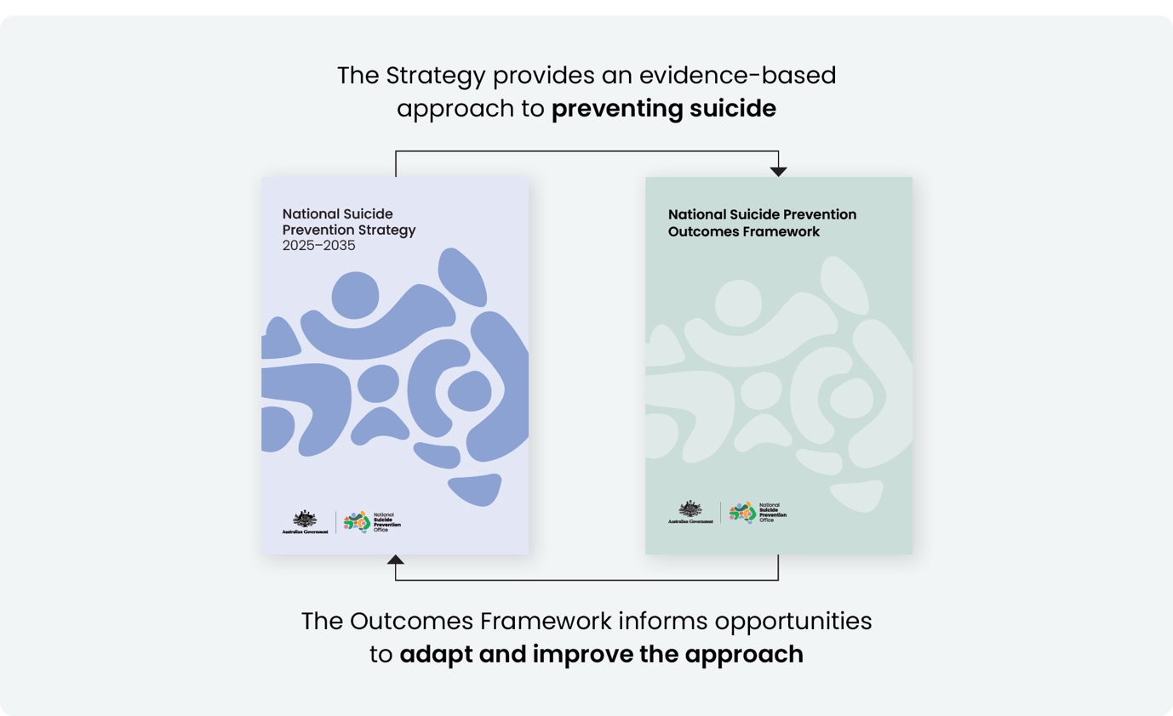
The Outcomes Framework converts the Strategy into outcomes that define what a more effective suicide prevention system looks like and describe the intended impact of the Strategy. Together, the Strategy and the Outcomes Framework support the NSPO to transparently monitor and report on progress towards achieving the outcomes, identify steps towards reaching the outcomes and understand the impact of the Strategy (see Figure 1).
Figure 1. Relationship between the National Suicide Prevention Strategy and the National Suicide Prevention
Outcomes Framework
While the Outcomes Framework is centred on the Strategy, the outcomes are also applicable to other suicide prevention policies, activities and efforts that are delivered outside of the Strategy.
The Outcomes Framework considers this broader context and contribution when interpreting and translating the progress being made towards achieving the outcomes and goals, and when determining the impact of the Strategy.

Australian examples of national outcomes frameworks
There are several examples of national outcomes frameworks including the following:
- Measuring What Matters is a national wellbeing framework that tracks progress towards a more healthy, secure, sustainable, cohesive and prosperous Australia.⁶
- The National Plan to End Violence against Women and Children 2022-2032⁷ is supported by an Outcomes Framework 2022-2032⁸ that links actions and activities being undertaken by governments to end gender-based violence with national outcomes and targets.
- Australia’s Disability Strategy 2021-2031⁹ is supported by an outcomes framework which includes quarterly updates and an annual report providing an overview of all measures being tracked for people with disability.¹⁰

Development of the Outcomes Framework
The Outcomes Framework was developed in consultation with an extensive range of stakeholders to ensure it represents what is important to people, is technically robust and is useful to those working in suicide prevention.
This work was guided by the NSPO Lived Experience Partnership Group, Advisory Board and Scientific Advisors. The AIHW and senior research experts established the method to use and integrate quantitative and qualitative data.
Leads from monitoring and reporting and suicide prevention policy, from all state and territory governments, as well as relevant Commonwealth portfolios, contributed to developing the Outcomes Framework. Targeted consultation with representatives from the suicide prevention sector and other relevant sectors, and from groups disproportionately impacted by suicide, also shaped its development.

Principles for the Outcomes Framework
The Outcomes Framework has a set of principles to guide its purpose and intent. These principles were developed in partnership with people with a lived and living experience of suicide. They were applied during the development of the Outcomes Framework and will help guide decisions about how the Outcomes Framework continues to improve and operate.
- Guided by lived and living experience – The Outcomes Framework uses outcomes and goals developed in partnership with people with lived and living experience of suicide to ensure the outcomes measure what matters. People with lived and living experience help interpret and translate findings so that reporting is useful, meaningful and accessible.
- Focusing on outcomes not activities – The Outcomes Framework focuses on monitoring progress against outcomes, i.e. not the activities that are being delivered, to improve understanding of whether suicide prevention efforts are having the intended impact (see Figure 2).
- Reflecting best available evidence and approach – The Outcomes Framework uses an evidence-based approach to measuring suicide prevention, incorporating lived experience, quantitative and qualitative inputs and seeks to align with the Strategy approach.
- Measuring what matters, not just what is available – The Outcomes Framework makes use of new and existing quantitative and qualitative data that is fit-for-purpose and prioritises data development to address data quality and gaps over time.
- Being comprehensive and coherent – The Outcomes Framework strives for a balance of measuring everything covered by the Strategy while providing reports that are easy to understand.
- Providing clear insights to drive action – The Outcomes Framework provides clear insights about progress and opportunities for improvement in suicide prevention, communicated in a way that is suitable for a range of audiences and helps to meaningfully inform efforts.

Structure used by the Outcomes Framework
“For me, person-centred outcomes mean putting people—their choices, dignity and recovery—at the heart of suicide prevention. When lived and living experience guides the way, we can hold systems accountable to the people they serve. It’s about making sure care feels human, and that wherever you live, you feel connected, supported and hopeful.”
– Ben Brien
NSPO Lived Experience Partnership Group
The Outcomes Framework uses a structure for the outcomes and goals that is aligned with the Strategy and other relevant outcomes frameworks. The structure supports the measurement of outcomes, not activities. Measurement of activities is outside the scope of the Outcomes Framework but is still important to inform reporting at a program level (see left box in Figure 2). The structure is described below (and in Figure 2) to aid understanding of the Outcomes Framework Overview and its other components.
- Goals – The goals are used to measure the impact of suicide prevention efforts. They describe the ultimate changes suicide prevention is aiming to achieve.
- Domains – The Domains are broad areas that have a specific aim and are used to group related outcomes together. These Domains are the same as those in the Strategy.
- Outcomes – The outcomes are translations of the Key Objectives in the Strategy and are used to measure and describe what a more effective suicide prevention system looks like from a person-centred perspective.
- Indicators – The indicators are used to measure the progress of an outcome or goal. These describe what needs to change and set the direction of that change. Some outcomes and goals have multiple indicators.
- Data measures – The data measures are the specific way that indicators are measured. Some indicators have multiple data measures.

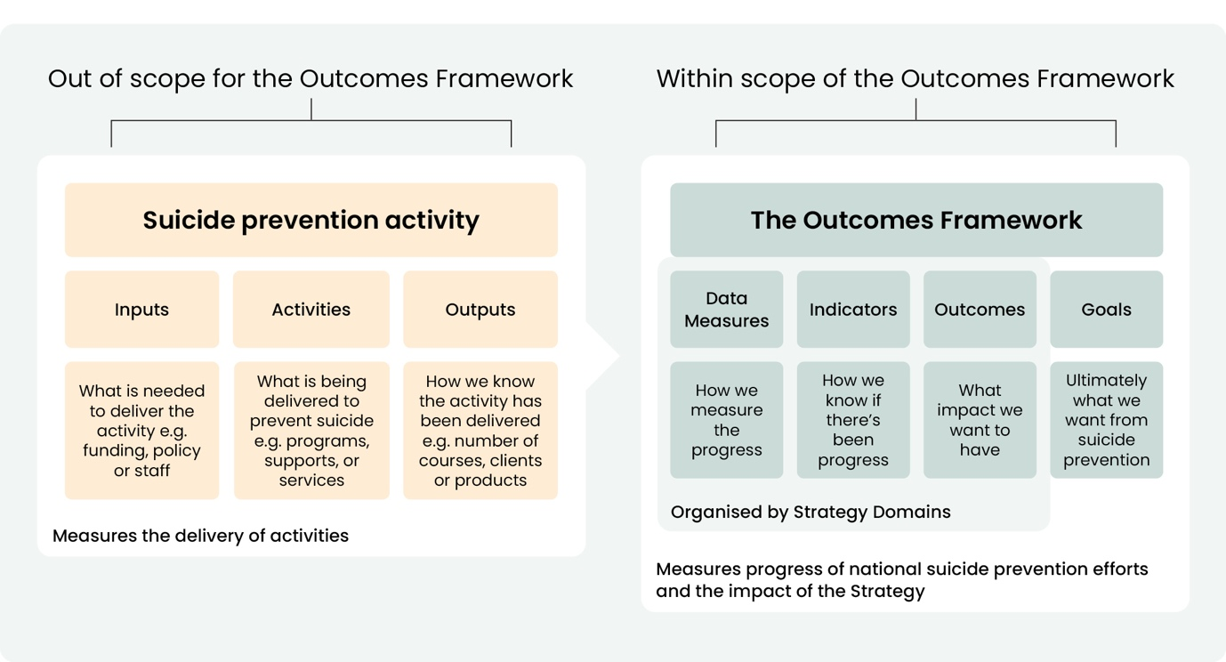
Figure 2. The structure used in the Outcomes Framework

State and territory examples of outcomes frameworks
The following are examples of state and territory outcomes frameworks that measure outcomes for wellbeing, mental health, and/or suicide prevention related to respective strategies and plans:
- New South Wales Tracking Change in Suicide Prevention: A Monitoring and Reporting Framework¹¹ for Shifting the Landscape Suicide Prevention Framework¹² and the Suicide Prevention Outcomes Framework for the NSW Suicide Prevention Plan (both under development).
- Northern Territory’s Social Outcomes Framework for governments, non-government organisations and communities to measure shared wellbeing outcomes for individuals and communities.¹³
- Queensland’s Suicide Prevention Monitoring and Outcomes Framework for governments and non-government organisations to monitor and report suicide prevention activities and outcomes (under development).
- South Australia’s implementation of statutory Suicide Prevention Plans based on the following five domains: partner, respect, prevent, respond and review.¹⁴
- Tasmania’s Evaluation of Implementation Plan One report¹⁵ for the Tasmanian Suicide Prevention Strategy 2023-2027: Compassion and Connection.¹⁶
- Victoria’s Mental Health and Wellbeing Outcomes and Performance Framework¹⁷ that supports the Accountability Framework¹⁸ for the Victorian Suicide Prevention and Response Strategy 2024-2034.¹⁹
- Western Australia’s Mental Health, Alcohol and Other Drugs Outcomes Measurement Framework for monitoring and reporting on mental health and alcohol and other drug systems and services (under development).²⁰

Components of the Outcomes Framework

The Outcomes Framework is made up of four components that together enable effective monitoring and reporting. Each component has a specific function. Components may be updated over time as the data landscape matures or the national approach to effective suicide prevention improves over time.

Outcomes Framework Overview (this document)
Provides an overarching description of the Outcomes Framework, including the purpose and orientation to the components.

The Overview can be used to understand the purpose of the Outcomes Framework and the role of each component.

Outcomes Map
Defines the goals, outcomes, indicators, and data measures within the Outcomes Framework, and links them to the aims and objectives of the Strategy. The Outcomes Map is underpinned by the theory of change provided in Appendix A that shows the connections between what is being measured and the Strategy. The Outcomes Map is updated as new data measures become available. The Outcomes Map can be used to link suicide prevention activities to the suicide prevention goals and outcomes. It can be used to provide a basis for performance reporting and evaluation of programs and services. Additionally, it provides a common language that can be used to reframe the way people talk about suicide prevention into what matters, increasing awareness and knowledge and reducing stigma.


Data Quality and Improvement Plan
Makes sure data is fit-for-purpose for the Outcomes Framework. It consists of a data quality framework and a data improvement plan.
The data quality framework outlines criteria to define what fit-for-purpose means specifically for the Outcomes Framework. The data quality framework is publicly available. All potential new and existing data is assessed against these criteria to determine its quality. Fit-for-purpose data is included as data measures in the Outcomes Framework, while data that is not fit-for-purpose informs the data improvement plan.
The data improvement plan is about working with relevant data custodians to make sure new and existing data improves its quality, validity, reliability and comprehensiveness over time, and is therefore fit-for-purpose. For quantitative data, this will leverage the work being done by governments to improve suicide data such as suicide attempt presentations in emergency departments. It will also include known gaps such as ensuring new and existing data can routinely be used to identify groups that are disproportionately impacted by suicide. For qualitative data, this will mean establishing new data collections and working with owners of existing data such as those who hold policies, reports, case studies, stories, etc., to make sure these are fit-for-purpose. This will make sure the Outcomes Framework is able to report on more of its outcomes and indicators over time. The status of the data improvement plan is regularly updated to provide an up-to-date outline of any data improvements still needed. The data improvement plan is publicly available.
The Data Quality and Improvement Plan can be used to understand why specific data is not yet included in the Outcomes Framework. The quality criteria can be applied to any suicide prevention data collected to improve the quality of data across the sector. It can also be used to understand the data improvement activities undertaken as part of the Outcomes Framework, as well as the improvement activities being done by governments and other relevant data custodians more broadly in suicide prevention.


Monitoring and Reporting Plan
Describes the reporting being done by the Outcomes Framework. The Monitoring and Reporting Plan covers the types of reports delivered and provides a schedule of when reporting is happening. There are two types of Outcomes Framework reporting: indicator and insight reporting (see below).
Indicator reporting shows the changes that have occurred over time for the indicators integrated across quantitative and qualitative data. Indicators are updated when all their data measures have available data, in line with the publication of the parent data source or when new data has been collected. This is done by the AIHW and senior research experts and is publicly available.
Indicator reporting can be used to understand what changes are happening in suicide prevention and what they mean for people. The frequency of reporting supports timely monitoring of what is happening across suicide prevention and can be used to identify parts of the suicide prevention system that require immediate attention or deeper exploration.
Insight reporting interprets the indicator findings into meaningful and useful observations that inform national suicide prevention efforts and translates them into prioritised recommendations for improvement by governments.
This reporting occurs cyclically at points where the greatest number of indicators have been updated. This is done by NSPO in consultation with stakeholders and is publicly available.
Insight reporting can be used to understand what progress is made in suicide prevention and what the priorities are for further improvement. This type and frequency of reporting support the ability to look at longer-term and system-wide trends, providing a big-picture view of national suicide prevention efforts. It can be used to identify where the connections between the Strategy and the goals and outcomes in the Outcomes Framework require more research to build the evidence. It can also be used to highlight what needs deeper exploration such as what is happening for a specific outcome or a particular group disproportionately impacted by suicide.
The Monitoring and Reporting Plan describes the processes around monitoring change, generating both indicator and insight reporting, and provides a schedule of when the reporting will happen.
The Monitoring and Reporting Plan can be used to understand what is reported and when. This can be used by people to plan how they can use the indicator and insight reports to support their work in suicide prevention.

Indicator reporting
- integrates quantitative and qualitative data into indicator reporting
- provides the statistical significance and meaningfulness of changes
- published by the AIHW

Insight reporting
- interprets and translates indicator reports to provide insights and recommendations for improvement of national suicide prevention efforts
- identifies topics for emerging trends for deeper exploration and reporting
- published by the NSPO

Using the Outcomes Framework to improve suicide prevention efforts
As described above, the individual components of the Outcomes Framework improve the monitoring and reporting of national suicide prevention efforts. The indicator and insight reports can be used directly to improve what is being done to prevent suicide. In addition, the Outcomes Framework has many features that can be used to improve suicide prevention in other ways (see Table 1).

Table 1. Other ways the Outcomes Framework will improve suicide prevention
Features of the Outcomes Framework | Improves suicide prevention by:
Goals and outcomes include protective factors alongside the reduction of suicide | - influencing suicide prevention programs to focus not only on preventing suicide but also on enhancing overall life quality and mental health  - encouraging a holistic assessment of factors contributing to suicide, considering the social determinants of suicide, effectiveness of supports and community influences  - promoting collaboration across sectors, such as healthcare, education, housing, employment, and community services to address underlying causes of suicide
Outcomes Map illustrates what a more effective suicide prevention system looks like | - influencing the design and intent of prevention and intervention activities  - providing new narratives to communicate about suicide and suicide prevention  - providing a foundation for a standardised approach to data collection
Clearly defined set of outcomes at a population level | - leveraging the existing investment in collecting suicide data  - reframing the way data on groups disproportionately impacted by suicide should be collected, i.e. population level data that can be broken down into groups instead of each group having to collect different data in isolation  - breaking down the population data by demographic characteristics to better identify which groups are experiencing change, and which are not
Engagement of stakeholders in developing and reporting on outcomes | - fostering community ownership and ensuring that the perspectives of people with lived and living experience of suicide are included  - building a shared understanding of the outcomes, their status and what is needed to achieve them  - enhancing collaboration between different sectors and organisations working towards common goals
Monitoring and reporting on clearly defined outcomes | - enhancing transparency for stakeholders, including government agencies, funders and the public  - informing an understanding of trends over time, which is crucial for assessing the long-term effectiveness of suicide prevention  - adapting indicators and data measures as new data emerges, ensuring that the Outcomes Framework is relevant and effective
Regular assessment of progress against the outcomes | - allowing for accountability, ensuring that all governments are meeting their commitments

Building on the evidence base
The Outcomes Framework reporting enhances the way progress in suicide prevention is measured. It does not replace the need to continue other types of monitoring, reporting and research, but it will establish new ones where needed to build a complete and comprehensive picture. The following are necessary to do this and will inform how the changes in the Outcomes Framework are interpreted and translated:
- Suicide trends and the protective and risk factors for suicide – Provides insight into emerging trends and the factors that need to be addressed to reduce suicide and ensures supports are timely and responsive.
- Performance and effectiveness of suicide prevention programs – Examines whether programs are performing as expected and how they are contributing to the prevention of suicide.
- Workforce planning – Models population needs for suicide prevention and intervention and the workforce required to support these needs to help with workforce planning and identify support gaps.
- Performance and impact of key suicide prevention strategies and plans – Tracks how other strategies and plans are contributing to suicide prevention.
- Performance of the National Mental Health and Suicide Prevention Agreement – Tracks progress against commitments included in the Agreement using specific key performance indicators established for the Agreement.
- Implementation progress of the Strategy – Tracks what actions and the degree to which the Strategy has or has not been implemented.
In addition to the Outcomes Framework reporting taking the above into consideration, the Outcomes Framework can also be used to enhance the monitoring and reporting for other efforts related to suicide prevention. Policy makers, service providers, researchers and communities can use the theory of change that underpins the Outcomes Framework (see appendix A) to demonstrate how they contribute to the goals, outcomes and indicators that define a more effective suicide prevention system, as described in
the Strategy. Indicator and insight reporting can be used to provide additional evidence to the findings coming from each type of monitoring and reporting, without needing to change the way the monitoring and reporting is being done.

How the Outcomes Framework works

Responsibilities and governance
Governance for the Outcomes Framework is managed in collaboration by the NSPO and the AIHW.
The Head of the NSPO is responsible for the development and operation of the Outcomes Framework, including the insight reporting and advice to governments. The NSPO does this through its existing organisational governance arrangements.
The AIHW is responsible for the data governance for the Outcomes Framework under its existing Data Governance Framework. This includes the Five Safes framework (i.e. safe people, safe projects, safe settings, safe data and safe outputs). AIHW data governance processes ensure that people’s data is managed ethically, with respect and in line with best practice.

Advisory bodies
The NSPO works with its Advisory Board, Lived Experience Partnership Group, and Scientific Advisors to set the strategic direction for the Outcomes Framework as part of the broader monitoring and reporting that the NSPO undertakes on the national suicide prevention system.
The Outcomes Framework also draws on advice from key stakeholders to support the continuous improvement of the Outcomes Framework, the Data Quality and Improvement Plan, and to consult on the interpretation and translation of findings into insight reports. These stakeholders include representatives from groups disproportionately impacted by suicide, governments, service providers and researchers.

Continuous improvement and evaluation
The Outcomes Framework has several mechanisms that support its continuous improvement such as the Data Quality and Improvement Plan, which ensures data remains relevant and high quality, and the NSPO insight reporting process, which ensures the outputs are meaningful, useful and impactful.
The NSPO intends for the Outcomes Framework itself to be evaluated to help ensure it achieves the objectives described in this paper.

Appendix A

Theory of Change
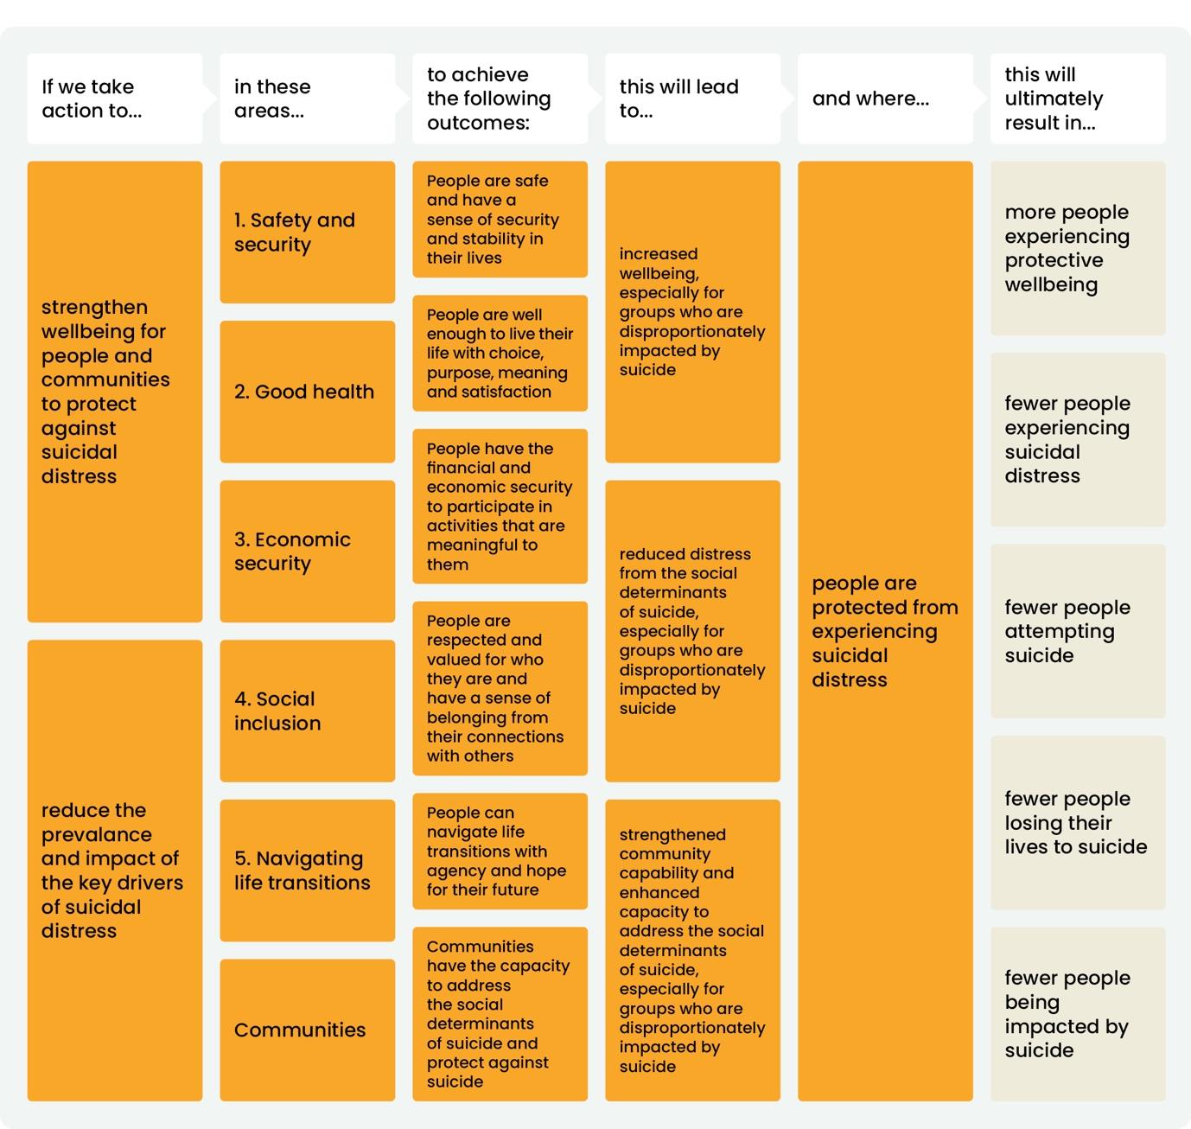
The theory of change for the Outcomes Framework underpins the Outcomes Map (i.e. the goals, outcomes, indicators and data measures) and shows the connections between the Strategy and what is being measured in the Outcomes Framework.

Figure A1. Theory of change for the Prevention Domain

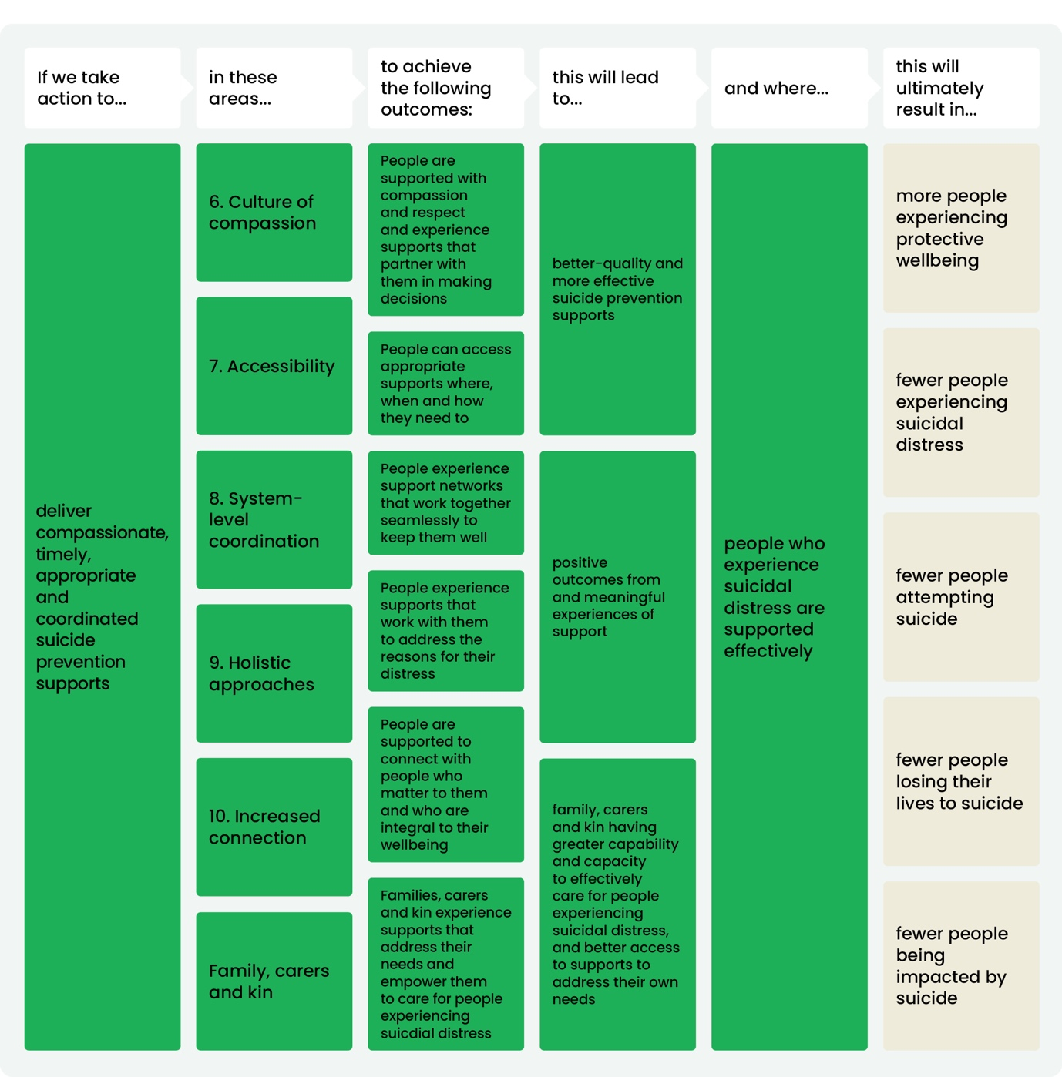
Figure A2. Theory of Change for the Support Domain

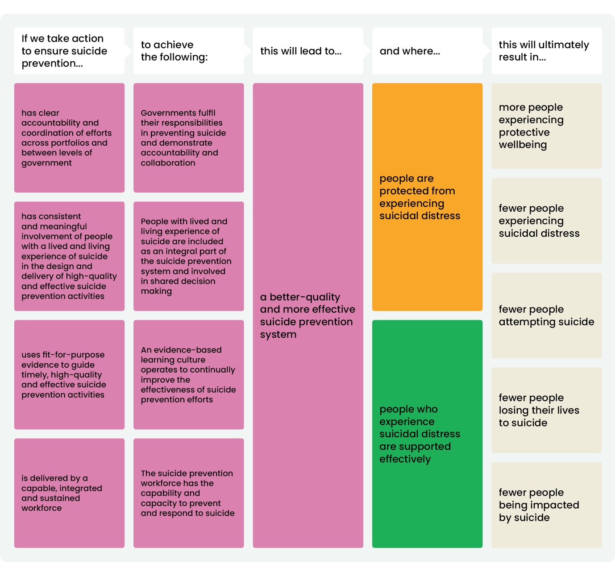
Figure A3. Theory of Change for the Critical enablers

References
- World Health Organization. Advocating for National Suicide Prevention Strategies. Available from: https://www.who.int/activities/advocating-for-national-suicide-prevention-strategies
- World Health Organization. National Suicide Prevention Strategies: Progress, examples and indicators. Available from: https://iris.who.int/server/api/core/bitstreams/9b9ea82a-b798-4c63-b90e-74bf8bdbf6b1/content
- Manatū Hauora Ministry of Health. Every Life Matters He Tapu te Oranga o ia tangata. Suicide Prevention Strategy 2019-2029 and Suicide Prevention Action Plan 2019-2024 for Aotearoa New Zealand. New Zealand Government. Available from: https://www.health.govt.nz/system/files/2025-09/suicide-prevention-action-plan-2025-2029-v2.pdf
- Scottish Government Riaghaltas na h-Alba. Outcomes Framework for Creating Hope Together: Scotland’s Suicide Prevention Strategy and Action Plan. Available from: https://www.gov.scot/binaries/content/documents/govscot/publications/advice-and-guidance/2023/06/outcomes-framework-creating-hope-together-scotlands-suicide-prevention-strategy-action-plan-june-2023/documents/outcomes-framework-creating-hope-together-scotlands-suicide-prevention-strategy-action-plan/outcomes-framework-creating-hope-together-scotlands-suicide-prevention-strategy-action-plan/govscot%3Adocument/outcomes-framework-creating-hope-together-scotlands-suicide-prevention-strategy-action-plan.pdf
- Department of Health. Connecting for Life: Ireland’s National Strategy to Reduce Suicide 2015-2024. Government of Ireland Rjaltas na hÉireann. Available from: https://www.gov.ie/en/department-of-health/publications/connecting-for-life-irelands-national-strategy-to-reduce-suicide-2015-2024/
- The Treasury. Measuring what matters. Australian Government. Available from: https://treasury.gov.au/policy-topics/measuring-what-matters
- Department of Social Services. National Plan to End Gender Based Violence. Australian Government. Available from: https://www.dss.gov.au/national-plan-end-gender-based-violence
- Department of Social Services. Outcomes Framework 2023-2032 under the National Plan to End Violence against Women and Children 2022-2032. Australian Government. Available from: https://www.dss.gov.au/system/files/resources/np-outcomes-framework.pdf
- Department of Health, Disability and Ageing. Australia’s Disability Strategy. Australian Government. Available from: https://www.health.gov.au/our-work/australias-disability-strategy
- Australian Institute of Health and Welfare. Australia’s Disability Strategy 2021-2031 Outcomes Framework 3rd annual report. Australian Government. Available from: https://www.aihw.gov.au/getmedia/5174e67a-8696-4de1-899d-5b489e35280f/aihw-ads-5.pdf?v=20250114090441&inline=true
- Mental Health Commission of New South Wales. Tracking Change in Suicide Prevention: A Monitoring and Evaluation Plan for Shifting the Landscape for Suicide Prevention in NSW 2022-2027. Government of New South Wales. Available from: https://www.nswmentalhealthcommission.com.au/sites/default/files/2023-09/NSW%20Suicide%20Prevention%20Monitoring%20and%20Evaluation%20Plan.pdf
- Mental Health Commission of New South Wales. Shifting the Landscape for Suicide Prevention in NSW: A whole-of-government Strategic Framework for a whole-of-community response 2022-2027. Government of New South Wales. Available from: https://www.nswmentalhealthcommission.com.au/sites/default/files/2022-10/The%20Framework%20-%20Shifting%20the%20Landscape%20for%20Suicide%20Prevention%20in%20NSW%202022-2027_0.PDF
- Northern Territory Government. Northern Territory Social Outcomes Framework. Available from: https://cmc.nt.gov.au/media/docs/poplulation/social-outcome-framework.pdf
- Preventative Health SA Suicide Prevention. South Australian Suicide Prevention Plan 2023-2026. Government of South Australia. Available from: https://www.preventivehealth.sa.gov.au/suicideprevention/south-australian-suicide-prevention-plan-2023-2026
- Tasmanian Centre for Mental Health Service Innovation. Tasmanian Suicide Prevention Strategy 2023-2027: Evaluation of Implementation Plan One. Tasmanian Government. Available from: https://www.health.tas.gov.au/sites/default/files/2024-12/tasmanian_suicide_prevention_strategy_implementation_plan_one_evaluation.pdf
- Department of Health. Tasmanian Suicide Prevention Strategy 2023-2027: Compassion and Connection. Tasmanian Government. Available from: https://www.health.tas.gov.au/sites/default/files/2022-11/tasmanian_suicide_prevention_strategy_2023-2027_final.pdf
- Department of Health. Mental Health and Wellbeing Outcomes and Performance Framework. Victoria State Government. Available from: https://www.health.vic.gov.au/mental-health/research-and-reporting/mental-health-and-wellbeing-outcomes-and-performance-framework
- Suicide Prevention and Response Office. Accountability Framework: Victorian Suicide Prevention and Response Strategy 2024-34. Victoria State Government. Available from: https://www.health.vic.gov.au/sites/default/files/2025-06/suicide-prevention-and-response-strategy-2024-34_accountability-framework.pdf
- Suicide Prevention and Response Office. Victorian Suicide Prevention and Response Strategy 2024-34. Victoria State Government. Available from: https://www.health.vic.gov.au/sites/default/files/2025-06/suicide-prevention-and-response-strategy-2024-34.pdf
- Mental Health Commission. Outcomes Measurement Framework. Government of Western Australia. Available from: https://www.mhc.wa.gov.au/our-initiatives/our-projects/outcomes-measurement-framework

National Suicide Prevention
Outcomes Framework Overview
For more information regarding this document, please contact: nspo@nspo.gov.au

