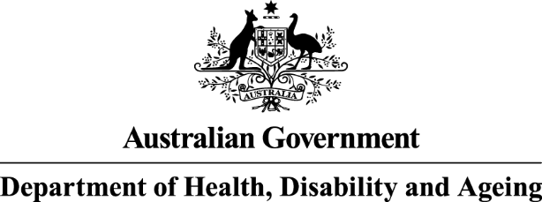

Privacy Notice and Consent Form

IMPORTANT INFORMATION
The National Mental Health Commission – part of the Australian Government Department of Health, Disability and Ageing (Department) – is bound by the Privacy Act 1988 (Cth), which includes the Australian Privacy Principles (APPs).
Collection of your personal information
The Department is collecting your personal information for the primary purpose of assessing your nomination and suitability to be appointed as member of a board or committee within the Health, Disability and Ageing Portfolio.
In order to consider your suitability to be appointed, the Department may collect some or all of the following types of information about you:
- contact details
- date of birth
- employment history and work experience
- current and previous membership of any board
- private, business and financial interests relevant to your nomination
- membership of a political, professional or trade association, or your criminal record (if any).
If you do not or are unable to provide the personal information requested by the Department, your suitability for the appointment may not be able to be fully assessed and your nomination is unlikely to be further considered.
Use and disclosure of your personal information
The Department will disclose your personal information to the office of the relevant Departmental delegates for the purposes of assessing your nomination and suitability to be appointed.
Consent to the handling of your personal information
By signing this form, you consent to the Department collecting, using and disclosing your personal information (including sensitive information) in accordance with this notice.

__________________________ | _______________________________
Full name | Signature

Further details about the Department’s Privacy Policy
The Department has an APP privacy policy which you can read at https://www.health.gov.au/resources/publications/privacy-policy. You can obtain a copy of the APP privacy policy by contacting the Department using the contact details set out at the end of this notice. The APP privacy policy contains information about:
- how you may access the personal information the Department holds about you and how you can seek correction of it; and
- how you may complain about a breach of
  - the APPs; or
  - a registered APP code that binds the Department; and
- how the Department will deal with such a complaint.
You can contact the Department by telephone on (02) 6289 1555 or freecall 1800 020 103 or by using the online enquiries form at www.health.gov.au.

