Monitoring the performance of Australia’s mental health system
National Report Card
2024
Technical Report
Table of Contents
Acknowledgement 3
Overview 4
CI 1: Prevalence of mental disorders 5
CI 2: Psychological distress 8
CI 3: Overall life satisfaction 11
CI 4: Feeling in control 14
CI 5: Proportion of children developmentally vulnerable 18
CI 6: Housing security (homelessness) 20
CI 7: Financial stress 23
CI 8: Employment rate 26
CI 9: Engagement in employment or study for young people 29
CI 10: Prevalence of physical health conditions 32
CI 11: Alcohol consumption 36
CI 12: Feeling lonely 38
CI 13: Experiences of discrimination 41
Acronyms and abbreviations 44

Acknowledgement

Acknowledgement of Country
The National Mental Health Commission (the Commission) acknowledges Aboriginal and Torres strait Islander peoples as the Traditional Custodians of the lands and waters on which we live, work and learn.

Recognition of Lived Experience
We recognise the individual and collective contributions of those with a lived and living experience of mental ill-health and suicide, and those who love, have loved and care for them. Each person’s journey is unique and a valued contribution to Australia’s commitment to mental health and suicide prevention systems reform.

Contributors
The Commission acknowledges the assistance
and cooperation of the Australian Bureau of Statistics and Australian Institute of Health and Welfare.

A note on language
The Commission acknowledges that language surrounding mental health and suicide can be powerful, emotive and at times contested. People make sense of their experiences in different ways, and there is no consensus on preferred terminology. The Commission has been conscious to use terminology throughout this report that is respectful of those whose experiences we are describing and is well understood by the audience reading this report. This report covers a broad range of topics in relation to mental health and suicide prevention.
Data collection activities and reports use terms like 'mental or behavioural conditions' and '12-month mental disorder' to clearly define the scope of the mental health experience(s) under consideration. This publication uses the same terms as used in these original sources to not misrepresent the findings. The Commission endorses and follows the Mindframe guidelines Our Words Matter and Images Matter. The Commission also endorses the Mindframe Guidelines on Media Reporting of Severe Mental Illness in the Context of Violence and Crime and requests that media using this report do so in accordance with the Guidelines.
Support

Support is available if you or someone you care for is in need of assistance. For information on support go to: www.mentalhealthcommission.gov.au/find-support

About this report
This report can be downloaded from our website: www.mentalhealthcommission.gov.au/
ISSN: 2209-8321 (online)
ISBN: 978-1-7636173-4-6 (online)

Suggested citation
Mental Health Commission. National Report Card 2024 Technical Report. Sydney: NMHC; 2025.

Learn more about our work
www.mentalhealthcommission.gov.au/

© National Mental Health Commission 2025
This product, excluding the National Mental Health Commission logo, Commonwealth Coat of Arms and material owned by a third party or protected by a trademark, has been released under a Creative Commons BY 3.0 (CC BY 3.0) licence. The excluded material owned by a third party includes data, images, accounts of personal experiences and artwork sourced from third parties, including private individuals.
You may distribute, remix and build upon this work. However, you must attribute the National Mental Health Commission as the copyright holder of the work in compliance with our attribution policy. Address enquiries and requests concerning reproduction or copyright to:
Office of the Chief Executive Officer
National Mental Health Commission
PO Box 9848
Sydney NSW 2001.

Overview
Each year, the National Mental Health Commission (the Commission) publishes a report on the state of Australia’s mental health system. In the last National Report Card 2023, the Commission refreshed its reporting approach, drawing on a small number of meaningful core indicators to inform the Commission’s assessment of how the system is performing.
The core indicators were selected as an initial set, based on objective criteria and informed by a review of existing and proposed mental health indicator frameworks. A respective primary data source was identified for each core indicator. These data sources were selected as they represent robust and reliable measures of mental health and social determinants. While the Commission intends to track these primary data sources over time, many of these data sources are not updated annually as they represent very large nationally representative surveys.
In 2024, the Commission has continued this empirically-based and simplified approach to reporting set out in the National Report Card 2023. The Report Card 2024 provides:
- updates across the core indicators, where new data is available from the primary data source
- an overview of new data from supplementary data sources collected up to, and throughout the 2024 calendar year to provide a more detailed and contemporary picture of how key outcomes are tracking over time.
Accompanying the National Report Card 2024 is this document – the National Report Card 2024 Technical Report (Technical Report). The Technical Report provides a detailed description of the scope, rationale, findings and primary data source for each of the 13 core indicators. The Technical Report explores data from our primary data sources exclusively. For technical information on supplementary data sources, please see Appendix A of the National Report Card 2024.
For each core indicator (CI), the Technical Report outlines what we are tracking and why, a summary of what the most recently available data tells us, technical information about the primary data source and additional information that is important to consider when interpreting the results. Where possible, for each indicator the Technical Report explores:
- data at both a whole of population level and for people with lived experience of mental health concerns
- comparisons between males and females, and different age groups
- comparisons between people living in different geographic areas (e.g., Major Cities, Inner Regional areas, Outer Regional and Remote areas)
- comparisons between people with different levels of relative socio-economic advantage and disadvantage (i.e., access to material and social resources, and their ability to participate in society).
For more information, including on the Commission’s reporting framework and selection of core indicators, please see the full National Report Card 2024 available at www.mentalhealthcommission.gov.au/monitoring-and-reporting/national-reports.

CI 1: Prevalence of mental disorders

What we are tracking (and why)
This indicator tracks the prevalence of 12-month anxiety, affective and substance use disorders for people in Australia aged 16-85 years. A 12-month mental disorder refers to people who met the diagnostic criteria for having a mental disorder at some time in their life and had sufficient symptoms of that disorder in the 12 months prior to completing the survey. A person may have more than one 12-month mental disorder.
Prevalence rates help us understand how common mental disorders are for people in Australia. While subject to a wide array of factors, low or reducing prevalence rates may indicate improvements in the mental health system, and/or improvements in external factors that impact mental health across society.

What the data tells us

Indicator findings
The estimated number of people with a 12-month mental disorder in Australia has increased from 3.1 million (19.5%) in 2007 to 4.3 million (21.5%) in 2020-2022. As shown in Figure A1 while the proportion of people in Australia with a substance use disorder decreased between 2007 and 2020-2022, the proportion of people with an anxiety and affective disorder increased.
Figure A1. Proportion of people aged 16-85 years in Australia with a 12-month mental disorder, by disorder type, 2007 to 2020-2022
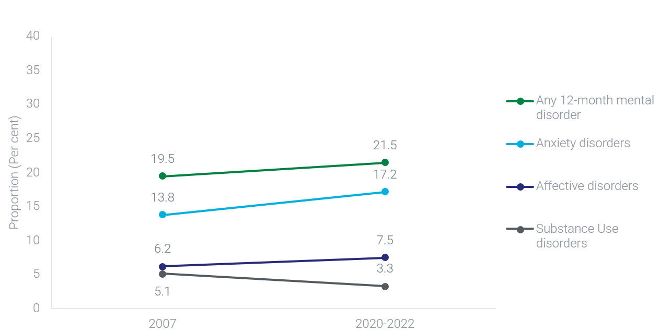

How do these findings differ between groups?
The prevalence of 12-month mental disorders varied according to both age and sex in 2007 and 2020-2022. Across the board, females were more likely than males to have had a 12-month mental disorder in 2007 (Females: 21.6%, Males: 17.4%) and 2020-2022 (Females: 24.6%, Males: 18.3%). In 2020-2022, a greater proportion of females experienced anxiety (21.1%) and affective disorders (8.6%) when compared to males (13.3% and 6.5% respectively), while the opposite was true for substance use disorders (Females: 2.1%, Males: 4.4%).
In terms of age group differences, 12-month mental disorders were more common among people aged 16-24 years relative to older adults and this difference was larger in 2020-2022 compared to 2007. The proportion of people aged 16-24 years with a 12-month mental disorder increased by 13.0 percentage points, from 25.8% in 2007 to 38.8% in 2020-2022. For the remainder of the population, the proportion of people with a 12-month mental disorder increased by 5.6 percentage points, from 18.3% to 23.8%.
Over time, the prevalence of 12-month mental disorders increased more for young females compared to young males. For males aged 16-24 years, around one in three (32.4%) had a 12-month mental disorder in 2020-2022, relative to 23.2% in 2007. For females aged 16-24 years, almost half (45.5%) had a 12-month mental disorder in 2020-2022, relative to 28.5% in 2007. An increase over time, although less pronounced, was also observed for females aged 25-34 years, and for both sexes aged 55-64 years and 65-74 years.
The only age group that showed a reduction in the prevalence of 12-month mental disorders over time was the 35-44 year age group. For this group, 20.5% of males had a 12-month mental disorder in 2007 compared to 16.7% in 2020-2022, and 24.9% of females had a 12-month mental disorder in 2007 compared to 23.8% in 2020-2022.
In 2020-2022, among people who were living in areas of most disadvantage according to Socio-Economic Indexes for Areas (SEIFA) scores (Quintile 1), 22.6% had a 12-month mental disorder. This was not significantly different from people with a 12-month mental disorder in Quintile 2 (22.1%), Quintile 3 (22.4%), Quintile 4 (20.7%), and Quintile 5 (20.4%). Similarly in 2020-2022, the proportion of people in Major City areas who had a 12-month mental disorder (21.3%), did not significantly differ from people in Inner Regional areas (22.3%), or Outer Regional and Remote areas (21.5%).

Technical information

Source
Australian Bureau of Statistics (ABS) National Study of Mental Health and Wellbeing, 2020-2022; ABS National Survey of Mental Health and Wellbeing, 2007

Frequency of data collection
Irregular. No future releases scheduled.

Limitations
- The study sample was designed to provide reliable national-level estimates, and thus there are limited state and territory breakdowns available.
- Estimates of the number of people with mental disorders may be lower than reality given the study assesses a selected number of mental disorders and certain groups are excluded from the scope of the NSMHW (e.g., people who are homeless or living in aged care facilities).
- The NSMHW uses objective diagnostic criteria, which may not necessarily reflect people’s lived experience of mental health.

Additional notes
- Data for this study was collected in two stages. The first cohort was conducted between December 2020 and July 2021. The second cohort was conducted between December 2021 and October 2022. Data presented in this report are derived from the combined sample of both cohorts. Data was collected through a face-to-face interview with an ABS interviewer for each respondent. Detailed information on the methodology is available on the ABS website.
- Mental disorders were classified according to the World Health Organization’s International Classification of Diseases, Tenth Revision (ICD-10). Changes were made to diagnostic criteria for post-traumatic stress disorder (PTSD) and obsessive-compulsive disorder (OCD) between the 2007 and 2020-2022 surveys. Data for 2007 in this report is re-derived using diagnostic criteria used in the 2020-2022 survey.
- Comparisons between males and females are based on sex recorded at birth (i.e., what was determined by sex characteristics observed at birth or infancy).
- SEIFA assigns collective socio-economic characteristics for people living within a designated geographic area. This measure broadly defines relative socio-economic advantage and disadvantage in terms of people’s access to material and social resources, and their ability to participate in society. Area levels indexes in this instance are used as a proxy measure of individual socio-economic advantage and disadvantage, and as a result there may be misclassification at a person-level. SEIFA classifications for 2016 are ranked according to quintiles for this analysis.
- Remoteness has been defined using the Australian Statistical Geography Standard (ASGS) and characterises relative geographic access to services. This has been grouped into three groups including ‘Major Cities of Australia’, ‘Inner Regional Australia’, and ‘Outer Regional and Remote Australia’. This analysis used ASGS classifications from 2016.
- Some proportions may not add up to 100% due to number perturbation implemented by the data source owner.

CI 2: Psychological distress

What we are tracking (and why)
This indicator tracks the proportion of people in Australia aged 18 years and over experiencing high or very high levels of psychological distress. This data is captured using the Kessler Psychological Distress Scale (K10), which includes 10 questions about emotional states (e.g., hopeless, depressed, nervous) to provide a simple measure of whether a person has experienced psychological distress in the four weeks prior to completing the survey.
Psychological distress, especially when experienced for prolonged periods of time, is associated with mental health conditions. Monitoring levels of psychological distress helps assess the mental health and wellbeing of people in Australia outside of diagnostic criteria. People with or without mental or behavioural conditions may experience negative emotional states for any length of time, and this indicator may provide an estimate of the need for support and services across the population. As with mental disorder prevalence rates, low or reducing levels of psychological distress may signal a more effective mental health system and/or improvements in external factors that impact mental health and wellbeing across society.

What the data tells us

Indicator findings

Whole of population
As shown in Figure A2, the proportion of people in Australia aged 18 years and over with high or very high levels of psychological distress remained relatively stable over time, from 12.6% (1.8 million) in 2001, to 10.8% (1.8 million) in 2011-12, to 13.0% (2.4 million) in 2017-18 and 14.6% (2.7 million) in 2022. There has been a significant increase in psychological distress between the low-point of 2011-12 and the most recently available data in 2022.
Figure A2. Age standardised proportion of people in Australia aged 18 and over who experienced high or very high levels of psychological distress, 2001-2022
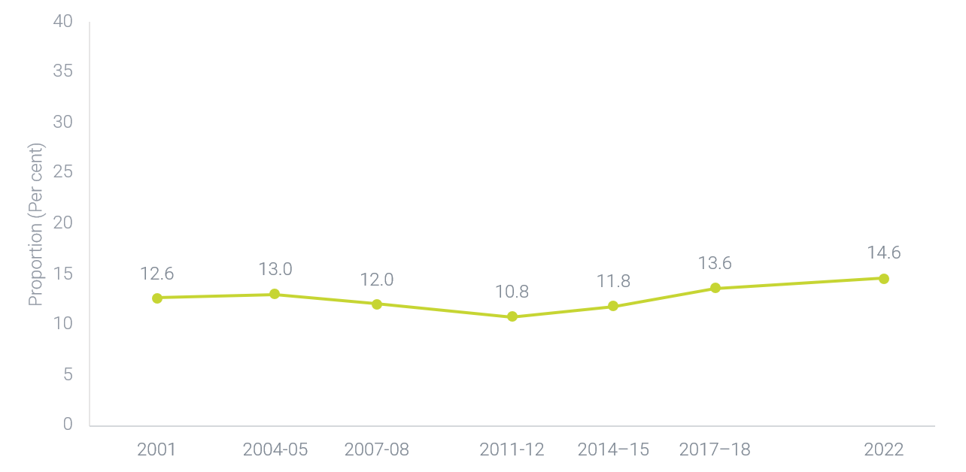

Lived Experience
In 2022, a significantly higher proportion of people with a mental or behavioural condition experienced high or very high levels of psychological distress (38.7%) compared to people without such conditions (4.7%). Looking at this in more detail, among people who experienced high levels of psychological distress, 71.9% had a mental or behavioural condition, and among people who experienced very high levels of psychological distress, 88.1% had a mental or behavioural condition. In contrast, a lower proportion of people who experienced low or moderate levels of psychological distress also had a mental or behavioural condition: among people who experienced low levels of psychological distress, 13.0% had a mental or behavioural condition, and among people with moderate levels of distress, 40.0% had a mental or behavioural condition.

How do these findings differ between groups?

Whole of population
In 2022, among people in Australia aged 18 years and over, a significantly higher proportion of females (16.7%) experienced high or very high levels of psychological distress when compared to males (11.8%). This difference is consistent with findings from 2017-18 (Females: 14.5%, Males: 11.3%). When comparing across age groups, the difference between males and females was largest among people aged 18-24 years (Females: 28.0%, Males: 13.1%). Over time, the proportion of females who experienced high or very high levels of distressed increased from 14.5% in 2017-18 to 16.7% in 2022, while there was no significant difference for males between these years.
In 2022, people aged 18-24 years were most likely to experience high or very high levels of psychological distress (20.2%), while people aged 65 years and over were the least likely to experience high or very high levels of psychological distress (10.5%). Similar patterns were observed in 2017-18: 15.2% of people aged 18-24 experienced high or very high levels of psychological distress, while 9.9% of people aged 65 years and over experienced high or very high levels of psychological distress.
In 2022, for people who were living in areas of most disadvantage according to SEIFA scores (Quintile 1), 21.9% experienced high or very high levels of psychological distress. This was significantly higher than people in Quintile 2 (15.2%), Quintile 3 (14.2%), Quintile 4 (11.7%), and Quintile 5 who were living in areas of least disadvantage (10.0%).
In 2022, among people who lived in a Major City area, 13.8% experienced high or very high levels of psychological distress. This was statistically significantly lower than for people in Outer Regional and Remote areas (17.4%), but not Inner Regional areas (16.2%).

Lived Experience
In 2022, among people with high or very high levels of psychological distress aged 18 years and over, 75.3% of males and 77.2% of females reported having a mental or behavioural condition. This difference was not statistically significant. When comparing across age groups, among people with high or very high levels of psychological distress, the highest proportion of those who reported having a mental or behavioural condition was among people aged 35-64 years (78.0%), followed by people aged 18-34 years (75.8%), and people aged 65 years and over (71.4%). The difference between people aged 35-64 years and 65 years and over was statistically significant. There were no other significant differences across sexes and age groups.
Among people with a mental or behavioural condition, people who were living in areas of most disadvantage were generally more likely to have experienced high or very high psychological distress when compared to people who were living in areas of least disadvantage. In 2022, for people with a mental or behavioural condition who were living in areas of most disadvantage according to SEIFA scores (Quintile 1), 50.4% experienced high or very high levels of psychological distress. This was significantly higher than people with a mental or behavioural condition in Quintile 2 (42.1%), Quintile 3 (36.7%), Quintile 4 (35.3%), and Quintile 5 (28.4%).
In 2022, among people with a mental or behavioural condition, the proportion of people experiencing high or very high levels of psychological distress did not significantly differ according to level of remoteness (Major City area: 37.4%, Inner Regional areas: 42.9% and Outer Regional and Remote areas: 43.3%).

Technical information

Source
Australian Bureau of Statistics (ABS) National Health Survey, 2022; ABS, National Health Survey, 2017-18; ABS National Health Survey, 2014-15; ABS Australian Health Survey, 2011-12; ABS National Health Survey, 2007-08; ABS National Health Survey, 2004-05; ABS National Health Survey, 2001.

Frequency of data collection
Approximately every three years. Note some differences in frequency of collection due to COVID-19.

Limitations
- The K10 assesses levels of psychological distress in the previous four weeks and as such, provides a point-in-time assessment of distress levels amongst the population. It does not signify longer-term levels of psychological distress.
- Detailed information on the methodology is available on the ABS website.

Additional notes
- Comparisons between males and females are based on sex recorded at birth (i.e., what was determined by sex characteristics observed at birth or infancy).
- For this indicator, mental or behavioural conditions are described as ‘Persons who have a current, self-reported mental and behavioural condition that has lasted, or is expected to last, for 6 months or more. Condition is not based on any diagnostic screening tool’.
- Some proportions may not add up to 100% due to number perturbation implemented by the data source owner.
- For age-standardised rates, proportions have been standardised to the 2001 Australian population to account for differences in the age structure of the population over time.
- SEIFA assigns collective socio-economic characteristics for people living within a designated geographic area. This measure broadly defines relative socio-economic advantage and disadvantage in terms of people’s access to material and social resources, and their ability to participate in society. Area levels indexes in this instance are used as a proxy measure of individual socio-economic advantage and disadvantage, and as a result there may be misclassification at a person-level. SEIFA classifications for 2016 are ranked according to quintiles for this analysis.
- Remoteness has been defined using the Australian Statistical Geography Standard (ASGS) and characterises relative geographic access to services. This has been grouped into three groups including ‘Major Cities of Australia’, ‘Inner Regional Australia’, and ‘Outer Regional and Remote Australia’. This analysis used ASGS classifications from 2021, 2016, and 2011.

CI 3: Overall life satisfaction

What we are tracking (and why)
This indicator tracks mean overall life satisfaction for people in Australia aged 15 years and over. Overall life satisfaction ratings reflect how satisfied people are feeling with their lives in general, ranging from 0 to 10, with 0 meaning ‘not satisfied at all’ and 10 meaning ‘completely satisfied’.
Life satisfaction is an element of overall wellbeing and can be described as a summary measure of subjective contentment or fulfilment with life. People with poorer mental health typically have lower life satisfaction than those with good mental health. Improvements in life satisfaction cannot be easily attributed to any one factor, but may signal improvements in the effectiveness of the mental health system and/or improvements across other systems that support the social determinants of mental health and wellbeing.

What the data tells us

Indicator findings

Whole of population
In 2020, mean overall life satisfaction for people in Australia aged 15 years and over was 7.2 (out of 10). Over time, mean overall life satisfaction has decreased slightly (and significantly), from 7.6 in 2014 and 7.5 in 2019.

Lived Experience
In 2020, mean life satisfaction for people in Australia with a mental health condition aged 15 and over was 5.8 (out of 10). This was significantly lower than mean life satisfaction among people without a mental health condition (7.4).
Life satisfaction among people with a mental health condition has been relatively consistent, with a mean rating of 6.6 in 2014 and 6.4 in 2019. However, as shown in Figure A3, there was a slight and significant decline in life satisfaction in 2020 (5.8). This decline was also present for people without a mental health condition, for whom life satisfaction significantly decreased from 2014 to 2019, and again in 2020.
Figure A3. Mean overall life satisfaction for people with and without a mental health condition, 2014-2020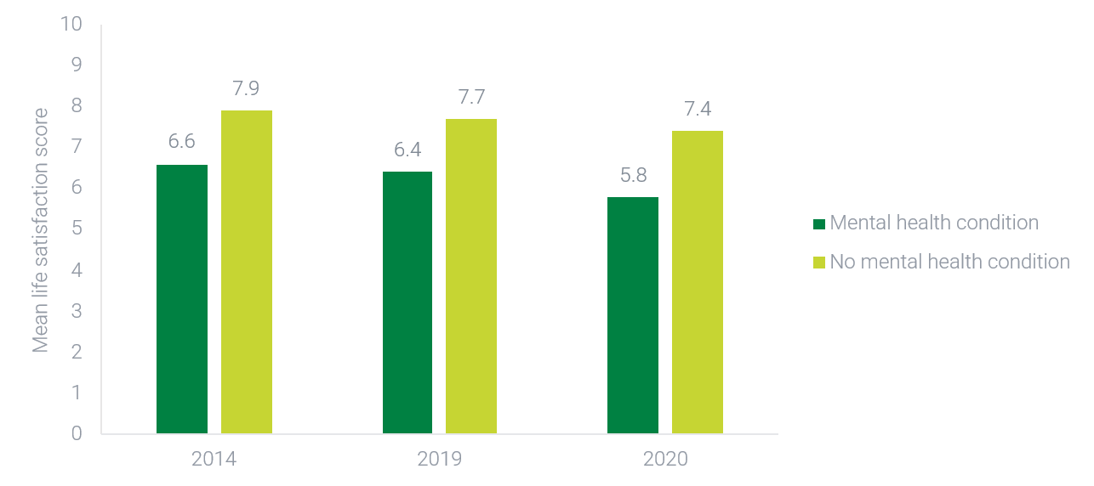

How do these findings differ between groups?

Whole of population
In 2020 mean life satisfaction for people in Australia was relatively consistent across age groups. The only notable exception was for people aged 65 years and over, who had higher mean life satisfaction (7.8) than all other age groups (range: 6.9–7.1).
Over time, there has been a consistent and significant decrease in mean life satisfaction for almost all age groups, ranging from 0.5 to 0.7-point differences from 2014 to 2020. The only age group that showed no significant decrease over this time period was the 65 years and over age group.
In 2020, males (7.1) and females (7.2) reported similar levels of life satisfaction. Males and females reported similar levels of life satisfaction from 2014 to 2020, regardless of their age group.
Across the whole population in 2020, people who were living in areas of most disadvantage according to SEIFA scores (Quintile 1), had a mean life satisfaction score of 7. This was similar to scores for people in Quintile 2 (7.2), Quintile 3 (7.3), Quintile 4 (7.1), and Quintile 5 (7.2).
In 2020, there were no significant differences for mean life satisfaction scores according to level of remoteness (Major city areas: 7.1, Inner Regional areas: 7.3, Outer Regional and Remote areas: 7.2)

Lived Experience
In 2020, across all age groups, people with a mental health condition reported lower life satisfaction compared to those without a mental health condition. The size of this gap was relatively consistent across age groups in 2020. Over time, however, this gap has consistently widened for people aged 15-24 years. In 2014, among people aged 15-24 years, there was 1.1-point difference between people with a mental health condition and people without, which increased to 1.3 in 2019 and 1.7 in 2020. By contrast, the gap across all other age groups has been relatively consistent over time.
In 2020, among people with a mental health condition, life satisfaction did not significantly differ between males (5.5) and females (5.9). The gap in life satisfaction between people with and without a mental or behavioural condition has remained relatively stable over time for both sexes.
In 2020, among people with a mental health condition aged 25-34 years, life satisfaction was significantly higher among males (7.5) compared to females (5.8). This is unlike data from 2014 and 2019 where no significant difference exists between males and females. For all other age groups, there was no significant difference between the sexes and this is consistent with findings from 2014 and 2019.
In 2020, people with a mental health condition who were living in areas of most disadvantage according to SEIFA scores (Quintile 1) had a mean life satisfaction score of 5.4. This was significantly lower than people in Quintile 4 (6.2), but similar to people in Quintile 2 (5.8), Quintile 3 (6.1) and Quintile 5 (5.3). For people without a mental health condition, there were no significant differences between SEIFA Quintiles. From 2014 to 2020, life satisfaction has decreased significantly over time across all Quintiles, excluding Quintile 4. The largest decrease in life satisfaction scores for people with a mental health condition was experienced for those who were living in areas of least disadvantage (Quintile 5), where life satisfaction scores dropped from 7.2 in 2014, to 5.3 in 2020. Quintiles 1, 2, and 3 experienced smaller but significant drops ranging from 0.6 to 0.8 points over the same time period.
For people living with a mental health condition in 2022, mean life satisfaction scores did not significantly differ according to level of remoteness (Major City areas: 5.8, Inner Regional areas: 5.8, Outer Regional and Remote areas: 5.8).

Technical information

Source
Australian Bureau of Statistics (ABS) General Social Survey, 2020; ABS General Social Survey, 2019; ABS, General Social Survey, 2014.

Frequency of data collection
Approximately every four years. Some changes in data collection schedule due to the COVID-19 pandemic.

Limitations
- Care should be taken when comparing 2020 data to earlier years due to changes in the survey methodology, higher rates of non-response and the impact of COVID-19 restrictions on the population.
- When assessing the presence of a mental health condition, respondents were asked if they were told by a doctor, nurse or other health professional that they have one of the listed conditions, which included ‘Mental health condition (including depression or anxiety)’. This question is asked for conditions that have lasted or are expected to last for six months or more.

Additional notes
- Overall life satisfaction measures a person's perceived level of life satisfaction in general and does not take into account specific illnesses or problems the person may have.
- Detailed information on the methodology is available on the ABS website.
- SEIFA assigns collective socio-economic characteristics for people living within a designated geographic area. This measure broadly defines relative socio-economic advantage and disadvantage in terms of people’s access to material and social resources, and their ability to participate in society. Area levels indexes in this instance are used as a proxy measure of individual socio-economic advantage and disadvantage, and as a result there may be misclassification at a person-level. SEIFA classifications for 2016 and 2011 are ranked according to quintiles for this analysis.
- Remoteness has been defined using the Australian Statistical Geography Standard (ASGS) and characterises relative geographic access to services. This has been grouped into three groups including ‘Major Cities of Australia’, ‘Inner Regional Australia’, and ‘Outer Regional and Remote Australia’. This analysis used ASGS classifications from 2016 and 2011.

CI 4: Feeling in control

What we are tracking (and why)
This indicator tracks the proportion of people in Australia over the age of 15 who report feeling a ‘high sense of control’. Sense of control is calculated through the Pearlin and Schooler’s (1978) Mastery Scale. For this indicator, individuals who score higher than 4.5 (out of 7) on this scale are classified as having a ‘high sense of control’.
Locus of control is the extent to which a person feels that life events are caused by their own actions rather than external factors beyond their control. A strong internal locus of control (or higher sense of control) describes someone who believes they are in control over what happens, while a strong external locus of control (or lower sense of control) describes someone who believes they have no control over what happens. Having a higher sense of control is generally associated with greater wellbeing and can support a person to be proactive in addressing their heath needs. Conversely, a lower sense of control is associated with depression, stress and anxiety-related disorders.
An increasing proportion of people with a ‘high sense of control’ cannot be easily attributed to any one factor but may signal improvements in the effectiveness of the mental health system and/or improvements across other systems that support the social determinants of mental health and wellbeing.

What the data tells us

Indicator findings

Whole of population
In 2023, for people aged 15 years and older, 71.3% reported feeling a high sense of control. As seen in Figure A4, this marks a significant decrease when compared to findings from earlier years (2011: 76.3%, 2015: 75.9%, 2019: 75.8%).

Lived Experience
In 2023, among people with a long-term mental health condition, 39.6% reported feeling a high sense of control, a significantly lower proportion than for the whole population. This proportion is consistent with 2011 (42.2%), 2015 (40.1%), and 2019 (42.8%).
In 2023, the proportion of the total population feeling a high sense of control varied according to the presence of a long-term health condition. These proportions were 62.4% for people with any long-term health condition and 39.6% for people with a long-term mental health condition, compared with 76.9% for people with no long-term health condition.
Figure A4. Proportion of people in Australia who reported a high sense of control, 2011-2023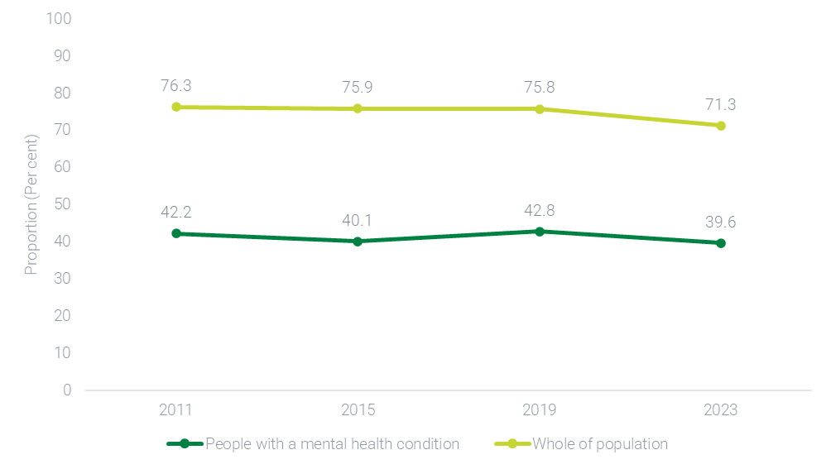

How do these findings differ between groups?

Whole of population
In 2023, 72.2% of males and 70.3% of females reported feeling a high sense of control. These proportions are similar to previous proportions observed in 2011 (Males: 76.7%, Females: 75.9%), 2015 (Males: 76.4%, Females: 75.4%) and 2019 (Males: 76.8%, Females: 74.8%), and show no significant differences between the sexes.
In 2023, 71.1% of people aged 15-34 years reported feeling a high sense of control, which was similar to people aged 35-64 years (71.5%) and 65 years and over (70.8%). This represents a shift from earlier years, when older adults consistently reported lower levels of control compared to younger age groups. In 2011, for example, a clear age gradient was evident: 79.7% of people aged 15-34 years, 75.8% of those aged 35-64 years, and 70.2% of those aged 65 years and over reported high levels of control. This gap steadily narrowed over time, with proportions becoming more closely aligned in 2015 (77.6%, 76.1% and 71.8%, respectively) and 2019 (76.9%, 75.7% and 73.9%, respectively), culminating in no substantial difference by 2023.
When examining SEIFA scores, in 2023, people who were living in least disadvantaged areas were more likely to report having a high sense of control, when compared to those who were living in most disadvantaged areas. This is consistent with findings from 2011, 2015, and 2019.
In 2023, people living in Major cities (71.5%), Inner Regional (70.8%) and Outer Regional Australia (69.2%), were less likely to report having a high sense of control. In contrast, people living in Remote areas were more likely to report having a high sense of control (74.5%).

Lived Experience
In 2023, among people with a long-term mental health condition, the proportion of people reporting a high sense of control did not significantly differ between males (39.5%) and females (39.7%). This is slightly different to earlier findings from 2011, 2015, and 2019, where females were consistently more likely to report a high sense of control (47.3%, 43.8% and 45.2%, respectively) when compared to males (36.1%, 35.6% and 39.3%, respectively).
Among people with a long-term mental health condition, the differences in the proportion of people reporting a high sense of control between age groups widened in 2023 compared to previous years. In 2023, among people with a long-term mental health condition, the largest proportion of people reporting a high sense of control was for people aged 15-34 years (43.9%), followed by people aged 35-64 years (38.3%) and 65 years and over (34.3%). This pattern is consistent with findings from 2011 and 2019. However, in 2015, a slightly different trend was observed, with a higher proportion of people aged 65 years and over (43.7%) reporting a high sense of control when compared to people aged 15-34 years (39.7%) and 35-64 years (39.2%).

Technical information

Source
Melbourne Institute of Applied Economic and Social Research. The Household, Income and Labour Dynamics in Australia Survey (HILDA), Wave 11, 15, 19, and 23

Frequency of data collection
Annually. Relevant items only collected every 4 years.

Limitations
- Data for this indicator relating to people with a long-term mental health condition have relative standard error sizes that in some cases makes it difficult to detect statistical differences between groups (e.g. some age groups).
- The HILDA methodology has a number of limitations around survey attrition, response rates, questionnaire design and data collection for 'Sex' (for further information, see the HILDA Survey User Manual). These do not, however, significantly impact the data and analyses presented for this indicator.

Additional notes
- Sense of control is calculated through seven items from the Pearlin and Schooler’s (1978) Mastery Scale, which measures the “extent to which one regards one’s life chances as being under one’s own control”. Individuals indicate how much they agree with the statements on a scale from 1 (’strongly disagree’) to 7 (‘strongly agree’). The Mastery Scale includes seven items – two items measuring personal mastery and five items measuring perceived constraints. The perceived constraint items are reverse-scored and the mean of the items is computed for respondents who have valid responses for all of the items on the scale. A higher score indicates a higher sense of control.
- For the purposes of this indicator, individuals who score higher than 4.5 fall under the category of ‘High sense of control’, while people who score lower than or equal to 4.5 fall under the category ‘Low sense of control’.
- The findings in the National Report Card 2024 differ from those reported in 2023 due to a refinement in the scoring approach used to measure sense of control, based on the Pearlin and Schooler Mastery Scale. In the 2024 analysis, the scoring approach has been updated to align more closely with established methodologies, including those used in the HILDA survey. Specifically, the five negatively worded items were reverse scored, while the two positively worded items were scored in their original form. This approach provides a more consistent interpretation of the scale, where higher scores uniformly indicate a greater sense of control. Given the same cut-off score (4.5) was used to distinguish between high and low sense of control, the revised scoring method has resulted in a different distribution of scores. Consequently, the 2024 estimates may differ from those published in the 2023 report. These differences reflect a methodological enhancement and should be considered when comparing results with the 2023 report.
- In the HILDA survey, the term ‘long-term health condition’ is used to describe any long-term health condition, impairment or disability that a respondent says restricts them in their everyday activities, and which has lasted or is likely to last for six months or more. People with a long-term mental health condition refers to respondents who indicated they had a nervous or emotional condition that requires treatment and/or any mental illness that requires help or supervision.
- Some proportions may not add up to 100% due to number perturbation implemented by the data source owner.
- SEIFA assigns collective socio-economic characteristics for people living within a designated geographic area. This measure broadly defines relative socio-economic advantage and disadvantage in terms of people’s access to material and social resources, and their ability to participate in society. Area levels indexes in this instance are used as a proxy measure of individual socio-economic advantage and disadvantage, and as a result there may be misclassification at a person-level. SEIFA classifications for 2021 are used for the HILDA analysis.
- Remoteness has been defined using the Australian Statistical Geography Standard (ASGS) and characterises relative geographic access to services. This has been grouped into three groups including ‘Major Cities of Australia’, ‘Inner Regional Australia’, and ‘Outer Regional Australia’ and ‘Remote Australia’. This analysis used ASGS classifications from 2021.
- Due to high standard errors for data related to SEIFA Quintiles and remoteness, analyses have been excluded from the lived experience section for this core indicator.

CI 5: Proportion of children developmentally vulnerable

What we are tracking (and why)
This indicator tracks the proportion of children considered developmentally vulnerable in the Australian Early Development Census (AEDC). In the AEDC, children are designated a score across five domains of early childhood development: physical health and wellbeing; social competence; emotional maturity; language and cognitive skills; and communication skills. This indicator examines the proportion of children considered vulnerable on one or more of the domains and on two or more of the domains.
Children who lag behind their peers during early school years may face significant difficulties completing their primary and secondary education, putting them at risk of poorer social, financial and health outcomes. Research also shows children who are developmentally vulnerable may face poorer mental health outcomes directly or indirectly. A reduction in the proportion of children who are developmentally vulnerable may forecast future improvements in mental health and wellbeing outcomes as children transition into adulthood.

What the data tells us

Indicator findings
As shown in Figure A5, the proportion of children in Australia who were developmentally vulnerable on one or more AEDC domain(s) has increased significantly since 2021. Steady increases in this figure since 2018 indicate that proportions are now no longer significantly different to those from 2009, where this figure was at its highest. The percentage of children who were developmentally vulnerable on two or more domains also significantly increased between 2021 and 2024, and is now significantly higher than figures from 2009.
Figure A5. Proportion of children considered developmentally vulnerable on one or more domains, developmentally vulnerable on two or more domains, and developmentally on track on five domains, 2009-2024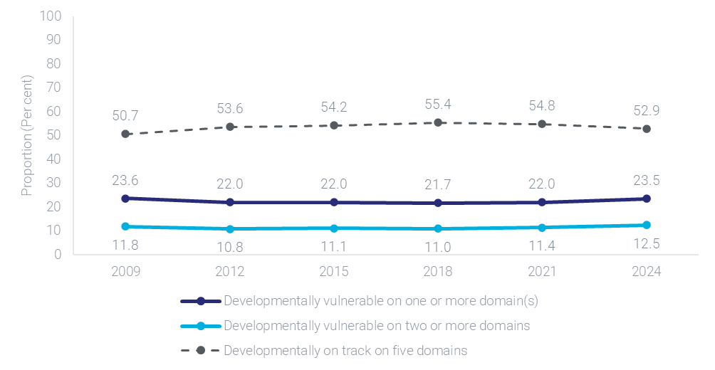

How do these findings differ between groups?
Detailed group analyses were not conducted for the purpose of this report. However, it should be noted that the 2021 AEDC report found that the proportion of children who were considered vulnerable in one or more domain was higher for children living in socio-economically disadvantaged communities. This trend was also observed in 2024.
The 2024 AEDC report noted several key differences between groups. Firstly, while the proportion of Aboriginal and Torres Strait Islander children who were on track in all five AEDC domains (33.9%) was significantly lower than the total population (52.9%) in 2024, it has stabilised since 2021 (34.3%) with a non-significant decline of 0.4 percentage points. Additionally, in 2024, children who were in Inner/Outer regional and Remote/Very remote areas were less likely to be developmentally on track on all five AEDC domains compared to Major cities. Despite this, there was a smaller decline in this proportion from 2021 to 2024 when compared to children in Major cities.

Technical information

Source
Australian Government. Department of Education Australian Early Development Census National Report 2024

Frequency of data collection
Every three years.

Limitations
- Data on developmental vulnerability does not speak to the cause of the developmental vulnerability, whether it relates to the child’s mental health, or whether the child has previously received or is currently receiving additional supports.

Additional notes
- Scores on the AEDC are teacher-rated.
- Children who score in the top 75% of the national AEDC population are classified as ‘on track’, while children who score in the lowest 10% are classified as ‘vulnerable’. Furthermore, children who are developmentally vulnerable in two or more domains are included in both developmentally vulnerable categories. As such the sum of the percentage of on track and developmentally vulnerable children does not add to 100%.
- AEDC results are not reported for children with special needs at a national level.
- Detailed information on the methodology is available on the AEDC website. Please note that at the time of publishing the 2024 AEDC Data Collection Technical Report is not available.

CI 6: Housing security (homelessness)

What we are tracking (and why)
This indicator tracks people in Australia aged 16-85 years who have ever been without a permanent place to live in their lifetime as measured by the National Study of Mental Health and Wellbeing (NSMHW). While various data sources measure current and lifetime rates of homelessness across the population, the NSMHW provides insights into the mental health status of people who have experienced homelessness in their lifetime using diagnostic criteria.
People who are without a permanent place to live and experience homelessness have poorer health outcomes and significant disadvantage across a wide range of social determinants. Health-related issues include chronic and acute physical conditions, as well as mental health conditions like anxiety, depression and substance use disorders. By contrast, access to secure housing is associated with improved mental health and wellbeing. As such, a decrease in the rate of lifetime homelessness may forecast improvements in mental health and a range of other social determinants like financial distress and employment.

What the data tells us

Indicator findings

Whole of population
In 2020-2022, 9.8% (1.9 million) of people in Australia aged 16-85 years had been without a permanent place to live in their lifetime.

Lived Experience
In 2020-2022, 17.7% (756,000) of people in Australia with a 12-month mental disorder had been without a permanent place to live in their lifetime. This was significantly higher than the proportion of people without a 12-month mental disorder (7.6% or an estimated 1.2 million people).

How do these findings differ between groups?

Whole of population
In 2020-2022, across the whole population, a significantly larger proportion of males (10.5%) had ever been without a permanent place to live when compared to females (9.1%). Furthermore, a significantly lower proportion of people aged 65-85 years (7.2%) had ever been without a permanent place to live compared to people aged 16-34 (9.9%) and 35-64 (10.7%) years.
Among people aged 16-34 years and 35-64 years, there were no significant differences between males and females. However, among people aged 65-85 years, males were significantly more likely to have been without a permanent place to live in their lifetime (9.8%) compared to females (5.1%).
In 2020-2022, among people who were living in areas of most disadvantage (Quintile 1) according to SEIFA scores, 15.6% had ever been without a permanent place to live. This proportion was significantly higher than Quintile 2 (12.0%), Quintile 3 (8.5%), Quintile 4 (8.9%), and Quintile 5 (5.5%).
In 2020-2022, for people living in Major City areas, 9.0% had ever been without a permanent place to live. This proportion was similar to people in Inner Regional areas (10.8%), but significantly lower than people in Outer Regional and Remote areas (14.2%).

Lived Experience
In 2020-2022, the proportion of people with a 12-month mental disorder who had ever been without a permanent place to live did not significantly differ between males (17.3%) and females (17.9%). However, among people without a 12-month mental disorder, a higher proportion of males (8.9%) had ever been without a permanent place to live compared to females (6.2%).
Among people with a 12-month mental disorder, the proportion of people who had ever been without a permanent place to live differed slightly across age groups. The proportion was highest for people aged 35-64 years (19.9%), followed by people aged 16-34 years (16.8%) and 65-85 years (12.4%). Similar age group trends were observed for people without a 12-month mental disorder, albeit at a smaller scale.
As shown in Figure A6, the disparity between people with a 12-month disorder and people without is seen across age groups and sexes. The largest gap was for females aged 35-64 years (12.1 percentage points) and the smallest gap was for males aged 65-85 years (2.5 percentage points).
Figure A6. Proportion of people in Australia aged 16-85 years who have ever been without a permanent place to live by 12-month mental disorder status, age group, and sex, 2020-2022
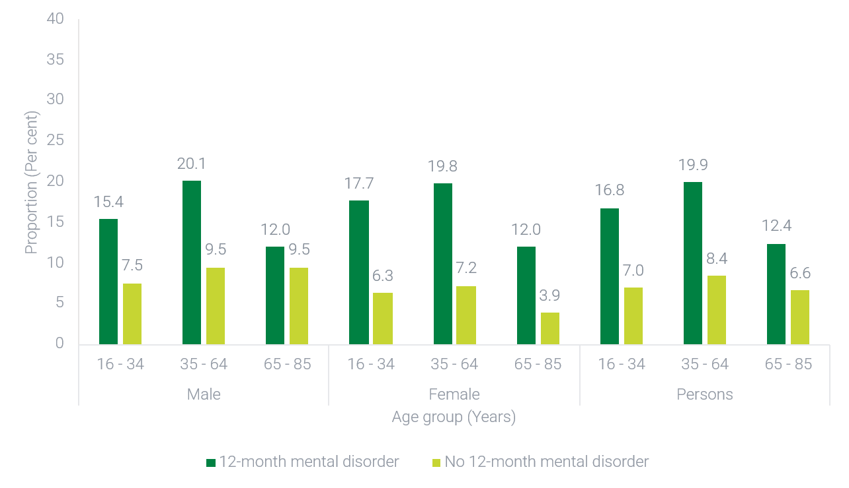
In 2020-2022, for people with a 12-month mental disorder who were living in areas of most disadvantage (Quintile 1) according to SEIFA scores, 28.5% had ever been without a permanent place to live. This was significantly higher than other Quintiles (Quintile 2: 20.5%, Quintile 3: 15.6%, Quintile 4: 16.1%, Quintile 5: 9.6%).
In 2020-22, among people with a 12-month mental disorder, 16.4% of people living in Major City areas had ever been without a permanent place to live. This proportion was similar to those in Inner Regional areas (17.7%) but significantly lower than people in Outer Regional and Remote areas (28.9%). Among people without a 12-month mental disorder, there were no significant differences in proportions between people living in Major City (7.1%), Inner Regional (8.7%), and Outer Regional and Remote areas (9.4%). Across all areas, proportions were higher for people with a 12-month mental disorder compared to those without a 12-month mental disorder.

Technical information

Source
Australian Bureau of Statistics National Study of Mental Health and Wellbeing, 2020-2022.

Frequency of data collection
Irregular. No future releases scheduled.

Limitations
- The NSMHW assesses whether a person has ever been without a permanent place to live, as opposed to current living arrangements. Findings therefore do not represent current rates of homelessness across the population, or among people with a mental disorder. Information on current estimates of homelessness from the latest Census is available at the ABS website.
- Detailed information on the methodology is available at the ABS website.

Additional notes
- Comparisons between males and females are based on sex recorded at birth (i.e., what was determined by sex characteristics observed at birth or infancy).
- People who had ever been without a place to live in their lifetime includes ‘sleeping rough, staying in a crisis or homeless shelter, staying in a refuge, staying with friends or relatives, staying in support/transitional accommodation, staying in a boarding house, staying in other’.
- A 12-month mental disorder refers to people who met the diagnostic criteria for having a mental disorder at some time in their life and had sufficient symptoms of that disorder in the 12 months prior to completing the survey. A person may have more than one 12-month mental disorder.
- Some proportions may not add up to 100% due to number perturbation implemented by the data source owner.
- SEIFA assigns collective socio-economic characteristics for people living within a designated geographic area. This measure broadly defines relative socio-economic advantage and disadvantage in terms of people’s access to material and social resources, and their ability to participate in society. Area levels indexes in this instance are used as a proxy measure of individual socio-economic advantage and disadvantage, and as a result there may be misclassification at a person-level. SEIFA classifications for 2016 are ranked according to quintiles for this analysis.
- Remoteness has been defined using the Australian Statistical Geography Standard (ASGS) and characterises relative geographic access to services. This has been grouped into three groups including ‘Major Cities of Australia’, ‘Inner Regional Australia’, and ‘Outer Regional and Remote Australia’. This analysis used ASGS classifications from 2016.

CI 7: Financial stress

What we are tracking (and why)
This indicator tracks the proportion of households in Australia that are unable to raise $2,000 within a week for something important. This measure does not prescribe how those funds would be raised, and so accounts for the diversity of resources that households might draw on, such as from savings, loans from family or friends, or selling belongings.
Financial stress is a significant risk factor for poor mental health and can cause or worsen psychological distress, anxiety, depression or suicidal thoughts. While mechanisms for how this occurs is complex, financial stress may be due to exposure to worse living conditions, unhealthy lifestyles, social isolation, or negative life events,. Increases in financial stress may forecast poorer mental health across the population in future, or increased pressure and reliance on mental health services.

What the data tells us

Indicator findings

Whole of population
In 2020, almost one in five (18.7%) of households in Australia were unable to raise $2,000 within a week for something important. As seen in Figure A7, proportions remained relatively stable from 2006 to 2014, before jumping significantly in 2019, and remaining stable through to 2020. Financial stress data is not currently available for the 2021-2023 period.
Importantly, data for the ability to raise $2,000 is not adjusted for inflation. The purchasing power of $2,000 was less in 2020 compared to 2006, yet a higher proportion of people were unable to raise $2,000 in 2020. The observed increase over time for this measure may therefore under-represent the actual rise in financial stress across the population.

Lived Experience
In 2020, 29.9% of people with a mental health condition were unable to raise $2,000 within a week for something important. This was significantly higher than people without a mental health condition (17.1%). The proportion of those who were unable to raise $2,000 within a week for something important has increased significantly between 2014 and 2020 for both those with and without a mental health condition. For people with a mental health condition, 25.3 % in 2014 and 33.3% in 2019 were unable to raise $2,000 within a week for something important. For people without a mental health condition, these figures were 10.3% and 17.4% respectively.
Figure A7. Proportion of households in Australia who were unable to raise $2,000 within a week for something important over time, 2006-2020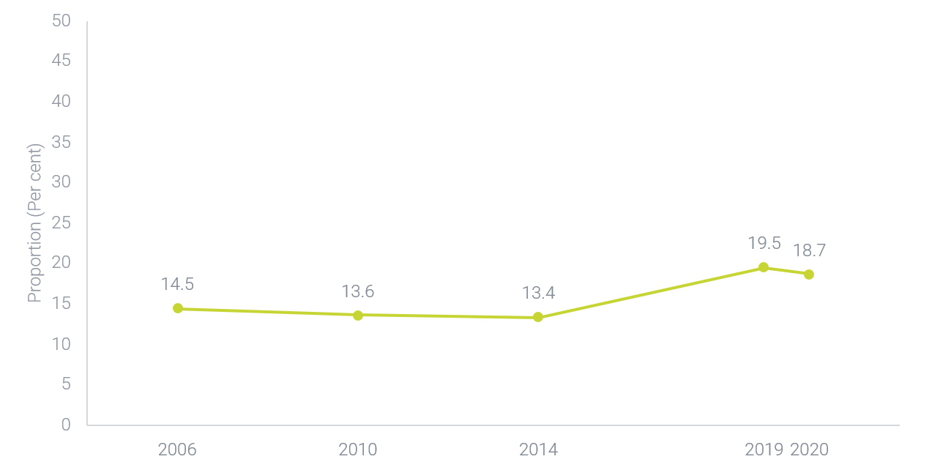

How do these findings differ between groups?

Lived Experience
In 2020, for people with a mental health condition who were living in areas of most disadvantage (Quintile 1) according to SEIFA scores, 43.7% could not raise $2,000 within a week. This was significantly higher than those in Quintile 3 (21.4%), Quintile 4 (22.3%) and Quintile 5 (12.9%), but not significantly different to people in Quintile 2 (44.6%). For people without a mental health condition, 26.3% of people living in areas of most disadvantage (Quintile 1) could not raise $2,000 within a week. This was significantly higher than people in Quintile 3 (17.3%), Quintile 4 (14.6%) and Quintile 5 (10.3%), but not significantly different to people in Quintile 2 (20.8%).
In 2020, among people with a mental health condition living in a Major City area, 29.1% could not raise $2,000 within a week. This was not significantly different to people in Inner Regional areas (32.4%). Over time the proportion of people in Major City areas with a mental health condition who could not raise $2,000 within a week has significantly increased from 22.8% in 2014, to 29.1% in 2020. In contrast, the proportion of people in Inner Regional areas who could not raise $2,000 has remained consistent over time (32.0% in 2014, to 32.4% in 2020).

Technical information

Source
Australian Bureau of Statistics (ABS) General Social Survey, 2020; ABS General Social Survey, 2019; ABS General Social Survey, 2014: ABS General Social Survey, 2010; ABS General Social Survey, 2006.

Frequency of data collection
Approximately every four years. Some changes in data collection schedule due to the COVID-19 pandemic period.

Limitations
- Care should be made when comparing 2020 data to earlier years due to changes in the survey methodology, higher rates of non-response in that survey, and the impact of COVID-19 restrictions on the population.
- When assessing the presence of a mental health condition, respondents were asked if they were told by a doctor, nurse or other health professional that they have one of the listed conditions, which included ‘Mental health condition (including depression or anxiety)’. This question is asked for conditions that have lasted or are expected to last for six months or more.
- There are several high standard error figures for SEIFA and Remoteness disaggregation analyses, which has limited the number of possible comparisons between groups.

Additional notes
- Data for the ability to raise $2,000 is nominal (not adjusted for inflation).
- Detailed information on the methodology is available on the ABS website.
- SEIFA assigns collective socio-economic characteristics for people living within a designated geographic area. This measure broadly defines relative socio-economic advantage and disadvantage in terms of people’s access to material and social resources, and their ability to participate in society. Area levels indexes in this instance are used as a proxy measure of individual socio-economic advantage and disadvantage, and as a result there may be misclassification at a person-level. SEIFA classifications for 2016 are ranked according to quintiles for this analysis.
- Remoteness has been defined using the Australian Statistical Geography Standard (ASGS) and characterises relative geographic access to services. This has been grouped into three groups including ‘Major Cities of Australia’, ‘Inner Regional Australia’, and ‘Outer Regional and Remote Australia’. This analysis used ASGS classifications from 2016 and 2011.

CI 8: Employment rate

What we are tracking (and why)
This indicator tracks the employment rate of people with a mental or behavioural condition in Australia aged 16-64 years.
Employment can improve mental health, acting as a protective factor in the short-term and reducing the likelihood of long-term reliance on mental health services. Employment can also help provide financial security, develop social and community relationships, and contribute to personal fulfilment. However, the relationship between employment and mental health is complex. People with mental health conditions may face significant barriers to securing meaningful work, such as discrimination, stigma, and lack of adequate support to engage in the workforce. While the employment rate is impacted by a complex interplay of social and economic factors, high or increasing employment rates may forecast improvements in the mental health, social connectedness and financial security of people in Australia, as well as a reduction in systemic stigma and discrimination related to employment.

What the data tells us

Indicator findings

Whole of population
According to the 2022 National Health Survey, for all people in Australia aged 16-64 years, the employment rate was 79.5%. This is higher than in previous years (75.7% in 2014-15; 76.5% in 2017-18).

Lived Experience
In 2022, among people in Australia aged 16-64 years with a mental or behavioural condition, the employment rate was 71.6%. As shown in Figure A8, the employment rate of people with a mental or behavioural condition has increased since 2014-15. Further, the employment rate for people with a mental or behavioural condition is increasing at a greater rate than the employment rate for people without a condition. However, in 2022, it remains significantly lower than the employment rate of 82.8% for people without a mental or behavioural condition.
Figure A8. Proportion of people in Australia who are employed by mental or behavioural condition status, 2014-15 to 2022
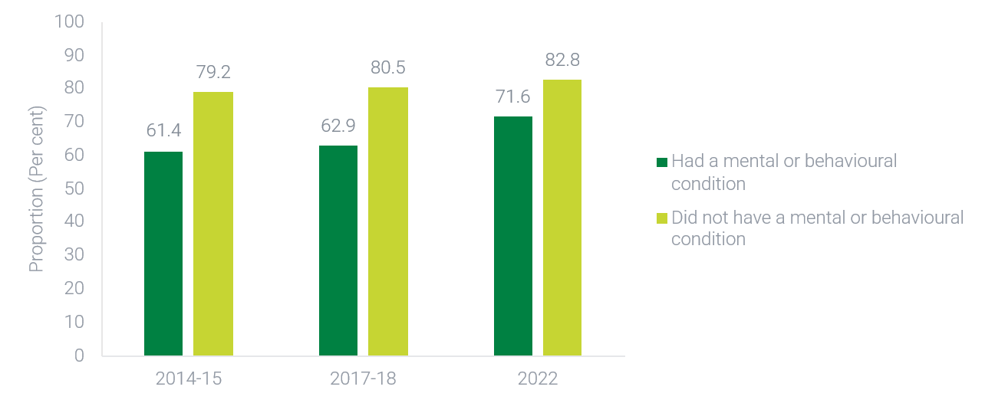

How do these findings differ between groups?

Whole of population
In 2022, a significantly higher proportion of males were employed (83.2%) compared to females (76.0%). The employment gap between males and females has reduced over the last decade, from 11.5 percentage points in 2014-15, to 9.8 in 2017-18 and 7.2 in 2022.
In 2022, the proportion of people employed was relatively uniform for those aged 25-34 (84.9%), 35-44 (86.3%), and 45-54 years (83.0%). However, the employment rate was lower for people aged 16-24 years (73.6%) and people aged 55-64 years (66.2%). Across all age groups, increases in the employment rate from 2014-15 to 2022 ranged from 2.3 to 3.8 percentage points, except for people aged 16-24 years. Among this group, there was a 7.3 percentage point increase, which is approximately double the increase observed for other age groups.
In 2022, 80.3% of people living in Major City areas were employed, which was significantly higher than people living in Inner Regional areas (75.7%), but not Outer Regional and Remote areas (78.8%). Between 2014-15 and 2022, people living in Major City areas were the only group to show an increase in employment rates over time.

Lived Experience
Analyses indicate there are complex interactions between employment, the presence of a mental or behavioural condition, sex and age.
For all age groups, the gap in employment rate between people with and without a mental or behavioural condition reduced slightly between 2014-15 to 2022. However, this gap still remains in 2022, with larger gaps present for older age groups compared to younger age groups. For people aged 25-34 years, 77.4% of people with a mental or behavioural condition were employed, which was 11.2 percentage points lower than people without a mental or behavioural condition (88.6%). A similar difference was observed for people aged 35-44 years, with a percentage point difference of 9.9. This difference was greater for people aged 45-54 years (15.8 percentage point difference) and people aged 55-64 years (21.2 percentage point difference).
In 2022, among all people with a mental or behavioural condition, the employment rate for males and females did not significantly differ. This was consistent with findings from 2017-18, but not with those from 2014-15 where there was a significant difference between males (64.9%) and females (58.9%). In 2022, for people without a condition, a greater proportion of males were employed (87.2%) compared to females (77.9%). This difference between males and females without a mental or behavioural condition was also observed in 2017-18 and 2014-15.
In 2022, for people aged 16-24 years with a mental or behavioural condition, a greater proportion of females (77.5%) were employed compared to males (67.7%), which was a 9.8 percentage point difference. Conversely, a greater proportion of males were employed compared to females among the 35-44 years age group (6 percentage point difference) and 45-54 years age group (9.1 percentage point difference).
In 2022, 74.0% of people with a mental or behavioural condition living in a Major City area were employed. This was significantly higher than people with a mental or behavioural condition in Inner Regional (64.7%), and Outer Regional and Remote areas (67.2%). For people without a mental or behavioural condition, there were no significant differences in employment rates for people in Major City (82.8%), Inner Regional (81.9%), and Outer Regional and Remote areas (84.9%). Between 2014-15 and 2022, people with a mental or behavioural condition in Major City areas have shown larger improvements in employment rates compared to people in Inner Regional areas and Outer Regional and remote areas. People without a mental or behavioural condition have seen improvements in Major City and Outer Regional and Remote areas compared to Inner Regional areas.

Technical information

Source
Australian Bureau of Statistics (ABS) National Health Survey, 2022; ABS National Health Survey, 2017-18; ABS National Health Survey, 2014-15.

Frequency of data collection
Every three years. Note some differences in frequency of collection due to COVID-19.

Limitations
- Items used within the National Health Survey are not primarily designed to capture and estimate employment rates across the whole population. Thus, findings may differ slightly to employment data sources reported elsewhere.

Additional notes
- The employment rate is just one of many relevant measures of participation in the labour market (e.g., unemployment rate, job vacancies, underemployment rate and labour force participation rate) which are impacted by a complex interplay of social and economic factors. Further information on other key measures is available at: https://www.aihw.gov.au/reports/australias-welfare/employment-unemployment.
- A related and commonly tracked measure is labour force participation. This is a broader measure of economic participation, encompassing both people who are employed and people who are unemployed but actively looking for work. Analyses of labour force data were conducted alongside employment figures to check for relevant differences, but findings were similar to employment figures. As a result, labour force findings have not been discussed for this indicator.
- The National Health Survey provides information on employment rates for people with a mental or behavioural condition and provides a comparison population of all people in Australia. For whole of population employment rate figures, please refer to labour force findings on the ABS website.
- Comparisons between males and females are based on sex recorded at birth (i.e., what was determined by sex characteristics observed at birth or infancy).
- People who are considered to meet the criteria for a mental or behavioural condition meet the following definition ‘Persons who have a current, self-reported mental and behavioural condition which has lasted, or is expected to last, for 6 months or more. Condition is not based on any diagnostic screening tool’.
- Some proportions may not add up to 100% due to number perturbation implemented by the data source owner.
- Remoteness has been defined using the Australian Statistical Geography Standard (ASGS) and characterises relative geographic access to services. This has been grouped into three groups including ‘Major Cities of Australia’, ‘Inner Regional Australia’, and ‘Outer Regional and Remote Australia’. This analysis used ASGS classifications from 2021, 2016, and 2011.SEIFA analyses have been excluded from this core indicator analysis. SEIFA is determined using income, education, employment, occupation, housing, and miscellaneous variables. Given employment is used to determine SEIFA scores, it should not be used to compare or cross-tabulate by SEIFA scores. For more information, please see the ABS website.
- Detailed information on the methodology is available on the ABS website.

CI 9: Engagement in employment or study for young people

What we are tracking (and why)
This indicator tracks people in Australia aged 16-24 years who are engaged in employment and/or enrolled for study in a formal secondary or tertiary qualification (full or part-time).
Engagement in employment or study is particularly important for young adults. The transition from school to further education or work is a critical period of personal and educational development, providing a foundation for life-long vocational skills, social connectivity and financial security. Research shows a lack of engagement in employment or study following compulsory education can contribute to future unemployment, lower incomes and employment insecurity. Among young adults, there is also a clear association between being engaged in employment and study and positive mental health and wellbeing outcomes. Higher rates of engagement by young people in employment and study may forecast improvements in the mental health, social connectedness, and financial security of young people in Australia.

What the data tells us

Indicator findings

Whole of population
In 2022, 94.0% of people in Australia aged 16-24 years were employed and/or studying. This proportion is higher than reported in previous years (2014-15: 89.9%, 2017-18: 90.5%).

Lived Experience
In 2022, 89.2% of people in Australia aged 16-24 years with a mental or behavioural condition were employed and/or studying. This is significantly lower than the proportion of people without a mental or behavioural condition who were employed and/or studying (96.4%).
As shown in Figure A9, the gap between people with and without a mental or behavioural condition who are employed and/or studying has decreased since 2014-15. When considering these findings, it should be noted that from 2014-15 to 2022, the overall number of people reporting a mental or behavioural condition has increased. The reduction in the gap may in part be driven by more people identifying as having a mental health or behavioural condition, including people with less severe symptoms.

Figure A9. Proportion of people with and without a mental or behavioural condition aged 16-24 years who are employed and/or studying, 2014-15 to 2022
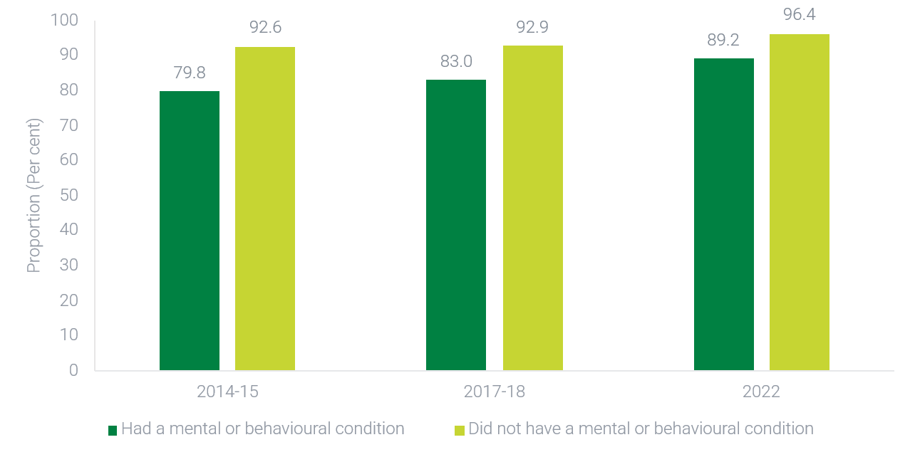

How do these findings differ between groups?

Whole of population
In 2022, rates of engagement in employment and study did not significantly differ between males (94.3%) and females (93.3%). This is consistent with findings from 2014-15 and 2017-18 where there were also no significant differences.
In 2022, among people aged 16-24 years who lived in Major City areas, 96.8% were employed and/or studying, which was significantly higher than those in Inner Regional (85.1%), and Outer Regional and Remote areas (85.5%). Between 2014-15 and 2022, only Major City areas have shown improvement in the proportion of people engaged in employment and/or study (2014-15: 90.4%, 2022: 96.8%).

Lived Experience
In 2022, for both males and females, people aged 16-24 years with a mental or behavioural condition were less likely to be employed and/or studying than people without a condition. This gap was larger for females (9.3 percentage point difference) compared to males (5.4 percentage point difference).
Over time, the proportion of females aged 16-24 years with a mental or behavioural condition who were employed and/or studying has remained stable. In 2017-18, 87.1% of females within this group were employed and/or studying, compared to 86.2% in 2022. In contrast, an increase over time was observed for males in the same group: 79.2% were employed and/or studying in 2017-18, compared to 91.4% in 2022. This difference may in part be due to a larger proportional increase in the number of males reporting a mental or behavioural condition over time compared to females. The increase over time for males with a mental health or behavioural condition was not mirrored among males without a mental or behavioural condition (2017-18: 95.1%, 2022: 96.8%).
In 2022, for people with a mental or behavioural condition living in a Major City area, 92.7% were employed and/or studying. This was significantly higher than for those in Outer Regional and Remote areas (79.6%). Over time, the proportion of people with a mental or behavioural condition who were employed and/or studying has improved for those in Major city areas: in 2014-15, 81.4% were employed and/or studying, which increased significantly to 92.7% in 2022.The proportion did not significantly differ over time for people with a mental or behavioural condition in Outer Regional and Remote areas.

Technical information

Source
Australian Bureau of Statistics (ABS) National Health Survey, 2022; ABS National Health Survey, 2017-18; ABS National Health Survey, 2014-15.

Frequency of data collection
Every three years. Note some differences in frequency of collection due to COVID-19.

Limitations
- Items used within the National Health Survey are not primarily designed to capture and estimate employment and/or studying rates across the relevant population. Thus, findings may differ slightly to data sources available elsewhere.
- Detailed information on the methodology is available on the ABS website.
- There are several high standard error figures for Remoteness analyses, which has limited the number of possible comparisons between groups.

Additional notes
- Comparisons between males and females are based on sex recorded at birth (i.e., what was determined by sex characteristics observed at birth or infancy).
- People who are considered to meet the criteria for a mental or behavioural condition meet the following definition ‘Persons who have a current, self-reported mental and behavioural condition which has lasted, or is expected to last, for 6 months or more. Condition is not based on any diagnostic screening tool’.
- Some proportions may not add up to 100% due to number perturbation implemented by the data source owner.
- Remoteness has been defined using the Australian Statistical Geography Standard (ASGS) and characterises relative geographic access to services. This has been grouped into three groups including ‘Major Cities of Australia’, ‘Inner Regional Australia’, and ‘Outer Regional and Remote Australia’. This analysis used ASGS classifications from 2021, 2016, and 2011. SEIFA analyses have been excluded from this core indicator analysis. SEIFA is determined using income, education, employment, occupation, housing, and miscellaneous variables. Given employment is used to determine SEIFA scores, it should not be used to compare or cross-tabulate by SEIFA scores. For more information, please see the ABS website.

CI 10: Prevalence of physical health conditions

What we are tracking (and why)
This indicator tracks the prevalence of long-term physical conditions and their co-occurrence with 12-month mental disorders for people in Australia aged 16-85 years. For this indicator, long-term physical conditions are those where a person had been told by a doctor or nurse that they had a long-term physical health condition, which had lasted, or was expected to last, for 6 months or more.
People with mental illness typically experience worse physical health outcomes than people without mental illness. Higher rates of co-occurring physical and mental conditions can result in reduced life expectancy, increased levels of ongoing disability, and reduced workforce participation. Reduction in the co-occurrence of physical and mental health conditions may signal an improvement in the system’s performance in improving the physical health of people with mental illness. It may also have flow-on effects for broader factors that influence mental health outcomes, such as improved employment rates or decreased financial stress.

What the data tells us

Indicator findings

Whole of population
In 2020-2022, 7.5 million (37.9%) people in Australia aged 16-85 years had a long-term physical condition. An estimated 5.8 million people (29.5% of the population) had a physical condition only, while an estimated 1.7 million people (8.4% of the population) had both a mental and physical condition.
Time series data on long-term physical conditions are not available for this data source. However, other data sources show no change over time in the proportion of people in Australia who have a chronic physical health condition (from 37.3% in 2007-08, to 38.7% in 2014-15 and 37.4% in 2022).

Lived Experience
For the 4.3 million people (21.5% of the population) aged 16-85 years with a 12-month mental disorder in 2020-2022, 1.7 million (8.4% of the population) also had a physical condition. A higher proportion (39.3%) of people with a mental disorder experienced a long-term physical condition compared to people without a mental disorder (37.5%), however this difference was not statistically significant.

How do these findings differ between groups?

Whole of population
In 2020-2022, the proportion of people with a physical condition increased consistently with age. For people aged 16-24 years, 15.4% had a physical condition, increasing to 34.7% for people aged 45-54 years and again to 83.1% for people aged 75-85 years.
A higher proportion of females had a physical condition (40.1%) compared to males (35.6%) in 2020-2022. However, this difference was significant only amongst older age groups. For people aged 65-74 years, 76.8% of females and 69.0% of males had a physical condition; similarly for the 75-85 age group, 86.4% of females and 78.3% of males had a physical condition.
As seen in Figure A10, across most age groups a higher proportion of people with a mental disorder had a physical condition compared to people without a mental disorder. This difference was most pronounced for people aged 55-64 years.
In 2020-2022, for people who were living in areas of most disadvantage (Quintile 1) according to SEIFA scores, 46.0% had a physical condition. This was significantly higher than people in Quintile 2 (42.0%), Quintile 3 (36.6%), Quintile 4 (33.3%), and Quintile 5 (34.6%).
In 2020-2022, for people living in Major City areas, 35.6% had a physical condition, which was significantly lower than people in Inner Regional (44.6%), and Outer Regional and Remote areas (44.6%).
Figure A10. Proportion of people in Australia aged 16-85 years with a physical condition, by age group and mental disorder status, 2020-2022
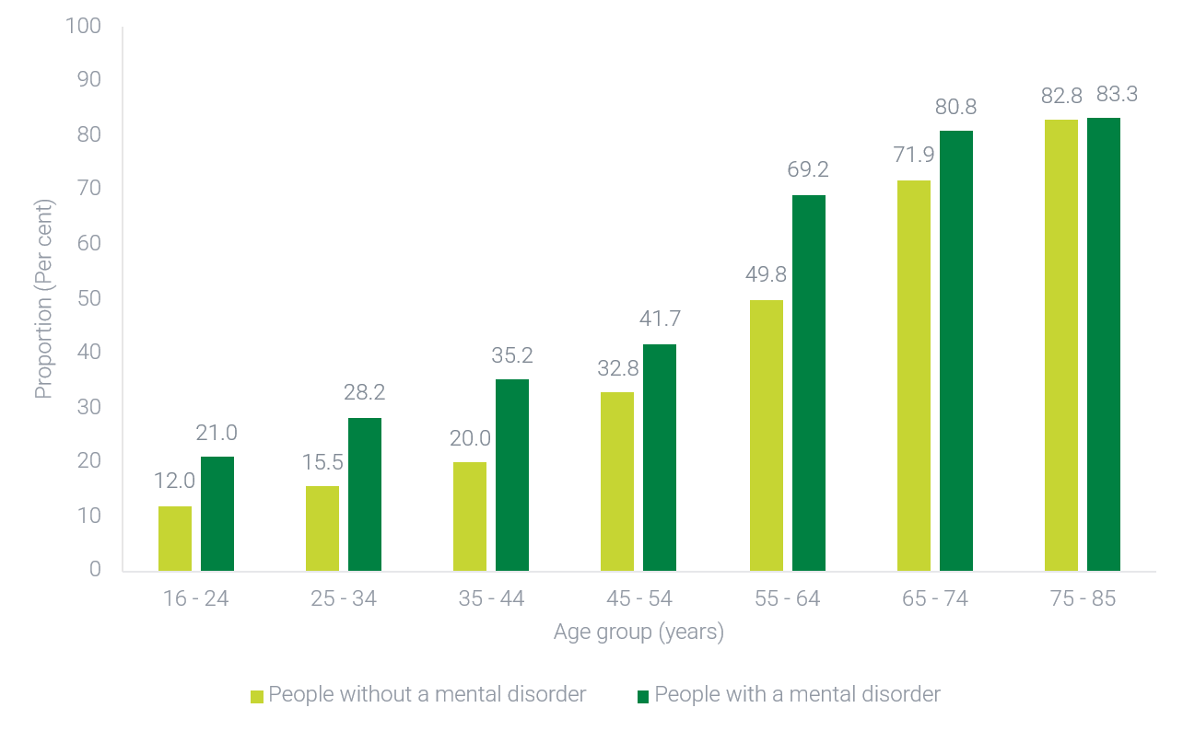

Lived Experience
In 2020-2022, across the whole population, there was a higher proportion of females with a 12-month mental disorder and co-occurring physical condition (10.5%) compared to males (6.3%). Furthermore, among people with a 12-month mental disorder, a higher proportion of males had no accompanying physical condition (65.2%) compared to females (57.3%). While the proportion of people with a physical condition increases with age, the proportion of people with a 12-month mental disorder that co-occurs with a physical condition remains relatively stable across age groups.
In 2020-2022, among people with a 12-month mental disorder who were living in areas of most disadvantage (Quintile 1) according to SEIFA scores, 48.5% had a co-occurring physical condition. This did not significantly differ from people living in Quintiles 2 (44.8%) or Quintile 3 (40.9%), but was significantly higher than those who were living in areas of least disadvantage (Quintile 4: 33% and Quintile 5: 32.3%).
In 2020-2022, for people with a 12-month mental disorder living in a Major City area, 36.9% had a co-occurring physical condition. This did not significantly differ from people in Inner Regional areas (43.2%), but was significantly lower than people in Outer Regional and Remote areas (50.4%). For people without a 12-month mental disorder living in a Major City area, 35.3% had a physical condition only. This was significantly lower than those living in Inner Regional (45.0%) and Outer Regional and Remote areas (42.8%).

Technical information

Source
Australian Bureau of Statistics (ABS) National Study of Mental Health and Wellbeing (NSMHW), 2020-2022; ABS National Health Survey (NHS), 2022; ABS National Health Survey, 2022; ABS National Health Survey, 2017-18; ABS National Health Survey, 2014-15; ABS Australian Health Survey, 2011-12; ABS National Health Survey, 2007-08.

Frequency of data collection
NSMHW – Irregular. No future releases scheduled.
NHS – Approximately every three years. Note some differences in frequency of collection due to COVID-19.

Limitations
- Due to the differences in questions used to assess physical health conditions, comparisons between the 2007 National Survey of Mental Health and Wellbeing and 2020-2022 National Study of Mental Health and Wellbeing for co-occurring mental and physical conditions are not possible.
- When interpreting findings presented for this indicator, it is important to consider that the effects physical conditions have on someone’s life can vary greatly. For instance, an individual living with asthma may have a very different experience with their mental health when compared to someone living with diabetes.
- NSHMW – Detailed information on the methodology is available at the ABS website.
- NHS – Detailed information on the methodology is available on the ABS website.

Additional notes
- Cross sectional analyses presented for the 2020-2022 reference period are sourced from the NSMHW, whereas time series analyses are sourced from the NHS. While descriptive statistics differ between these data sources due to methodological differences, the general pattern of findings is consistent.
- Comparisons between males and females are based on sex recorded at birth (i.e., what was determined by sex characteristics observed at birth or infancy).
- A 12-month mental disorder refers to people who met the diagnostic criteria for having a mental disorder at some time in their life and had sufficient symptoms of that disorder in the 12 months prior to completing the survey. A person may have more than one 12-month mental disorder. Mental disorders are classified according to the World Health Organization’s International Classification of Diseases, Tenth Revision (ICD-10).
- Within the context of public health surveillance, it is important to consider conditions which pose significant health problems. Findings from the NHS include selected ‘chronic physical health conditions’ that include arthritis, asthma, back problems (dorsopathies), cancer (malignant neoplasms), chronic obstructive pulmonary disease (COPD), diabetes mellitus, heart, stroke and vascular disease, kidney disease and osteoporosis. The NHS includes persons who have a current health condition which has lasted, or is expected to last, for 6 months or more; except for persons reporting diabetes mellitus and/or heart, stroke and vascular disease which are included irrespective of whether the condition is current and/or long-term.
- Some proportions may not add up to 100% due to number perturbation implemented by the data source owner.
- SEIFA assigns collective socio-economic characteristics for people living within a designated geographic area. This measure broadly defines relative socio-economic advantage and disadvantage in terms of people’s access to material and social resources, and their ability to participate in society. Area levels indexes in this instance are used as a proxy measure of individual socio-economic advantage and disadvantage, and as a result there may be misclassification at a person-level. SEIFA classifications for 2016 are ranked according to quintiles for this analysis.
- Remoteness has been defined using the Australian Statistical Geography Standard (ASGS) and characterises relative geographic access to services. This has been grouped into three groups including ‘Major Cities of Australia’, ‘Inner Regional Australia’, and ‘Outer Regional and Remote Australia’. This analysis used ASGS classifications from 2016.

CI 11: Alcohol consumption

What we are tracking (and why)
This indicator tracks the proportion of people in Australia aged 14 years and over who exceeded the Australian Guidelines To Reduce Health Risks From Drinking Alcohol (the Australian Alcohol Guidelines) released in 2020. For this indicator, exceeding the Australian Alcohol Guidelines is interpreted as consuming more than 10 standard drinks per week, consuming more than 4 standard drinks on any day at least monthly, or exceeding both components on average in the previous 12-months.
Consuming alcohol at harmful levels is shown to increase the risk of experiencing some physical conditions and may contribute to existing mental illness. It can also contribute to violence and assaults, avoidable injury, motor accidents and birth defects. A low or decreasing proportion of people who consume alcohol at harmful levels may signal improvements in the general health and wellbeing of people in Australia and reduced demand on the health and mental health system.

What the data tells us

Indicator findings

Whole of population
In 2022-2023, 30.7% of people in Australia aged 14 years and over exceeded the Australian Alcohol Guidelines. This equates to about 6.6 million people. There has been a steady downwards trend in the proportion of people in Australia who exceeded the Australian Alcohol Guidelines since 2010 (37.7%), which has been slightly less pronounced in recent years (from 33.2% in 2016 to 32.0% in 2019 and 30.7% in 2022-23).

Lived Experience
As shown in Figure A11, in 2022-2023 a higher proportion of people with a mental illness aged 18 years and over exceeded the Australian Alcohol Guidelines (36.9%) than people without a mental illness (31.6%). This gap has increased over time.
Figure A11. Proportion of people aged 18 years and over who exceeded the Australian Alcohol Guidelines by mental health status, 2010 to 2022-2023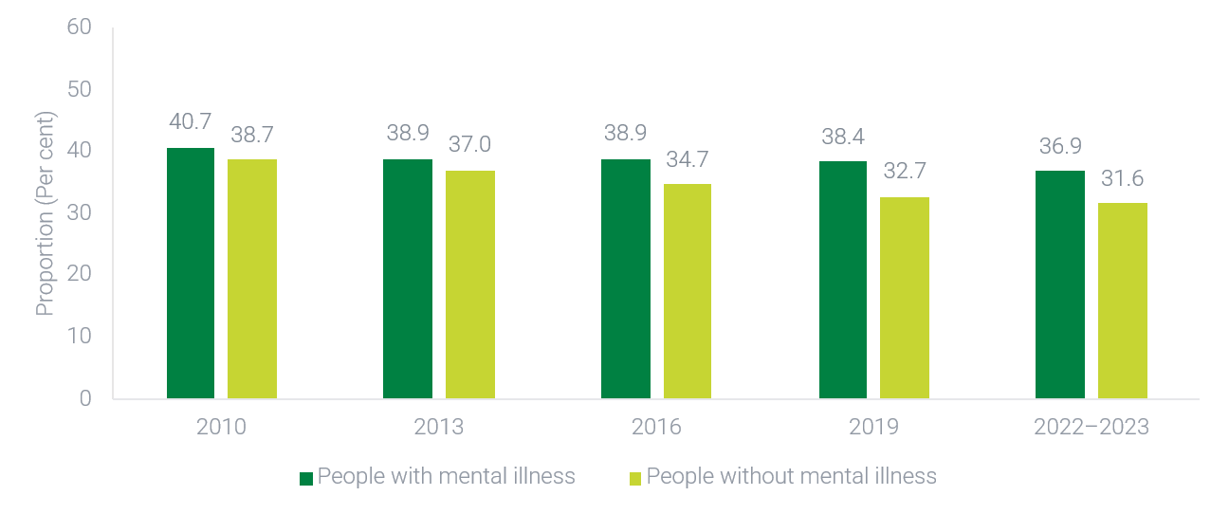
When looking at specific drinking behaviours, close to one-third (30.4%) of people with a mental illness consumed on average more than 10 standard drinks per week in the previous 12-months, compared to one-quarter (25.3%) of people without a mental illness. Similarly, 29.0% of people with a mental illness consumed more than 4 standard drinks in a single day at least monthly on average in the previous 12-months, compared to 24.6% of people without a mental illness. These rates are comparable to previous years.

How do these findings differ between groups?
In 2022-2023, the proportion of people in Australia who exceeded the Australian Alcohol Guidelines varied according to both gender and age. Among people aged 14 years and over, 31.8% of males consumed on average more than 10 standard drinks per week in the previous 12-months compared to 17.8% of females. A similar difference was observed when comparing rates for people who consumed on average more than 4 standard drinks in a single day at least monthly in the previous 12-months, but not as often as weekly (Males: 12.7%, Females: 8.7%).
In general, in 2022-2023 younger people were more likely to have exceeded the Australian Alcohol Guidelines by drinking more than 4 standard drinks in a single day at least monthly, while older people were more likely to do so by consuming more than 10 standard drinks per week in the previous 12-months. The proportion of people who exceeded the Australian Alcohol Guidelines has been relatively consistent since 2016 across different age groups. However, among people aged 14-17 years there was a reduction in the proportion of people exceeding the Australian Alcohol Guidelines for adults between 2019 (9.5%) and 2022-2023 (5.5%).
Data disaggregated by age, sex, SEIFA Quintiles, and Remoteness for people with a mental illness is currently unavailable.

Technical information

Source
Australian Institute of Health and Welfare (AIHW) National Drug Strategy Household Survey, 2022-2023; AIHW National Drug Strategy Household Survey, 2019; AIHW National Drug Strategy Household Survey, 2016; AIHW National Drug Strategy Household Survey, 2013; AIHW National Drug Strategy Household Survey, 2010.

Frequency of data collection
Approximately every three years.

Limitations
- Data are self-reported, and people may not accurately report information relating to alcohol consumption. Detailed information on the methodology, including limitations, is available on the AIHW website.

Additional notes
- It is important to note that adherence to the Australian Alcohol Guidelines minimise the risks associated with consuming alcohol, but they do not eliminate the risk entirely.
- People with a mental illness include those who self-reported that they had been diagnosed or received treatment for depression, an anxiety disorder, schizophrenia, bi-polar disorder, other form of psychosis or an eating disorder in the previous 12 months.
- For analyses presented for people with a mental illness, the age range of the sample population is 18 years and over. For other analyses presented, the age range of the sample population is 14 years and over.

CI 12: Feeling lonely

What we are tracking (and why)
This indicator tracks the proportion of people in Australia aged 15 years and over who reported feeling lonely.
Loneliness can be described as a subjective unpleasant or distressing feeling of a lack of connection to other people, along with a desire for more or more satisfying, social relationships. People who feel lonely are more likely to experience depression, social anxiety, poorer wellbeing, and premature death. Decreases in the rates of loneliness across the population may signify improvements in external factors that impact mental health and wellbeing across society.

What the data tells us

Indicator findings

Whole of population
Overall, 15.3% of people in Australia aged 15 years and over reported feeling lonely in 2023. As seen in Figure A12, this proportion is not significantly different to previous years reported (2011: 15.3%, 2015: 15.0%, 2019: 15.6%, 2022: 16.3).
Figure A12. Proportion of people in Australia aged 15 and over who reported feeling lonely, 2011-2023
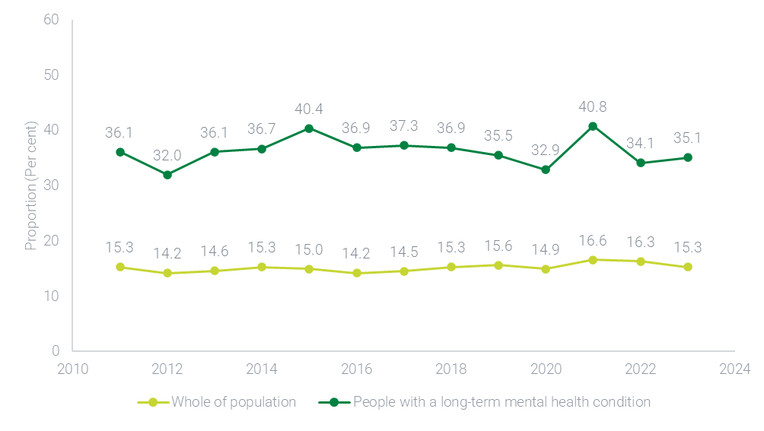

Lived Experience
Among people in Australia aged 15 and over with a long-term mental health condition, 35.1% reported feeling lonely in 2023. This proportion is similar to previous years (2011: 36.1%, 2015: 40.4%, 2019: 35.5%, 2022: 34.1%) and is more than double the rate observed for the whole population.
In 2023, similar to previous years, people who reported being diagnosed with a long-term health condition, disability or impairment were more likely to report feeling lonely (19.0%) compared to people who did not (12.3%). However, rates were not as high as those observed for people with a long-term mental health condition.

How do these findings differ between groups?

Whole of population
In 2023, across the whole population, a similar proportion of males (15.0%) and females (15.5%) reported feeling lonely. When comparing proportions across age groups, there was also limited variation. The lowest rate of people feeling lonely was observed for people aged 15-34 years (14.1%) and the highest was for people aged 35-64 years (16.0%).
There was no consistent pattern in terms of the difference in the proportion reporting loneliness between males and females and age groups over time.
When examining SEIFA scores, in 2023, people who were living in more disadvantaged areas were more likely to report feeling lonely, while people who were living in least disadvantaged areas were less likely to report feeling lonely.
In 2023, people who lived in Inner Regional areas (17.0%) and Outer Regional Australia (19.5%), were more likely to report feeling lonely compared to people living in Major City areas (14.4%) and Remote areas (15.0%)

Lived Experience
Compared to the relatively uniform findings for the whole population, there was a greater degree of variation across age groups and sexes for people with a long-term mental health condition who reported loneliness. These differences were not found to be statistically significant due to the smaller sample sizes involved.
In 2023, among people with a long-term mental health condition, 33.6% of males and 36.1% of females reported feeling lonely. These proportions are broadly in line with those observed in 2011 (Males: 33.7%, Females: 38.1%) and 2019 (Males: 33.4%, Females: 37.0%). However, gender differences in reported loneliness have fluctuated over time. In some years, such as 2015 (Males: 45.9%, Females: 35.8%), 2021 (Males: 44.4%, Females: 38.2%) and 2022 (Males: 40.0%, Females: 30.1%), males reported notably higher levels of loneliness than females. In other years, females reported slightly higher proportions. Overall, there is no consistent pattern in gender differences in loneliness among people with a long-term mental health condition. In 2023, the highest rate of people with a long-term mental health condition feeling lonely was for the 35-64 years age group (36.5%), followed by the 65 years and over group (35.5%) and the 15-34 years age group (32.9%).

Technical information

Source
Melbourne Institute of Applied Economic and Social Research. The Household, Income and Labour Dynamics in Australia Survey (HILDA), Waves 8-23.

Frequency of data collection
Annually.

Limitations
- The smaller sample size for people with a long-term mental health condition reduces the chance of detecting statistically significant findings.

Additional notes
- Data is collected using a 3-item scale (‘People don’t come to visit me as often as I would like’, ‘I often need help from other people but can’t get it’, and ‘I often feel very lonely’), as opposed to the single item ‘I often feel very lonely’, which can be affected by stigma associated with loneliness.
- In the HILDA survey, people with a long-term mental health condition refers to respondents who indicated they had a nervous or emotional condition which requires treatment or/and any mental illness which requires help or supervision and has lasted, or is likely to last, for 6 months or more.
- Some proportions may not add up to 100% due to number perturbation implemented by the data source owner.
- SEIFA assigns collective socio-economic characteristics for people living within a designated geographic area. This measure broadly defines relative socio-economic advantage and disadvantage in terms of people’s access to material and social resources, and their ability to participate in society. Area levels indexes in this instance are used as a proxy measure of individual socio-economic advantage and disadvantage, and as a result there is likely to be misclassification at a person-level. SEIFA classifications for 2021 are used as part of the HILDA analysis.
- Remoteness has been defined using the Australian Statistical Geography Standard (ASGS) and characterises relative geographic access to services. This has been grouped into three groups including ‘Major Cities of Australia’, ‘Inner Regional Australia’, and ‘Outer Regional Australia’ and ‘Remote Australia’. This analysis used ASGS classifications from 2021.
- Detailed information on the methodology is available in the HILDA Survey User Manual.

CI 13: Experiences of discrimination

What we are tracking (and why)
This indicator tracks the proportion of people in Australia aged 15 years and over who experienced discrimination (e.g., on the basis of sexual orientation, age, disability or health condition) or were treated unfairly all or most of the time in the previous 12 months.
Negatively stereotyped attitudes and behaviours can harm a person’s day-to-day health and wellbeing by excluding, devaluing or shaming them, and can cause and exacerbate distress,. Discrimination can cause a person to believe negative stereotypes about themselves, increase feelings of isolation, reduce help-seeking and create barriers to social, economic and cultural participation.
Higher proportions of people who experience discrimination suggest lower levels of wellbeing. A reduction in experiences of discrimination and unfair treatment may indicate more inclusive attitudes and behaviours across the community and in service provision, including mental health services.

What the data tells us

Indicator findings
In 2020, among people with a mental health condition, 20.8% reported they had experienced discrimination in the past 12 months and, of those who had experienced discrimination, 14.5% reported being treated unfairly ‘all or most of the time’. These proportions were almost double those observed for people without a mental health condition (12.3% and 7.3%, respectively). These differences were statistically significant.
Looking over time, similar differences were observed in previous years. In 2014 and 2019, for people with a mental health condition who had experienced discrimination, 18.0% and 15.3% respectively reported being treated unfairly all or most of the time. For people without a mental health condition, these proportions were 12.0% (2014) and 10.8% (2019). Of note, rates of discrimination among people with a mental health condition were comparatively higher in 2019 (31.7%) than 2020 (20.8%). However, care should be taken when interpreting this difference, due to differences in the data collection method.
As shown in Figure A13, people experienced discrimination across a range of different settings and for various reasons. In 2020, a significantly larger proportion of people with a mental health condition experienced discrimination on the basis of a disability or health issue, when dealing with people involved in health care and when dealing with the justice system, compared to people without a mental health condition. Among people with a mental health condition who experienced discrimination, the most common reasons for the most recent incident of discrimination were the respondent’s gender, a disability or health issue, and age.

Figure A13. Proportion of people in Australia aged 15 years and over reporting discrimination, by reason for discrimination, place of discrimination and presence of a mental health condition, 2020
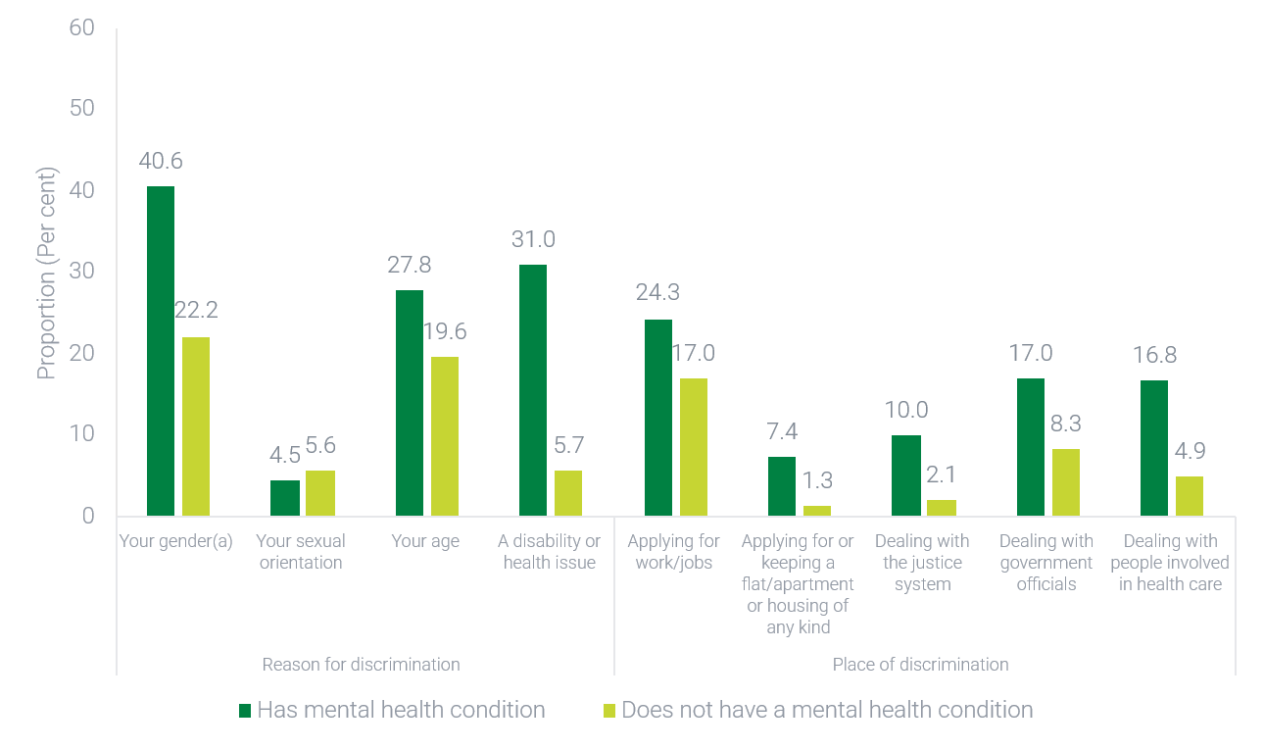
(a) Proportion has a high margin of error and should be used with caution.

How do these findings differ between groups?
In 2020, the disparity in discrimination between people with a mental health condition and people without was more pronounced for females compared to males. Among females, 24.3% of people with a mental health condition experienced discrimination in the past 12 months, compared to 12.3% of females without a mental health condition. Among males, 14.9% of people with a mental health condition experienced discrimination compared to 12.3% of males without a mental health condition.
The sample size in the 2020 General Social Survey does not allow for detailed disaggregations, including comparisons across age groups, SEIFA Quintiles, and Remoteness areas for people with a mental health condition.

Technical information

Source
Australian Bureau of Statistics (ABS) General Social Survey, 2020; ABS General Social Survey, 2019; ABS General Social Survey, 2014.

Frequency of data collection
Approximately every four years. Some changes in data collection schedule in 2020 due to the COVID-19 pandemic.

Limitations
- Care should be made when comparing 2020 data to earlier years due to changes in the survey methodology, higher rates of non-response and the impact of COVID-19 restrictions on the population.
- High standard errors and margins of error make it difficult to detect statistical differences between people with a mental health condition and people without a mental health condition.

Additional notes
- Data from 2014 includes people who are aged 18 years and over.
- When assessing mental health condition presence, respondents are asked if they were told by a doctor, nurse or other health professional whether they have one of the listed conditions, which included ‘Mental health condition (including depression or anxiety)’. This question is asked for conditions that have lasted or are expected to last for six months or more.
- Data for 2020 and 2019 capture people with a ‘mental health condition (including depression and anxiety)’, while data from 2014 includes ‘depression or feeling depressed, behavioural or emotional disorders, dependence on drugs or alcohol, feeling anxious or nervous and problems learning or understanding things’.
- Some proportions may not add up to 100% due to number perturbation implemented by the data source owner.
- Detailed information on the methodology is available on the ABS website.


Acronyms and abbreviations
ABS | Australian Bureau of Statistics
AEDC | Australian Early Development Census
AIHW | Australian Institute of Health and Welfare
ASGS | Australian Statistical Geography Standard
CI | Core Indicator
HILDA | Household, Income and Labour Dynamics in Australia
ICD-10 | World Health Organization International Classification of Diseases, Tenth Revision
K10 | Kessler Psychological Distress Scale
NHS | National Health Survey
NMHC | National Mental Health Commission
NSMHW | National Study of Mental Health and Wellbeing
OCD | Obsessive-Compulsive Disorder
PTSD | Post-traumatic Stress Disorder
SEIFA | Socio-Economic Indexes For Areas

www.mentalhealthcommission.gov.au

Australian Bureau of Statistics. Socio-Economic Indexes for Areas (SEIFA), Australia [Internet]. Canberra: ABS; 2021 [cited 2025 June]
For further information regarding diagnostic criteria and thresholds, refer to National Study of Mental Health and Wellbeing methodology.
Kessler RC, Andrews G, Colpe LJ, Hiripi E, Mroczek DK, Normand SL, Walters EE, Zaslavsky AM. Short screening scales to monitor population prevalences and trends in non-specific psychological distress. Psychol Med. 2002 Aug;32(6):959-76. doi:10.1017/s0033291702006074.
Lombardo P, Jones W, Wang L, Shen X, Goldner EM. The fundamental association between mental health and life satisfaction: results from successive waves of a Canadian national survey. BMC Public Health. 2018 Mar 12;18(1):342. doi:10.1186/s12889-018-5235-x
Rotter JB. Generalized expectancies for internal versus external control of reinforcement. Psychological Monographs: General and Applied. 1966; 80(1): 1-28.
Botha F, Dahman SC. Working Paper Series Locus of control, self-control and health outcomes. Applied Economic & Social Research, Melbourne Institute. 2022.
Pearlin LI, Schooler C. The structure of coping. Journal of Health and Social Behavior. 1978;19: 2-21. doi.org/10.2307/2136319
The methodology for the sense of control personal mastery items score may be reported as either negative or positive. While the trends and findings from this data are the same, it should be noted that the results published in this report may differ slightly from other HILDA-related publications depending on the approach taken.
Boulton Z, Gregory T, Harman-Smith Y. Early childhood development and later social-emotional wellbeing and mental health outcomes (AEDC Research Snapshot). Australian Government, Canberra. 2023 [Accessed 3 June 2024]. Available at www.aedc.gov.au.
Department of Education, Skills and Employment. Australian Early Development Census National Report 2021. Canberra: DESE; 2022.
Department of Education. Australian Early Development Census National Report 2024. Canberra; 2025.
Stafford A, Wood L. Tackling Health Disparities for People Who Are Homeless? Start with Social Determinants. Int J Environ Res Public Health. 2017 Dec 8;14(12):1535. doi:10.3390/ijerph14121535.
Bensken WP, Krieger NI, Berg KA, Einstadter D, Dalton JE, Perzynski AT. Health Status and Chronic Disease Burden of the Homeless Population: An Analysis of Two Decades of Multi-Institutional Electronic Medical Records. J Health Care Poor Underserved. 2021;32(3):1619-1634. doi:10.1353/hpu.2021.0153.
Guan N, Guariglia A, Moore P, Xu F, Al-Janabi H. Financial stress and depression in adults: A systematic review. PLoS One. 2022 Feb 22;17(2):e0264041. doi:10.1371/journal.pone.0264041.
Hassan, M., Hassan, N., Kassim, E., & Said, Y. Financial Wellbeing and Mental Health: A Systematic Review. Studies of Applied Economics. 2021; doi.org/10.25115/EEA.V39I4.4590.
Outer Regional and Remote area cells had high standard errors and therefore could not be included in this analysis.
Drake RE, Wallach MA. Employment is a critical mental health intervention. Epidemiology and Psychiatric Sciences. 2020;29:e178. doi:10.1017/S2045796020000906.
Groot C, Rehm I, Andrews C, Hobern B, Morgan R, Green H, Sweeney L, Blanchard M. Report on Findings from the Our Turn to Speak Survey: Understanding the impact of stigma and discrimination on people living with complex mental health issues. 2020, SANE Australia: Melbourne.
Australian Institute of Health and Welfare. Australia’s youth: Engagement in education or employment [Internet]. Canberra: Australian Institute of Health and Welfare, 2021 [cited 2024 Jun. 4]. Available from: https://www.aihw.gov.au/reports/children-youth/engagement-in-education-or-employment
Gariépy G, Danna SM, Hawke L, Henderson J, Iyer SN. The mental health of young people who are not in education, employment, or training: a systematic review and meta-analysis. Soc Psychiatry Psychiatr Epidemiol. 2022 Jun;57(6):1107-1121. doi:10.1007/s00127-021-02212-8. Epub 2021 Dec 21.
National Mental Health Commission. Equally Well: quality of life—equality in life. Improving the physical health and wellbeing of people living with mental illness in Australia. Sydney: NMHC; 2017.
Time series data drawn from National Health Surveys 2007-08 to 2022. Proportions differ from those reported above due to differences in questions asked about physical conditions between data sources.
National Health and Medical Research Council. Australian Guidelines to Reduce Health Risks from Drinking Alcohol. Canberra: Commonwealth of Australia; 2020.
Department of Health and Aged Care. National alcohol strategy 2019–‍2028. Canberra: Commonwealth of Australia; 2019.
The Australian alcohol guidelines have different advice for people under the age of 18 years, recommending that people under the age of 18 years do not consume alcohol, as any level of consumption can put their health a risk. The proportion of people aged 14-17 years who had consumed any alcohol in the previous year was 30.2% in 2019 and 31.0% in 2022-2023.
Badcock JC, Holt-Lunstad J, Garcia E, Bombaci P, Lim MH. Position statement: Addressing social isolation and loneliness and the power of human connection. Global Initiative on Loneliness and Connection (GILC). 2022 [accessed 9 February 2024. Our Position Statements | GILC].
Cacioppo JT, Hawkley LC, Thisted RA. Perceived social isolation makes me sad: 5-year cross-lagged analyses of loneliness and depressive symptomatology in the Chicago Health, Aging, and Social Relations Study. Psychol Aging. 2010 Jun;25(2):453-63. doi:10.1037/a0017216. [accessed 19 June 2024].
Lim MH, Rodebaugh TL, Zyphur MJ, Gleeson JFM. Loneliness over time: The crucial role of social anxiety. Journal of Abnormal Psychology. 2016;125(5):620–630. doi.org/10.1037/abn0000162 [accessed 19 June 2024].
Holt-Lunstad J, Smith TB, Baker M, Harris T, Stephenson D. Loneliness and Social Isolation as Risk Factors for Mortality: A Meta-Analytic Review. Perspectives on Psychological Science. 2015;10(2):227-237. doi.org/10.1177/1745691614568352 [accessed 19 June 2024].
Manera KE, Smith BJ, Owen KB, Phongsavan P, Lim MH. Psychometric assessment of scales for measuring loneliness and social isolation: an analysis of the household, income and labour dynamics in Australia (HILDA) survey. Health Qual Life Outcomes. 2022 Mar 5;20(1):40. doi:10.1186/s12955-022-01946-6. Erratum in: Health Qual Life Outcomes. 2023 Sep 29;21(1):109.
Link B, Phelan J. Conceptualizing Stigma. Annual Review of Sociology. 2001;27:363-85. http://www.jstor.org/stable/2678626
Corrigan PW, Rao D. On the self-stigma of mental illness: stages, disclosure, and strategies for change. Can J Psychiatry. 2012 Aug;57(8):464-9. doi:10.1177/070674371205700804.
Groot C, Rehm I, Andrews C, Hobern B, Morgan R, Green H, et al. Report on Findings from the Our Turn to Speak Survey: Understanding the impact of stigma and discrimination on people living with complex mental health issues. Melbourne; 2020.

