National Mental Health and Suicide Prevention
Agreement
2023-2024
Year 2
Annual National Progress Report
Table of Contents

Acknowledgements 3

1. Executive Summary 4

2. Introduction 7

3. Implementation progress 12
3.1 Progress against Agreement outputs 12
3.2 Whole-of-government approach (Schedule A) 17
3.3 Maintenance of investment 18
3.4 Aligning with Closing the Gap 20
3.5 Lived experience engagement 22
3.6 Initiatives under the Commonwealth-State Bilateral Schedules 24
Australian Capital Territory and Commonwealth Bilateral Schedule 27
New South Wales and Commonwealth Bilateral Schedule 29
Northern Territory and Commonwealth Bilateral Schedule 32
Queensland and Commonwealth Bilateral Schedule 34
South Australia and Commonwealth Bilateral Schedule 37
Tasmania and Commonwealth Bilateral Schedule 40
Victoria and Commonwealth Bilateral Schedule 42
Western Australia and Commonwealth Bilateral Schedule 45

4. Enablers for measuring change and impact 49

5. Conclusions 51

Appendices 52

A. Methodology 53

B. About the Agreement 54

C. Status of output milestones with specified due dates 56

D. Bilateral Schedule initiatives 58

E. Overview of priority data and indicators 60

F. Acronyms and abbreviations 64

G. Glossary 65

Acknowledgements

Acknowledgement of Country
The National Mental Health Commission (the Commission) acknowledges Aboriginal and Torres Strait Islander peoples as the Traditional Custodians of the lands and waters on which we live, work and learn.

Recognition of
Lived Experience
We recognise the individual and collective contributions of those with a lived and living experience of mental health challenges and suicide, and those who love, have loved and care for them. Each person’s journey is unique and a valued contribution to Australia’s commitment to mental health suicide prevention systems reform.

About this report

This report can be downloaded from our website: www.mentalhealthcommission.gov.au

Requests and enquiries concerning reproduction and rights should be directed to:

Office of the Chief Executive Officer

GPO Box 9848

Sydney NSW 2001

ISSN: 2982-0022 (online)

ISBN: 978-1-7636173-2-2 (online)

Suggested citation

National Mental Health Commission. National Mental Health and Suicide Prevention Agreement, Annual National Progress Report 2023-2024: Summary. Sydney: NMHC; 2025.

A note on language
The Commission acknowledges that language surrounding mental health and suicide can be powerful, emotive and at times contested. People make sense of their experiences in different ways, and there is no consensus on preferred terminology. The Commission has been conscious to use terminology throughout this report that is respectful of those whose experiences we are describing and is well understood by the audience reading this report. This report covers a broad range of topics in relation to mental health and suicide prevention. The language used to discuss these topics adheres to the language conventions outlined in the Life in Mind National Communications Charter, where applicable. The National Communications Charter represents a unified approach and promotes a common language in referring to issues around mental health, mental ill-health and suicide, with the intention of reducing stigma and promoting help-seeking behaviours. For this reason, and within the context of this report, the Commission aligns its terminology with the conventions in the Charter.
For instances where using certain terminology may misrepresent the source being cited, the terminology used by the source has been used. The Commission endorses the Mindframe Guidelines on Media Reporting of Severe Mental Illness in the Context of Violence and Crime and requests that media using this report do so in accordance with the Guidelines.

Learn more about our work
www.mentalhealthcommission.gov.au/

© National Mental Health Commission 2025
This product, excluding the National Mental Health Commission logo, Commonwealth Coat of Arms and material owned by a third party or protected by a trademark, has been released under a Creative Commons BY 3.0 (CC BY 3.0) licence. You may distribute, remix and build upon this work. However, you must attribute the National Mental Health Commission as the copyright holder of the work in compliance with our attribution policy. Address copyright enquiries to:
Office of the Chief Executive Officer
National Mental Health Commission GPO Box 9848
Sydney NSW 2001

1. Executive Summary

This is the second Annual National Progress Report for the National Mental Health and Suicide Prevention Agreement (the Agreement), detailing progress for the reporting period 1 July 2023 to 30 June 2024.

About the Agreement
- The Agreement between Commonwealth and State and Territory governments aims to support their joint planning and funding of services of the mental health and suicide prevention system0F in Australia.
- The Agreement specifies 13 high-level outputs, a whole-of-government approach to reform, minimum levels of financial investment and necessary collaboration with Aboriginal and Torres Strait Islander Peoples and people with lived experience. Eight Commonwealth-State Bilateral Schedules detail initiatives targeting the local needs of each jurisdiction.

About this report
- This report informs the Australian community about the progress governments are making to implement the outputs and initiatives outlined in the Agreement in the 2023-2024 reporting period. The Final Review of the Agreement, led by the Productivity Commission, examines the Agreement’s outcomes.
- The Parties (Commonwealth and State and Territory governments) provide the primary source of information for this National Progress Report, via the provision of completed Joint Annual Jurisdiction Performance Reports, as per the reporting arrangements under the Agreement. Delays in the completion of these reports have impacted the timely finalisation of this Annual National Progress Report.
- Working groups also provide input for inclusion in the National Progress Report.
- Progress relating to the third year of the Agreement (1 July 2024 to 30 June 2025) will be reported in the next National Progress Report.
- For more on the limitations to this report, see Appendix A.

Report snapshot:
Progress this period | Barriers to implementation | Commission recommendations
- Although several deliverables were completed or well progressed, a number remained delayed or faced potential delays  - Activities under current whole-of-government approach to reform (Schedule A) did not progress beyond information sharing towards cross-portfolio action  - Governments spent more than the minimum required (2018-19 funding levels). | - Challenges persisted across workforce, infrastructure and funding, impacting progress  - Governance and communication improved, however there were still some challenges  - Collaboration with people with lived experience and Aboriginal and Torres Strait Islander Peoples, to ensure initiatives meet people’s needs, has been variable. | - Prioritise the completion of delayed or at-risk deliverables  - Timely completion of Joint Annual Jurisdiction Progress Reports by the Parties in Years 3 and 4 to enable timely completion of this National Progress Report  - Enhance engagement with people with lived experience and Aboriginal and Torres Strait Islander communities  - Improve the whole-of-government approach to foster cross-portfolio action.

Progress against Agreement outputs

- Working groups reported that by the end of this reporting period, 10 of the 61 milestones associated with implementing the Agreement’s outputs were ‘completed’, 45 were ‘commenced – on track’, 2 were ‘commenced – not on track’ and 4 were ‘yet to commence’.
- Working groups noted areas working well which included engagement and participation of members working together to progress key deliverables, collaboration and information sharing.
- Challenges to implementation included potential disconnects between mental health and disability reforms, and administrative and governance issues. There was also some slippage in implementation timeframes for various reasons including ensuring sufficient consultations.

Whole-of-government approach (Schedule A)
- The Schedule A Working Group rated the status of all Schedule A commitments as ‘commenced - on track’.
- While the group reported it had facilitated information sharing and identified gaps, it was unresolved as to whether, and how, it should extend its impact and seek to deliver tangible outputs or actions against Schedule A commitments. The group noted its terms of reference and workplan were still awaiting renewal and agreement.
- The members made several suggestions to improve arrangements, including prioritising commitments, agreeing on clear outputs, and exploring mechanisms for linking into other relevant work underway.

Maintenance of investment
- Latest data on governments’ spending on mental health and suicide prevention activities showed total government mental health and suicide prevention spending between 2018–19 and 2022-23 increased in real terms by 12.6%, from $11.15 billion to $12.56 billion. Per capita spending, in real terms, increased from $469 in 2018–19 to $501 in 2022–23.
- This reflected a continued upward trend in government spending on mental health and suicide prevention with per capita expenditure increasing from $442 in 2014–15 to $501 in 2022–23 in real terms.
- The data used for this analysis did not include spending on related activity that occurred outside of the health portfolio, and it did not include 2023-2024 expenditure data, which is yet to be released.

Aligning with Closing the Gap
- The Social and Emotional Wellbeing Policy Partnership (SEWB Policy Partnership) representatives on the Mental Health and Suicide Prevention Suicide Prevention Senior Officials (MHSPSO) group noted positive work underway at all levels of government and community sectors to improve outcomes for Aboriginal and Torres Strait Islander Peoples.
- The SEWB Policy Partnership representatives noted that challenges to implementing the Agreement’s commitments related to Aboriginal and Torres Strait Islander Peoples outcomes included inefficient governance and clearance processes, and short-term and election cycle-based funding of initiatives.
- The Parties reported that engagement with Aboriginal and Torres Strait Islander communities, peoples and community-controlled services helped inform the design and implementation of bilateral measures in the reporting period.

Lived experience engagement
- The Parties established the LEG this reporting period, with the inaugural meeting in February 2024 marking an important milestone. Members highlighted the value of leadership from people with lived experience, inclusive membership, and revised terms of reference recognising suicide prevention.
- The members reported some emerging challenges included limited opportunities for the full group to meet, unclear role definition, and challenges with communication and information flows between the LEG and other groups within the governance structure. Some working group members felt their input was acknowledged, others reported experiences of tokenism and lack of authentic co-design.
- The Parties noted steps to strengthen engagement processes and highlighted examples where lived experience has informed design and delivery of initiatives.

Initiatives under the Commonwealth-State Bilateral Schedules

- Of the 83 initiatives under the 8 Commonwealth-State Bilateral Schedules, the Parties rated 10 as ‘complete’, 29 as ‘well progressed’, 39 as ‘partially progressed’ and 5 as ‘yet to commence’.
- Some areas that were commonly seen as supporting implementation included collaboration at the local level between those implementing initiatives, improvements in governance and strategic planning.
- Some commonly cited barriers to implementation included issues with workforce, data and infrastructure, communication between the governance and steering groups, and sustainability of funding.
- The Parties proposed a range of improvements including enhancements to implementation and reporting arrangements, as well as initiatives aimed at supporting more long-term approaches to planning and funding.

Enablers for measuring change and impact

- While this report primarily examined implementation of initiatives under the Agreement, the Commission noted work under the Agreement to strengthen data and evaluation in mental health and suicide prevention. These efforts were expected to enhance the monitoring of progress towards improved system effectiveness and outcomes.
- The Data Governance Forum (DGF) and Evaluation Project Group (EPG) reported progress made during this period advancing data linkage and sharing, development of national priority indicators, and the development of a National Evaluation Framework and Sharing Guidelines.

Conclusions
- Based on the information provided by the Parties, the Commission concludes the Parties were making progress in implementing commitments, noting significant further work will be required to realise completion by the end of the Agreement.
- Some issues continued to challenge implementation, including uneven momentum across working groups and ongoing issues that persisted since the first reporting period such as workforce shortages, infrastructure issues and sustainable funding.
- The Commission recommends that the Parties:
  - enhance engagement with people with lived experience and Aboriginal and Torres Strait Islander Peoples – for example, through more effective collaboration with the LEG and the SEWB Policy Partnership.
  - improve the whole-of-government approach – for example, renewing the Schedule A group’s work plan and ensuring it moves beyond information sharing towards cross-portfolio action.
  - explore mechanisms to support long-term approaches to planning and funding – for example, exploring the role of tools such as the National Mental Health Service Planning Framework and the national suicide prevention service planning model currently under development.
  - ensure implementation of commitments is not isolated from related policy work happening elsewhere – for example, working groups could connect with other actors driving related reforms.
  - prioritise completion of deliverables that are delayed or at risk of delay – for example, the National Guidelines on Regional Planning and Commissioning and Bilateral Schedule initiatives rated amber or red.
  - prioritise completion of their Joint Annual Jurisdiction Performance Reports in Years 3 and 4 to support completion of this Annual National Progress Report and prevent future delays.
- Timely completion of this National Progress Report is essential to enable the identification and resolution of implementation barriers and to promote transparency regarding the Agreement’s progress.

2. Introduction
The Agreement between Commonwealth and State and Territory governments aims to support collaborative planning and funding of mental health and suicide prevention services in Australia.
The Commonwealth and State and Territory governments are jointly responsible for planning and funding mental health and suicide prevention care across the country. Australia’s mental health and suicide prevention system is a complex mix of structures. Previous reviews, such as the Productivity Commission’s Inquiry into Mental Health in 2020, have identified the need for greater collaboration among governments to achieve a more cohesive and integrated system.
Achieving a more integrated mental health and suicide prevention system requires effective partnership between governments. The Agreement outlines the national objectives, outcomes and outputs for mental health and suicide prevention reform. Underpinning the Agreement are 8 Commonwealth-State Bilateral Schedules that detail initiatives targeting the local needs of each jurisdiction. Schedule A to the Agreement outlines a whole-of-government approach which seeks to address social determinants of mental health and suicide prevention. The Agreement came into effect in March 2022, with Commonwealth-State Bilateral Schedules signed by May 2022. Read more about the Agreement here.

Annual National Progress Report
Throughout the life of the Agreement, the Commission is tasked by the Parties with producing an Annual National Progress Report to inform the Australian community about the progress Parties are making to implement the Agreement and the 83 initiatives set out in the Bilateral Schedules.
The 2022-2023 Annual National Progress Report (‘the First Report’) reported on progress made to facilitate early commitments and establish necessary interjurisdictional governance and working groups. See ‘Recap of the First Report’ (page 10). The 2023-2024 Annual National Progress Report (‘the Second Report’) is based on information provided by the governance and working groups about progress implementing the Agreement’s 13 high-level outputs (see Figure 1), and by the Commonwealth and State and Territory Governments about progress implementing the 83 initiatives under the Bilateral Schedules, over the reporting period 1 July 2023 to 30 June 2024.

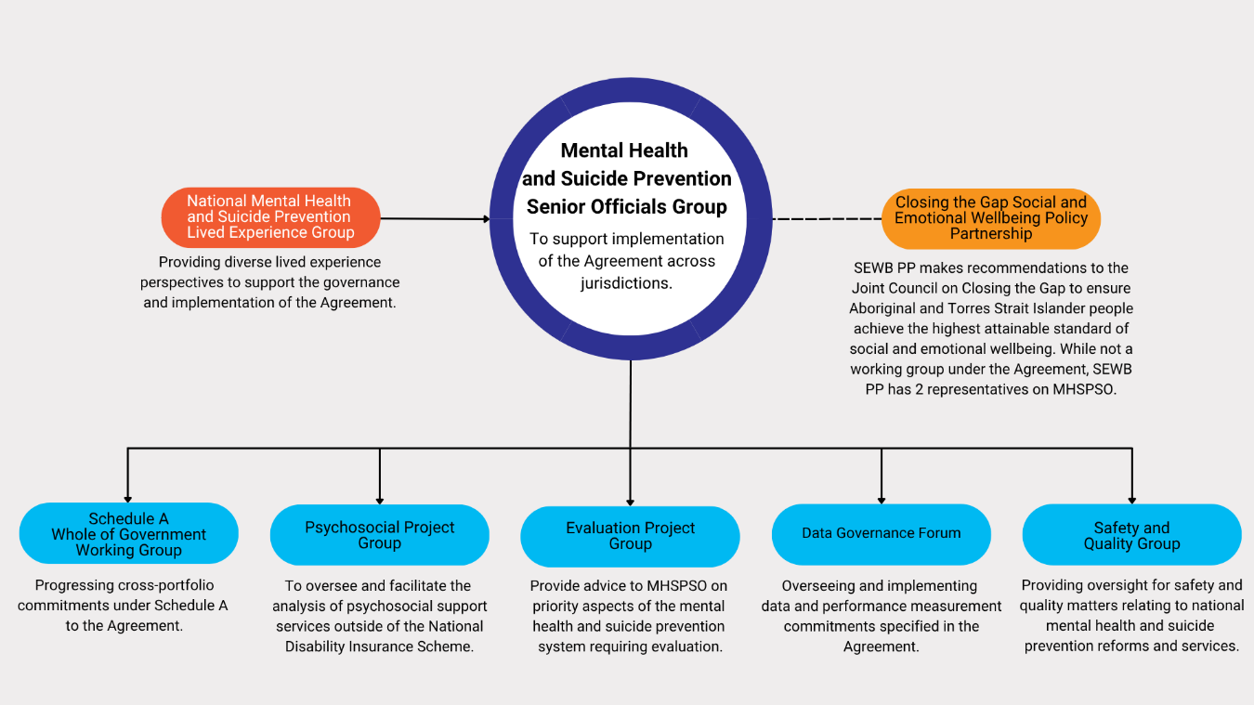
Figure 1: Governance and working groups (at 30 June 2024) that provided information to this report. See Appendix B for further details of governance arrangements.
The Parties provide the primary source of information for this National Progress Report, via the provision of completed Joint Annual Jurisdiction Performance Reports, as per the reporting arrangements under the Agreement. Delays in the completion of these reports have delayed completion of this Annual National Progress Report. Working groups also provide input for inclusion in the National Progress Report. For more on the limitations to this report, see Appendix A. Progress relating to the third year of the Agreement (1 July 2024 to 30 June 2025) will be reported in the next National Progress Report.
While this Annual National Progress Report is focused on implementation status and progress, the Final Review into the Agreement examines the Agreement’s outcomes and effectiveness in achieving desired change in the system. Further information on the Final Review is available here.


















Figure 2. Overview of the National Mental Health and Suicide Prevention Agreement
QLD
NSW
ACT
VIC
TAS
NT
SA
WA
83 Initiatives in total across the jurisdictions
8 Commonwealth-State Bilateral Schedules
Maintenance of Investment
Community collaboration
Lived experience involvement
Aligning with Closing the Gap
Maintaining governments’ spending on mental health and suicide prevention at 2018-19 levels
Whole-of-government approach (Schedule A)
Work to embed mental health and suicide prevention across government
National Mental Health and Suicide Prevention Agreement
13 Outputs
(consisting of 61 milestones)
Analysis of psychosocial support services
Implementation plans & Performance Reports

Annual National Progress Report

Improvements to data collection, sharing and linkage
National Evaluation Framework

Shared evaluation findings

National Stigma and Discrimination Reduction Strategy
National Suicide Prevention Office

National Guidelines on Regional Planning and Commissioning
National Mental Health Workforce Strategy

Report on progress increasing FTE professionals
Submission to mid-point NHRA review

Final review of the National Agreement

0BRecap of the 2022-2023 Progress Report
The First Report detailed progress achieved against the Agreement between 1 July 2022 and 30 June 2023. MHSPSO agreed the First Report would focus on high-level updates against key commitments and Bilateral Schedule initiatives, acknowledging that 2022-2023 was an establishment year.
Status of outputs: Of the five outputs due in the 2022-2023 reporting period, the First Report noted progress had been made on two: Joint Commonwealth-State Implementation Plans and the analysis of psychosocial support services outside the National Disability Insurance Scheme (NDIS). MHSPSO approved extended timeframes for the three other outputs (completion of the National Evaluation Framework, the National Guidelines on Regional Planning and Commissioning, and National Mental Health Workforce Strategy). Working groups reported the remainder of the 13 outputs were progressing well, with most rated ‘on track’.
Whole-of-government approach (Schedule A): The Schedule A Working Group met 4 times during the reporting period and considered the Schedule A commitments relating to workplaces, education and housing and homelessness. Overall, the Working Group indicated that all commitments had commenced and were on track.
Maintenance of investment: Governments’ mental health and suicide prevention expenditure had increased to $11.6 billion in 2021-22 from $10.7 billion in 2018-19 (the reference year for maintaining minimum annual funding). Data for 2022-23 were not available.
Aligning with Closing the Gap: MHSPSO and the Closing the Gap Joint Council agreed the SEWB Policy Partnership would be the key mechanism to advise governments, with two SEWB Policy Partnership representatives and two Aboriginal and Torres Strait Islander representatives with lived experience of mental ill-health appointed to MHSPSO in May 2023.
Lived Experience engagement: Working groups were largely positive about the extent to which governance arrangements included lived experience representation. Several states also highlighted local efforts to ensure implementation of bilateral initiatives was informed by lived experience, though some identified opportunities to strengthen this.
Status of Bilateral Schedule initiatives: Implementation progress against Bilateral Schedule initiatives had been mixed overall. Of the 781F bilateral initiatives where the Parties agreed on a progress rating:
- 1 was rated ‘complete’
- 9 were rated ‘well progressed’
- 65 were rated ‘partially progressed’
- 3 were rated ‘yet to commence’ but were considered ‘on track’.
Conclusions: The First Report concluded that the establishment of governance structures to support implementation of commitments was a key achievement in the period. It also highlighted challenges to implementation including the re-direction of resources, difficulties in recruiting and retaining critical workforces, and the need for consultation. The Commission suggested the Parties undertake several actions including:
- improving communication between working groups and the Parties to clarify roles and responsibilities
- establishing a mechanism to build awareness among non-government stakeholders
- moving Schedule A work plans beyond information sharing towards specific relevant action.
The 2022-2023 Annual National Progress Report Summary is available to read here. See page 12 for the status of outputs in 2023-2024 and page 48 for progress implementing recommendations.

External factors
The broader context in which the implementation of the Agreement is taking place can have a bearing on the progress of reforms. Here, the Commission notes some contextual developments during this reporting period that may be relevant in terms of influencing either implementation of the Agreement or demand on the system2F. The Commission does not suggest these developments had a direct causal impact on implementation this period. Rather, we seek to present a contextual snapshot of the broader environment in which implementation is occurring. For a detailed environmental scan, see the Commission’s National Report Card.

Developments relevant to implementation
Changes to key system enablers, such as infrastructure and funding, in mental health or related systems such as disability care, have the potential to influence implementation of the Agreement, especially its national-level outputs that may have linkages to other areas of health or social policy.
- Related systems reform. In September 2023, the Royal Commission into Violence, Abuse, Neglect and Exploitation of People with Disability released its Final Report, detailing 222 recommendations to improve laws, policies, structures and practices. In December 2023, the NDIS Review released its Final Report which proposed 26 recommendations to improve the system. In March 2024, in response to the report, the Commonwealth introduced the National Disability Insurance Scheme Amendment Bill 2024 to Parliament.
- New or expanded system infrastructure. In May 2024, the 2024-2025 Federal Budget included a $361 million four-year mental health package including a national early intervention service and the rebranding of existing Head to Health centres/satellites to Medicare Mental Health Centres and enhancement of centres’ clinical capacity. In December 2023, the Commonwealth announced $456.7 million over five years for support services and specialised digital mental health services.
- Changes to policy and practice. The TGA announced that from 1 July 2023, medicines containing the psychedelic substances psilocybin and MDMA could be prescribed by specifically authorised psychiatrists for the treatment of certain mental health conditions. In May 2024, the Psychotropic Medicines in Cognitive Disability or Impairment Clinical Care Standard, providing guidance to clinicians, services and consumers, was released.

Developments relevant to system need
Changes related to population mental health have the potential to influence current and emerging demand for services and could, in turn, have implications for the delivery of local initiatives under the Bilateral Schedules.
- Cost of living impacts. In September 2023, Mental Health Australia released research reporting more than one in two Australians said the rising cost of living was having a major impact on their mental health.
- Needs of specific age cohorts. In early 2024, latest HILDA data showed that loneliness among 15 to 24 year olds had increased from 14.4% in 2008 to 24.9% in 2022. In February 2024, new Butterfly Foundation research reported that 27% of the estimated 1.1 million Australians living with an eating disorder are aged under 19, up from 15% in 2012. In April 2024, a report showed social media was a key concern for 59% of parents and carers. At the other end of the age spectrum, in January 2024, a Macquarie University report found that treatment for depression in residential aged care is adhered to only 12% of the time.
- Environmental impacts. In June 2024, a survey of 3,500 Australians found 80% felt anxious about the impact of extreme weather, while Lifeline Australia reported a 25% increase in calls to its disaster recovery helpline. Also in June, the AIHW released a framework with 30 indicators for measuring how climate change and environment impact population health.

3. Implementation progress
The Agreement and associated Bilateral Schedules include a range of outputs and commitments.
This section provides an overview of progress that has occurred between 1 July 2023 and 30 June 2024 against:
- outputs specified in the Agreement
- whole-of-government approach (Schedule A)
- maintenance of investment
- aligning with Closing the Gap
- lived experience engagement
- initiatives under the 8 Commonwealth-State Bilateral Schedules.

3.1 Progress against Agreement outputs
Under the Agreement, the Parties commit to 13 high-level outputs that relate to reporting, data, policy development and implementation. Table 2 provides an overview of progress and status of the high-level outputs, based on the information provided to the Commission by respective working groups and the Commonwealth Department of Health, Disability and Ageing. The outputs below are assigned status ratings by the relevant working groups and these are not independently verified by the Commission.

Table 1: Description of status ratings
Category | Definition
 | There has been no activity towards achieving this action to date.
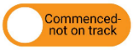 | Implementation of this action has commenced but progress has stalled or been delayed.
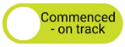 | The action is progressing as expected and will be completed by the milestone date listed or as reasonably expected (where no milestone date is specified).
 | The action has been completed, and no further work is required.

Table 2. Status of the 13 high-level outputs
Output |  | Progress: 2022-2023 period | Progress: 2023-2024 period
 | The analysis of psychosocial  support services outside of the NDIS completed as soon as possible within the first two years of this Agreement, to commence within the first 12 months of the Agreement being signed. | Procurements undertaken for suppliers to undertake the analysis. The First Report noted the work was on track for completion by March 2024. | The unmet need analysis was completed in May 2024. The Final Report and accompanying statement was endorsed by jurisdictional MHSPSO members in June 2024 and was being finalised for Ministerial endorsement.
 | Progress rating: | 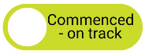 | 
 | Commonwealth-State implementation plans and Annual Jurisdiction Performance Reports. | Five Joint Implementation Plans under the eight Bilateral Schedules commenced with others being jointly developed by the Commonwealth and states at 30 June 2023. Implementation of initiatives still progressed in the absence of agreed plans. | Eight Commonwealth-State Implementation Plans were in place. Annual Jurisdiction Performance Reports 2022-2023 (revised due date: September 2023) completed by October 2023.
 | Progress rating: | Not rated in this period
 | Annual National Progress Reports. | Planning for completion of the First Report was underway at 30 June 2023. | Due to delays in the Parties’ provision of completed Jurisdiction Performance Reports to the Commission, the First Report was delivered to MHSPSO and endorsed in April 2024 (but not yet published by the end of the period). Planning for completion of the Second Report was underway at 30 June 2024 (status will be reported in the Year 3 report).
 | Progress rating: | Not rated in this period | 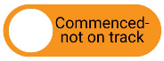
 | A range of improvements to data collection, sharing and linkage. | A Technical Implementation Plan to guide development of priority data and indicators was being finalised for endorsement, while work on a governance framework for data sharing and a pilot data linkage project had commenced. | A pilot data linkage project was underway to link State and Territory community mental health data to health systems data. Governance framework to enable data sharing was expected to be completed by December 2024. The Technical Implementation Plan was finalised and endorsed.
 | Progress rating:
 | The development of a National  Evaluation Framework within the first 12 months of signing this agreement.  Revised due date: 30 October 2023. | Consultant procured to develop Evaluation Framework and Sharing Guidelines. Development of the draft Framework and Guidelines on track to meet the agreed revised deadline of 30 October 2023. | The National Evaluation Framework, along with Sharing Guidelines and an approach to implementing the framework, was endorsed by MHSPSO in June 2024. The framework was expected to be endorsed by HCEF in coming months.
 | Progress rating:
 | Shared evaluation findings, in  accordance with the National Evaluation Framework and associated guidelines. | This deliverable was on track to meet the revised timeframes agreed by MHSPSO of 30 November 2023. | Parties advised they were on track to share evaluation findings in accordance with the approach in the National Evaluation Framework and Sharing Guidelines after these documents were finalised and published (which was expected in 2024-25 after endorsement by HCEF).
 | Progress rating:
 | Consideration and implementation of relevant actions of the National Stigma and Discrimination Reduction  Strategy once finalised. | The final draft Strategy was being considered by Government. | MHSPSO reported that the Strategy was considered by the Australian Government and provided to MHSPSO to inform joint action. Read more about the strategy here.
 | Progress rating:
 | The establishment of the National Suicide Prevention Office (NSPO). | The Commonwealth provided $12.8 million through the 2021-22 Budget to the Commission for the establishment and ongoing operation of the NSPO. The NSPSO was established on 10 September 2021. | No further update. Read more about the NSPO here.
 | Progress rating:
 | The development of National Guidelines on Regional Planning and Commissioning within the first 12 months of signing this Agreement.  Revised due date: December 2023 | In May 2023, MHSPSO extended the deadline for the guidelines to December 2023 to allow time to develop meaningful guidance and undertake consultations. It agreed to establish a working group to develop the Guidelines. | MHSPSO advised the timeframe was further extended to allow consideration of the role of the proposed guidelines within the national context, including alignment with National Health Reform Agreement (NHRA) activities. The Commonwealth noted it continues to work with MHSPSO on this deliverable.
 | Progress rating:
 | The development of the National Mental Health Workforce Strategy and  identification of priority areas for action by mid-2022.  Revised due date: December 2022 | Deadline was extended to December 2022 due to change to Federal Government and delays to endorsement process. All jurisdictions endorsed the Strategy by January 2023. A working group was established in March 2023 to oversee strategy’s implementation. | The strategy was published on 10 October 2023. The working group established to guide implementation of the Strategy meets quarterly and has agreed priorities under a multi-year work plan. The strategy is available here.
 | Progress rating:
 | Report on progress toward increasing the number of fulltime equivalent (FTE) mental health professionals per 100,000 population to meet community need for the life of this Agreement. | Implementation of this deliverable was in very early stages and would be discussed at the Working Group meeting expected to be held in October 2023. | In June 2024, the DGF endorsed indicator specifications to report the Agreement indicators ‘growth and distribution of the mental health workforce’. The 2024-25 Federal Budget provided for a national census of peer workers.
 | Progress rating:
 | A submission to the mid-point NHRA review, due to be completed by December 2023. | In May 2023, MHSPSO members developed their submission to the NHRA mid-point review. The submission was provided to NHRA Reviewers on 5 June 2023. | No further update. The NHRA mid-term review final report was published in October 2023 and is available here.
 | Progress rating:
 | A final review of this Agreement provided to all Parties by June 2025 | Output falls outside this reporting period. | Planning for the completion of the Final Review into the Agreement had commenced.
 | Progress rating: | Not rated in this period

3.1.1 Progress ratings against Agreement outputs
The working groups also rated the progress of the 61 milestones that make up the outputs, as at 30 June 2024:
- 10 were ‘completed’
- 45 were ‘commenced – on track’
- 2 were ‘commenced – not on track’
- 4 milestones were ‘yet to commence’, being reliant on the completion of other outputs.
Figure 3. Agreement output milestones by progress rating3F
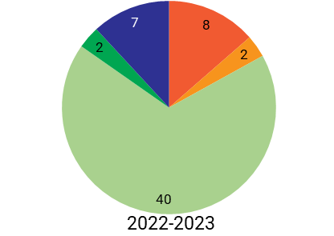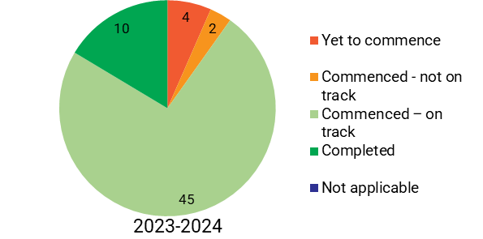
The 4 milestones rated as ‘yet to commence’ in this reporting period were:
- develop frameworks and procedures for researchers and other organisations not party to the Agreement to seek access to linked data for approved purposes (Clause 92g)
- broader linked data will be available to the Parties within 30 months of this Agreement (Clause 94b)
- the Parties will work together to develop and agree future psychosocial support arrangements (including roles and responsibilities) for people who are not supported through the NDIS (Clause 127)
- the Parties agree further clauses relating to future arrangements for psychosocial supports outside of the NDIS to be developed after the analysis work has been completed (Clause 129).
Of the milestones that were due in this reporting period:
- one was rated ‘completed’ (the analysis of psychosocial support services outside of the NDIS)
- one was rated ‘commenced – not on track’ (the National Guidelines on Regional Planning and Commissioning)
- six were rated ‘commenced – on track’ which were largely progressed or near completion (the National Evaluation Framework; development of evaluation sharing guidelines; a governance framework to enable data sharing; a subset of data is supplied, linked and available to the parties for analysis; national guidance on domains and measures to assess effectiveness and efficiency of programs; commence reporting against KPIs).
See Appendix C for the status of all milestones that have specified due dates in the Agreement.

3.1.2 Perspectives of working groups on implementation
In addition to providing status updates against the outputs, working groups were asked about enablers and barriers in implementing the Agreement commitments they are responsible for.

Areas working well
MHSPSO reported there was genuine engagement from its members and working groups to progress key deliverables both in and out of session. It said that working groups continued to progress relevant commitments and report regularly to MHSPSO.

Some groups described the benefits of collaboration and information sharing during the period. For instance:
- the Psychosocial Project Group (PPG) reported that bilateral meetings, workshops and regular group meetings had improved collaboration and information sharing to progress the analysis into unmet need
- the EPG reported its meetings had been valued for sharing information and insights on evaluation activity between jurisdictions.
The Safety and Quality Group (SQG) noted its terms of reference had been established and that model provisions for the mutual recognition of mental health orders have been drafted to assist states and territories in making the necessary legislative changes to allow mutual recognition of orders.
The DGF highlighted the support and leadership provided by the AIHW, which is funded by the Commonwealth to provide project support to the group.

Areas not working well
The PPG noted significant interdependencies between mental health systems and disability systems reforms which are being progressed in parallel. The group reported that potential disconnects between these reforms poses risks to the effective implementation of the commitments it is progressing.
Other groups pointed to administrative or governance issues. For instance, the SQG noted that changes to its chair arrangements likely impeded its progress, while the EPG noted delays in establishing appropriate governance under MHSPSO and subsequent impact on procurement timeframes led to delays in achieving its deliverables.
Similarly, MHSPSO highlighted slippage in timeframes, noting some deliverables had required extensions for reasons including ensuring sufficient consultations and adequate alignment with other reforms including the NHRA. MHSPSO reported that work continued to be progressed out-of-session to facilitate timely delivery of commitments. The First Report similarly noted that slippage in timeframes was a common challenge in the 2022-2023 period.

Suggested improvements
When asked how implementation of Agreement commitments could be improved, several working groups highlighted the need to strategically align with related work happening both within and outside the Agreement:
- the SQG reported it will explore how to better align priorities with MHSPSO and work closely with other working groups, including the DGF and LEG
- the PPG highlighted a need to more deliberately integrate its work, including use of the unmet needs analysis, with the foundational supports reform related to psychosocial supports, and ensure a new siloed system does not emerge
- the Schedule A Working Group noted its members wanted to explore mechanisms for linking into work that is already underway and relevant to the group’s work.

1BSummary:
- Working groups reported that by the end of this reporting period, 10 of the 61 milestones associated with implementing the Agreement’s outputs were ‘completed’, 45 were ‘commenced – on track’, 2 were ‘commenced – not on track’ and 4 were ‘yet to commence’.
- Working groups noted areas working well which included engagement and participation of members to progress key deliverables, collaboration and information sharing.
- Challenges to implementation included potential disconnects between mental health and disability reforms, and administrative and governance issues. There was also some slippage in implementation timeframes for various reasons including ensuring sufficient consultations.

3.2 Whole-of-government approach (Schedule A)
Under the Agreement, the Parties commit to work together to implement a whole-of-government approach to mental health and suicide prevention as outlined in Schedule A (Clause 168). There are seven action areas under the schedule: homelessness; education; workplaces; financial counselling; justice; substance use; and family, domestic and sexual violence, including child maltreatment. Commitments across the seven areas can include identifying and sharing best practice examples of supports, approaches for mental health literacy and capability, and improving referral pathways.
The Schedule A Working Group was established in August 2022 to support the implementation of the Schedule with membership from First Minister’s departments, health departments and mental health commissions (Clauses 11,12 – Schedule A). The Parties commit to developing a work plan to guide implementation of the actions in Schedule A (Clause 13 – Schedule A) with progress updates to be provided to senior officials every six months (Clause 13b – Schedule A). There is no funding in the Agreement associated with implementing Schedule A. The Agreement does not specify how regularly the Schedule A Working Group should meet during the reporting period.

3.2.1. Progress this period
The Schedule A Working Group reported that it had provided MHSPSO with an update at 3 of their meetings during the reporting period. An update was also provided to the First Deputies Group.
The Schedule A Working Group met 3 times during the reporting period. The group noted that significant work was underway through “other intergovernmental forums and ministerial councils”, and as a result commitments are still being delivered, though not always as drafted in the Schedule. The group rated the status of all Schedule A commitments as ‘commenced - on track’.
The group reported that areas that worked well during the reporting period included:
- strong collaboration across different sectors, both within government and non-government sectors, which supported progress on commitments
- information sharing and building connections across different portfolios and jurisdictions
- ability to progress work in jurisdictions when timing is right for specific policy development —for example, discussions on housing and homelessness
- effective engagement processes that capture diverse perspectives, along with strong feedback mechanisms, ensure commitments reflect community needs and drive continuous improvement.
Of areas not working well in this reporting period, the group noted:
- it was still unresolved as to whether, and how, it should extend its impact beyond information sharing and seek to deliver tangible products and/or actions against Schedule A commitments
- concern that specific commitments were “static” and not necessarily representative of urgent or emerging priority areas (e.g. cost of living stress)
- the focus on addressing one commitment at a time meant forgoing opportunities to explore issues that cut across several priority areas at once, and risk of duplication as work was being done through other intergovernmental forums
- members noted the group’s terms of reference and work plan were still awaiting renewal and agreement, and delays may lead to windows of opportunity being missed.
Suggestions to improve the implementation of the group included agreeing to a prioritisation of commitment and clearly identifying outputs for delivery. The group also suggested exploring better mechanisms for linking into work that is underway and relevant to Schedule A. It also suggested its members continue to share information and build connections out of session.

2BSummary:
- The Schedule A Working Group rated the status of all Schedule A commitments as ‘commenced - on track’.
- While the group reported it had facilitated information sharing and identified gaps, it was unresolved as to whether, and how, it should extend its impact and seek to deliver tangible outputs or actions against Schedule A commitments. The group noted its terms of reference and workplan were still awaiting renewal and agreement.
- The members made several suggestions to improve arrangements, including prioritising commitments, agreeing on clear outputs, and exploring mechanisms for linking into other relevant work underway.

3.3 Maintenance of investment
Under the Agreement, the Commonwealth and State and Territory governments are required to maintain or increase their existing levels of investment in mental health and suicide prevention over the life of the Agreement, against 2018-19 funding levels (Clause 105).

3.3.1. Spending since 2018-19
Latest data on governments’ spending on mental health and suicide prevention activities from the AIHW’s Expenditure on mental health services report showed that total government mental health and suicide prevention spending between 2018–19 and 2022-23 increased by 12.6%, from $11.15 billion to $12.56 billion4F. Per capita spending, in real terms, increased from $469 in 2018–19 to $501 in 2022–23. The average growth rate in total government expenditure was 3% per annum for the period 2018–19 to 2022–23.
Commonwealth Government mental health and suicide prevention spending between 2018-19 and 2022-23 increased by 12.2%, from $4.09 billion to $4.59 billion. This included spending on:
- payments and programs, which increased by 13.4%, from $1.68 billion to $1.91 billion (included payments to the states, e.g. National Partnership Agreements, and programs such as the National Depression Initiative)
- mental health-related Medicare Benefits Scheme (MBS) spending, which increased by 7%, from $1.44 billion to $1.55 billion
- mental health-related Pharmaceutical Benefits Scheme (PBS) spending, which increased by 1.8%, from $647 million to $659 million
- mental-health related research grants, which increased by 56.1%, from $106 million to $165 million
- the National Suicide Prevention Program, which increased by 79.1%, from $84 million to $150 million.
State and territory government mental health and suicide prevention spending between 2018-19 and 2022-23 increased by 12.8%, from $7.06 billion to $7.97 billion. This included spending on:
- mental health-related public hospital spending, which increased by 7.2%, from $3.12 billion to $3.35 billion
- psychiatric community services, which increased by 16.9%, from $2.70 billion to $3.15 billion
- psychiatric residential services, which increased by 16.3%, from $449 million to $522 million
- other expenditure including grants to mental health-related non-governmental organisations, which increased by 22.8%, from $859 million to $1.05 billion.

3.3.2. Longer-term trends
There were challenges in comparing governments’ spending in 2018–19 with the subsequent financial years associated with the emergency phase of COVID-19. Over this period, there was significant disruption to normal service delivery of services due to restrictions on face-to-face contact, which saw a reduction in the year-on-year growth rate of spending for 2018–19 to 2019–20 from between 4% to 2%. Due to these short-term fluctuations, examining expenditure over a longer timeframe can provide a more reliable picture of how government spending is changing over time. For instance, in the period between 2014-15 and 2018-19, total government mental health and suicide prevention spending increased in real terms by 12%, from $9.95 billion to $11.15 billion. To put this increase in a broader context, the AIHW’s Health expenditure Australia data showed that total government recurrent health spending between 2014-15 and 2018-19 increased by 14.3%, from $125.7 billion to $143.7 billion.
During the 2014-15 to 2018-19 period:
- Commonwealth Government mental health and suicide prevention spending increased in real terms by 8.3%, from $3.78 billion to $4.09 billion
- State and Territory Government mental health and suicide prevention spending increased in real terms by 14.3%, from $6.17 billion to $7.06 billion.
As seen in Figure 4 below, total government mental health and suicide prevention spending on a per capita basis, in real terms, increased from $442 in 2014–15 to $469 in 2018–19 and $501 in 2022–23.

Figure 4: Government expenditure, 2014-15 to 2022-23.

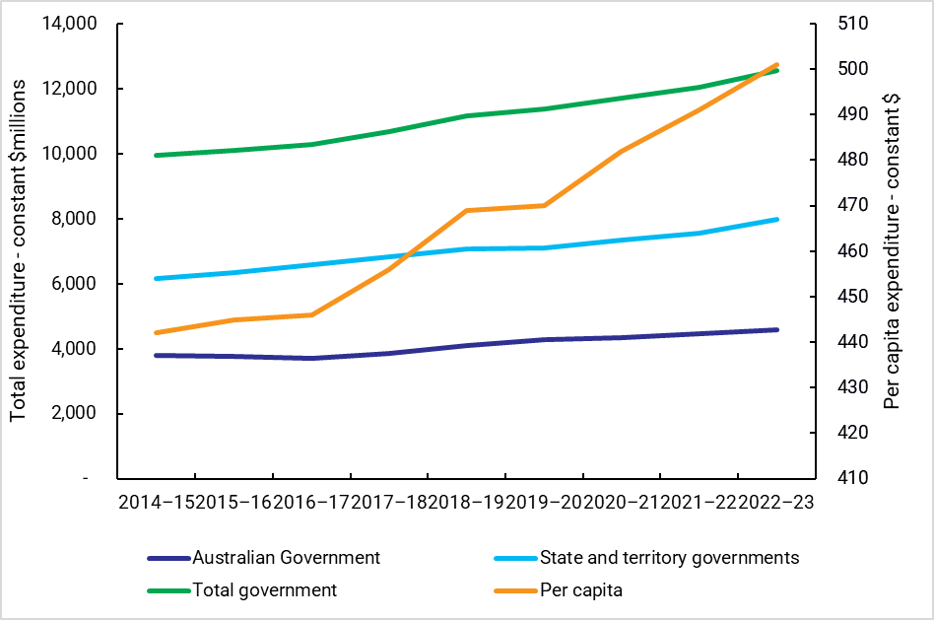
Source: AIHW Expenditure on mental health-related services.

3.3.3. Data limitations
Data for this reporting period, 2023-2024, was not yet available for this report. The data to support the above analysis relate to direct health spending by governments, i.e. those typically administered by the respective health departments and agencies across governments. However, a large amount of mental health and suicide prevention related activity occurs outside of health portfolios. For instance, at the Commonwealth Government level, previous analysis of 2012–13 data by the Commission for the 2014 National Review of Mental Health Programmes and Services found that 34% ($3.3 billion) of the Australian Government’s $9.6 billion mental health spend was administered by the then Department of Health. It should be noted that the data supply from all Australian Government entities for the National Review was a special arrangement and has not been repeated subsequently. Similarly, the data does not include some related areas of disability expenditure, such as funding of psychosocial supports via the NDIS. Further, at the jurisdictional level, there is a range of mental health and suicide prevention related activity occurring outside of health departments, such as those provided in educational and justice/correctional settings.
Summary:
- Latest data on governments’ spending on mental health and suicide prevention activities showed total government mental health and suicide prevention spending between 2018–19 and 2022-23 increased by 12.6%, from $11.15 billion to $12.56 billion. Per capita spending, in real terms, increased from $469 in 2018–19 to $501 in 2022–23.
- This reflected a continued upward trend in government spending on mental health and suicide prevention, with per capita expenditure increasing from $442 in 2014–15 to $501 in 2022–23 in real terms.
- The data used for this analysis did not include spending on related activity that occurred outside of health portfolios, and it did not include 2023-2024 expenditure data, which is yet to be released.

3.4 Aligning with Closing the Gap
Under the Agreement, the Parties commit to work in partnership with Aboriginal and Torres Strait Islander Peoples, their communities, organisations and businesses to improve Aboriginal and Torres Strait Islander Peoples mental health, social and emotional wellbeing, and access to, and experience with, mental health and wellbeing services. The Agreement specifies that the Parties will ensure alignment with the Agreement on Closing the Gap and associated implementation plans (Clause 110).
The SEWB Policy Partnership is the key group advising governments on improving Aboriginal and Torres Strait Islander Peoples mental health, social and emotional wellbeing and suicide prevention outcomes. Gayaa Dhuwi (Proud Spirit) Australia and the Department of Health, Disability and Ageing jointly administer the SEWB Policy Partnership. In May 2023, the Parties appointed two representatives from the partnership and two Aboriginal and Torres Strait Islander Peoples representatives with lived or living experience of mental ill-health as MHSPSO members.

3.4.1. Progress this period
The SEWB Policy Partnership representatives on MHSPSO reported there was a relatively collaborative approach between the joint secretariat teams, and a significant amount of positive work underway at all levels of government and community sectors to improve the mental health, social and emotional wellbeing of Aboriginal and Torres Strait Islander Peoples.
However, the members also identified several challenges to implementation:
- inefficient governance and clearance processes that can hinder the effective utilisation of SEWB Policy Partnership’s expertise through delayed release of important policy documents, such as the National Aboriginal and Torres Strait Islander Suicide Prevention Strategy
- short-term and election cycle-based funding of initiatives that has implications for continuity of care, workforce wellbeing and overall robustness of services
- inconsistent implementation of policies and initiatives across jurisdictions that can lead to service delivery discrepancies
- poor digital infrastructure that further limits the potential of telehealth services as an offering in regional and remote areas
- the need to collaborate to strengthen data collection and analysis to ensure more efficient policy and program development
- maintaining the spirit of the Agreement for all Parties to work in genuine partnership to improve the lives and wellbeing of Aboriginal and Torres Strait Islander Peoples.
The SEWB Policy Partnership representatives made several suggestions to improve Aboriginal and Torres Strait Islander Peoples mental health, including:
- better utilise the policy expertise and strengths of the SEWB Policy Partnership - for instance, solidifying the authorising environment and endorsement processes for key policy documents such as the Gayaa Dhuwi Declaration Framework and Implementation Plan and the National Aboriginal and Torres Strait Islander Suicide Prevention Strategy
- collaborate to strengthen data collection and analysis to inform policy and program development
- apply the principles and obligations of the Agreement consistently to avoid service delivery discrepancies across jurisdictions
- strengthen the investment in community-led programs, including greater investment into outreach services and workforce training to improve access to services in remote and regional areas, and move to longer-term resourcing
- allocate additional resources to remote and regional areas to ensure more equitable access to services and improve digital infrastructure in remote areas to allow an effective expansion of telehealth
- providing cultural competence training for all mental health professionals and service providers and incorporating a mix of traditional healing practices into mainstream mental health services.

Views of the Parties
MHSPSO highlighted the attendance of four Aboriginal and Torres Strait Islander Peoples members at their first MHSPSO meeting in August 2023 as something that worked well in the period, and said it looked forward to continuing to engage with the SEWB Policy Partnership. The PPG reported that Aboriginal and Torres Strait Islander Peoples stakeholders will be specifically approached to provide input on future arrangements informing its work.
Elsewhere, the Parties reported that engagement with Aboriginal and Torres Strait Islander communities, peoples and community-controlled services helped inform the design and implementation of bilateral initiatives in the reporting period. There were examples of Aboriginal and Torres Strait Islander Peoples engagement to help shape the implementation of various initiatives, such as Head to Health Kids (H2HK) and Aftercare services, and to inform workforce initiatives, position statements and models of care.
Summary:
- The SEWB Policy Partnership representatives on MHSPSO noted positive work underway at all levels of government and community sectors to improve outcomes for Aboriginal and Torres Strait Islander Peoples. However, they also identified several challenges to implementing the Agreement’s commitments related to Aboriginal and Torres Strait Islander Peoples outcomes, such as inefficient governance and clearance processes, and short-term and election cycle-based funding of initiatives.
- The Parties reported that engagement with Aboriginal and Torres Strait Islander communities, peoples and community-controlled services helped inform the design and implementation of bilateral measures in the reporting period.

3.5 Lived experience engagement
Under the Agreement, the Parties commit to embedding lived experience of mental ill health and/or suicide and those who care for them in the design, planning, delivery and evaluation of services (Clause 47h), consulting with lived experience throughout implementation of the Agreement (Clause 55) and including input from people with lived experience in the Agreement’s governance forum (Clause 84).

3.5.1. Progress this period
During this period, the Parties established the MHSPSO LEG. The LEG membership contains a mix of people with lived experience of mental ill health, suicide, or of both, and those who support and care for them. In addition, the five lived experience members of MHSPSO are also members of the LEG. The Commission heard a concern that there has not been authentic co-design with lived experience from the inception of MHSPSO governance structures. The LEG raised concerns that lived experience was not embedded appropriately from the beginning.
Outlining what has worked well in the reporting period, members of LEG reported that the inaugural induction meeting in February 2024 was an important milestone for the group as a relationship building opportunity that set the tone for future collaboration. Specifically, they highlighted:
- the importance of having co-chairs and deputy co-chairs with lived experience
- the opportunity to meet and come together as a group in an understanding and empathetic environment
- the group composition, with a cross section of people providing an intersectional lens
- revised terms of reference for the LEG, that explicitly included lived experience of suicide and suicide prevention as part of the group's scope and membership, were approved at the first meeting.
In terms of barriers experienced by the LEG, members identified a lack of communication between MHSPSO governance and working groups and the LEG as the main challenge, with a sense of missed momentum due to only one meeting of the group being held during the reporting period. Other issues that were highlighted by members included:
- needing a better understanding of the purpose of the LEG within the broader MHSPSO structure, including pathways for influence, a structured feedback loop and clearer direction for the group
- an opportunity to leverage the skills and expertise of members within the group through inclusion in working groups
- inadequate background and briefings provided prior to governance and working group meetings and inadequate preparation time
- governance and working group meetings feeling tokenistic, and with too much emphasis on bureaucratic processes and language
- imbalances of power and equity in governance and working groups, with some LEG members not feeling their contributions had been acknowledged or their insights utilised
- lack of reporting mechanisms from the MHSPSO governance and working groups to the LEG, which contributed further to a lack of clarity
- some members reported experiences of tokenism, combined with the lack of reporting mechanisms from MHSPSO governance and working groups, which contributed to a sense of exclusion and diminished influence
- lack of clarity around the membership of the LEG which hinders understanding of lived experience collaboration and feedback processes (e.g. clarifying membership of other working groups)
- working group confidentiality restrictions, which hinder sharing of information
- the need for shared lived experience spaces for collaboration and partnership between the new lived experience peaks, lived experience representatives on the other working groups, the LEG executive and the broader LEG membership.
When asked to what extent the contributions of people with lived experiences had been heard and understood in the MHSPSO governance and working groups, some members felt they had been heard and respected while others said that progress had been slow with little evidence their contributions had been incorporated into ongoing work. The members noted the lack of a robust feedback loop to track how lived experience input was considered or acted upon made it difficult to ascertain what influence was being made and remained a major barrier.
Members suggested several changes to enhance the participation of people with lived experience in MHSPSO governance and working groups, including:
- meeting more regularly
- more frequent and detailed communication being provided, e.g. sharing news about activities and progress being made by working groups, updates about future meetings and priorities, and more information to enable an informed understanding of how lived experience is contributing
- meeting papers being distributed earlier to provide members with more time to digest and respond
- greater opportunities for members to participate in implementation of the Agreement, including more often and in more areas
- taking a co-design approach to ensure more effective listening, responding and reporting within the governance and working groups
- providing an environment free of stigma to facilitate safe and open communication, being mindful of the sensitive nature of suicide and ensuring appropriate supports are in place.

Views of the Parties
Some lived experience representatives raised concerns about working groups’ engagement with lived experience in their implementation of outputs. Working groups noted steps taken in the reporting period to improve their approach.
For instance, the PPG noted that during finalisation of the final report into psychosocial support services outside of the NDIS, the Lived Experience and Aboriginal and Torres Strait Islander Peoples MHSPSO members raised concerns regarding lived experience engagement in the Final Report. The group noted new lived experience representatives would be appointed to the PPG to inform the next phase of work on future psychosocial support arrangements.
Similarly, the SQG reported that while it had appointed two lived experience representatives during the reporting period, there were significant delays with appointing a carer representative. The group added it would be exploring ways to work closely with the LEG. The Schedule A Working Group noted that lived experiences representatives to MHSPSO, including Aboriginal and Torres Strait Islander representatives, had raised concerns about lack of focus in reporting and discussion on that priority population and their needs. The group said it had worked to address those concerns through the inclusion of both ongoing and rotating lived experience representatives in future meetings, along with implementation of principles for effective lived experience representation.
Elsewhere, the Parties noted numerous instances where engagement with people with lived experience was helping to inform the design and implementation of bilateral initiatives in the reporting period. There were examples of lived experience consultation and engagement in some jurisdictions’ implementation of initiatives such as the Medicare Mental Health Centres and Satellite Network and Head to Health Kids Hubs, the Distress Brief Support trial and Aftercare services, and lived experience participation on state advisory committees. For example, the Commonwealth particularly highlighted the Lived Experience of Suicide Service Guidelines for Aftercare, which were developed with people with lived experience of suicide and published in April 2024.
Summary:
- The Parties established the LEG this reporting period, with the inaugural meeting in February 2024 marking an important milestone. Members highlighted the value of leadership from people with lived experience, inclusive membership, and revised terms of reference recognising suicide prevention.
- The members reported some emerging challenges included limited opportunities for the full group to meet, unclear role definition, and challenges with communication and information flows between LEG and other groups within the governance structure. Some working group members felt their input was acknowledged, others reported experiences of tokenism and lack of authentic co-design.
- The Parties noted steps to strengthen engagement processes and highlighted examples where lived experience has informed design and delivery of initiatives.

3.6 Initiatives under the Commonwealth-State Bilateral Schedules
The Bilateral Schedules between the Commonwealth and the jurisdictions outline specific initiatives that have been individualised to meet the local circumstances. In this section, the report provides a national overview of the implementation status of the 835F initiatives that the Parties are implementing in total across the jurisdictions, before presenting a series of snapshots summarising each Commonwealth-State Bilateral Schedule.

3.6.1. National overview
The Parties jointly assigned progress and risk ratings to the Bilateral Schedule initiatives as at 30 June 2024.

Table 3: Description of ratings assigned to Bilateral Schedule initiatives.
Category |  | Definition
Progress
 |  | Planning or implementation has not yet commenced.
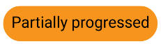 |  | Planning and implementation underway, some aspects yet to be determined.
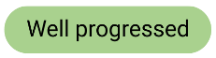 |  | Planning complete, establishment of service has commenced.
 |  | Service established, with ongoing monitoring and reporting required.
Risk
 | Red | Significant delays or risk to initiative.
 | Amber | Some issues or delays to achieving milestones.
 | Green | On track.

In terms of progress ratings assigned by the Parties, shown in Figure 5 on the following page, 10 initiatives were rated ‘complete’ and 29 were rated ‘well progressed’. Of the 5 initiatives rated yet to commence in 2023-2024:
- 3 related to the Commonwealth-South Australia Bilateral Schedule that was renegotiated during this reporting period
- 2 related to the Initial Assessment and Referral initiative (in New South Wales and Queensland).
Figure 5. Bilateral initiatives by progress ratings.
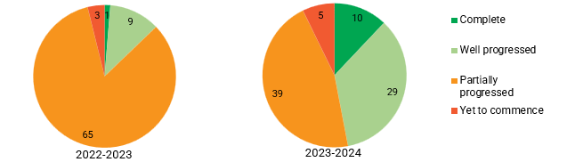
Note: 2022-2023 figures excluded 3 of the 81 initiatives given disparate progress ratings by the Parties. | Note: 2023-2024 figures include a total of 83 initiatives, due to an increase of 3 initiatives in South Australia and a decrease of 1 initiative in Victoria.

In terms of risk ratings, shown in Figure 6 below, the two initiatives rated red in 2023-2024 were:
- The Perinatal Mental Health Screening in the Australian Capital Territory (rated amber in 2022-2023). The Parties report delays with accessing screening data from the Digital Health Record continue to impact this initiative’s timeframes
- Enhancement and Integration of Youth Mental Health Services in Victoria (rated amber in 2022-2023). The Parties report the scale and complexity of reforms in Victoria required a more gradual approach, with enhanced integration work paused during this reporting period. However, Victoria’s integration efforts across the sector continued.
Figure 6. Bilateral initiatives by risk ratings
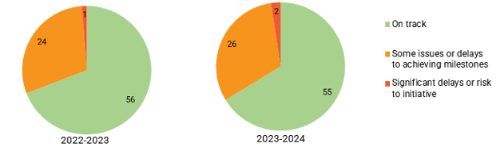

3.6.2. Bilateral Schedule snapshots
The following section presents a series of snapshots that summarise the progress being made implementing the initiatives under each of the 8 Commonwealth-State Bilateral Schedules. The snapshots are intended as a high-level overview of the detailed progress information provided to the Commission by the Parties through their Joint Annual Jurisdiction Performance Reports.
Given the implementation of initiatives has been individualised to suit local need and context, as per the intention of the Bilateral Schedules, the Commission suggests each snapshot should be read in isolation and cautions against making comparisons between jurisdictions. The snapshots highlight the specific implementation experiences and approaches that the Parties are taking in each jurisdiction.
Each snapshot provides an overview of progress in the period, the progress and risk ratings of initiatives as assigned by the Parties, and a summary of the status of each initiative based on the information provided by the Parties.

3BNotes on reading the Bilateral Schedule snapshots:
- The ‘Key achievements’ section includes milestones nominated by both the Commonwealth and respective jurisdiction as an achievement in the period, or where the Commission considered the milestone a noteworthy achievement, such as a considerable growth in service volume or a significant first.
- The ‘Deliverables’ for each initiative are often lengthy, complex and multi-faceted and vary across initiatives and jurisdictions (e.g. specifics around establishing or expanding centres or services). Therefore, the Commission does not name the deliverables in the snapshots given their intention as a high-level overview; however, where the Parties rated a deliverable as ‘complete’ or ‘delayed’ the deliverable is identified in the accompanying narrative description of status of the initiative.
- The narrative description of status of each initiative draws on qualitative information provided by the Parties summarising key developments, challenges and approaches to mitigate issues.
- The Bilateral Schedule snapshots should be read as a point-in-time view as at the end of the 2023-2024 reporting period.
- While ‘Performance indicators’ are specified for each initiative in the Joint Annual Jurisdiction Performance Reports, the Commission has omitted these from the snapshots due to shortcomings with the data. See ‘Limitations’, Appendix A.
Table 4: Description of ratings assigned to Bilateral Schedule initiatives.
Category |  | Definition
Deliverable (e.g. D1, D2)
 | Delayed | Deliverable is delayed beyond the agreed timeframe.
 | On track | Deliverable is on track.
 | Ongoing | Deliverable expected to be ongoing for the life of the Bilateral Schedule.
 | Complete | Deliverable has been completed.

Note: For a general description of the initiatives under the Bilateral Schedules, see Appendix D.

Bilateral Schedule snapshot: 2023-2024

Australian Capital Territory and Commonwealth Bilateral Schedule

Overview
Strong stakeholder collaboration and partnerships have assisted with implementation progress of the initiatives under this agreement. Two initiatives have been rated complete, with the remaining initiatives marked as well or partially progressed. Challenges such as data sharing and infrastructure issues have resulted in delayed timeframes of some initiatives; however, work remains ongoing overall to improve system integration.
Progress Risk
Progress ratings across the 10 initiatives. Risk ratings across the 10 initiatives. 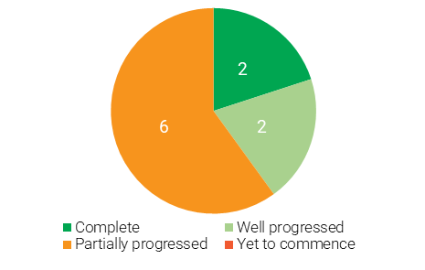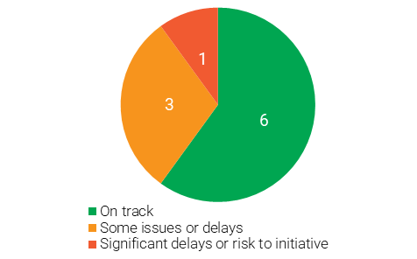

Key achievements
- Finalising the safe transition of aftercare services from the Beyond Blue Way Back Support model and commencement of Australian Capital Territory’s Minds Together program.
- Collaborative arrangements and partnership with the Australian Capital Territory’s Primary Health Network (PHN).
- Progress for youth mental health including engagement in consultation for the Youth at Risk Project and rolling out of headspace Enhancement funding which boosted service capacity.
- A substantial increase in service volume at the Canberra Medicare Mental Health Centre during the reporting period. Activity continues to grow for the implemented services in Early Intervention Service Eating Disorders and the Medicare Mental Health (formerly Head to Health) Phone Service.

Status of initiatives
Initiative | Progress Rating |  |  |  | Deliverables Status
Initiative |  | 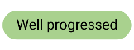 | 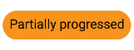 | 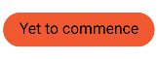 | Complete | On track | Ongoing* | Delayed
Medicare Mental Health Centres (formerly Head to Health) | 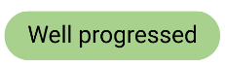
Medicare Mental Health Centres (formerly Head to Health) | - The Canberra centre continues to operate, and in 2023-24 there was a 77.5% increase in service volume from 2022-23  - There were delays in site approval for a centre in Tuggeranong, leading to a ‘delayed’ deliverable.  - A new search for an alternative site has commenced, with services expected to open in the next reporting period.
Investing in Child Mental Health and Social and Emotional Wellbeing
- A lack of ACT Government property availability impacted establishing a site location for Head to Health Kids, leading to a ‘delayed’ deliverable.
- Prolonged negotiations between ACT and the Commonwealth have also delayed procurement of a service provider.
- Negotiations for a new site are ongoing.
Enhancement and Integration of Youth Mental Health Services
Enhancement and Integration of Youth Mental Health Services | - One existing headspace service was allocated Enhancement funding in 2023-24.  - The Youth at Risk Youth Reference Group, Service Development Working Group and Emerging Minds have co-designed the Trauma Informed Practice Training Try Test and Learn model; a first cohort is underway.
Aftercare Services and expanded trial pathways
Aftercare Services and expanded trial pathways | - Services have safely transitioned from the Beyond Blue support model and the ACT is considering adaption of the service model to meet local needs. Work on developing a model of services and improving system integration is ongoing.
Perinatal Mental Health Screening
Perinatal Mental Health Screening | - Ongoing delays to accessing screening data from ACT’s Digital Health Record continues to impact timeframes and implementation, leading to a ‘delayed’ deliverable.
Early Intervention Service Eating Disorders | 
Early Intervention Service Eating Disorders | - The Early Intervention Service Eating Disorders service has been fully implemented from February 2023, leading to a ‘completed’ deliverable.
National Phone/Digital Intake Service
National Phone/Digital Intake Service | - The Phone Service was launched nationally on 1 July 2022. Activity continues to increase.
Initial Assessment and Referral |  |  |  |  | 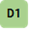
Initial Assessment and Referral | - This initiative did not receive any Commonwealth funding to support implementation.  - ACT Health is currently undertaking a commissioning project to redesign the mental health NGO system which provides an opportunity to incorporate and implement the IAR-DST in services throughout the Territory.
Workforce
Workforce | - The ACT Mental Health Workforce Strategy Framework for Action 2023-2026, including 2024 Work Plan was released on 27 November 2023.
Regional Planning and Commissioning
Regional Planning and Commissioning | - A Development and Implementation Committee involving the Local Health Network (LHN) has been established.  - A Lived Experience Reference Group is also in development, and consultation planning progresses.

Bilateral Schedule snapshot: 2023-2024

New South Wales and Commonwealth Bilateral Schedule

Overview
The initiatives under this agreement continue to progress. This has included significant expansion in aftercare services and Expanded Referral Pathways trials. Two initiatives have been rated complete, one rated yet to commence, with remaining initiatives marked as well or partially progressed. Stakeholder engagement and extensive co-design, as well as workforce shortages have impacted implementation of some initiatives.
Progress Risk
Progress ratings across the 11 initiatives. Risk ratings across the 11 initiatives. 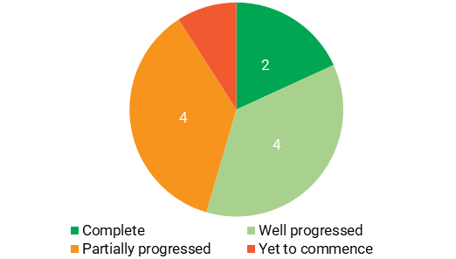 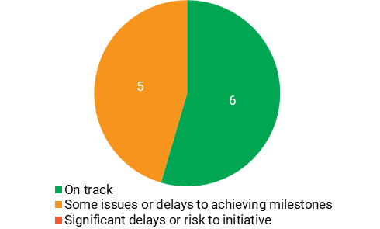

Key achievements
- Collaboration between New South Wales, the Commonwealth and PHNs supported effective implementation of several initiatives.
- Development of a shared vision supported service guidance of the Youth Mental Health Service initiative before commencing Local Health District (LHD) implementation, and roll out of headspace Enhancement funding, which boosted service capacity and improved workforce attraction and retention.
- Safe transition of aftercare services from the Beyond Blue Way Back Support model, with 19 aftercare services operational and three Expanded Referral Pathways trials established.
- The development the DBS Trial model, the National Principles and Operating Guidance document and confirmation of trial site locations.

Status of initiatives
Initiative | Progress Rating |  |  |  | Deliverables Status
Initiative |  |  |  |  | Complete |  | On track | Ongoing* | Delayed
Medicare Mental Health Centre and Satellite Network (formerly Head to Health) |  |  |  |  | 
- Services in Penrith, Liverpool, Parramatta, Central Coast, Shellharbour, Canterbury, Lismore, Hawkesbury, Moruya, and Muswellbrook are open. Coffs Harbour is expected to open in July 2024.
- Centres in Dubbo, Wagga Wagga, Bathurst and Young are delayed but are expected to open in the next reporting period.
- Extensive co-design and formal agreements to sites commencing establishment has impacted timeframes for services across a number of LHDs, leading to 2 ‘delayed’ deliverables.
Investing in Child Mental Health and Wellbeing
Investing in Child Mental Health and Wellbeing | - Limited availability of suitable premises, increased construction costs, capital funding process and negotiating short term leases has led to a ‘delayed’ deliverable.  - Interdepartmental collaboration to navigate these issues has been a key mitigation strategy.  - The NSW H2HK Hubs Advisory Group continues to inform the establishment of further hubs.
Enhancement and Integration of Youth Mental Health Services
Enhancement and Integration of Youth Mental Health Services | - New headspace centres in Hawkesbury and Shellharbour are now operating, and establishment in Narellan is underway with operation expected to commence in December 2024.  - Enhancement funding was allocated to 33 headspace services in 2023-24 and was used to boost capacity.  - LHDs have begun collaborative planning with local headspace services and PHNs to adapt the service model to the local context.
Perinatal Mental Health Screening
Perinatal Mental Health Screening | - Delays in stakeholder engagement and consultation of the Safe Start policy has impacted service implementation, leading to a ‘delayed’ deliverable.  - Funding to address resource gaps was released to LHDs in November 2023 for recruitment of 11 extra positions to improve Safe Start coordination or Perinatal and Infant Mental Health Services, although several LHDs report experiencing delays in local recruitment processes.
Aftercare services
Aftercare services | - 19 aftercare services now operational, with 2 new services in Penrith and Cumberland.  - 3 Expanded Referral Pathways trials are being established which focus on older people, people with psychosocial disability, and Aboriginal people.
Distress Brief Support Trial
Distress Brief Support Trial | - The National Principles and Operational Guidance for the DBS Trial has now been finalised.  - Establishing stakeholder partnerships to commence local co-design and planning has impacted starting trial sites, leading to a ‘delayed’ deliverable.
Postvention Support
Postvention Support | - NSW has supported the Commonwealth in their management of the national funding agreement with Youturn Ltd trading as StandBy Support After Suicide.  - The Commonwealth is exploring funding options for services in 2025-26.
National Phone/Digital Intake Service
National Phone/Digital Intake Service | - The Phone Service was launched nationally on 1 July 2022. Activity continues to increase.
Initial Assessment and Referral | 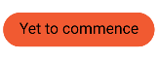
Initial Assessment and Referral | - Information sharing and scoping work occurred in earlier years of the Bilateral Schedule.  - Use of the IAR-DST is yet to commence in NSW and is expected to be progressively implemented across NSW from early 2026.  - The NSW Ministry of Health plans to collaborate with key partners and stakeholders, including PHNs and LHDs, to support implementation.
Regional Planning and Commissioning
Regional Planning and Commissioning | - 8 out of 10 joint regional mental health and suicide prevention plans have been submitted by the PHN. The 2 outstanding were provided with extensions on agreement that existing plans will be updated and provided in 2025.
Workforce
Workforce | - NSW Health has developed Mental Health Pathways in Practice (MHPiP), a workplace-based capabilities education program for nurses and other clinicians working in mental health.

Bilateral Schedule snapshot: 2023-2024

Northern Territory and Commonwealth Bilateral Schedule

Overview
Despite the significant complexities in delivering health services across remote regions, the initiatives under this agreement continue to grow service volume and ensure consideration of alternative, place-based approaches. Two initiatives have been rated complete, with over half the remaining initiatives marked as well progressed. Workforce recruitment that addresses capability, and flexible approaches for implementation timeframes to establish system reform, remain as challenges for implementation across the Territory.
Progress Risk
Progress ratings across the 10 initiatives. Risk ratings across the 10 initiatives.
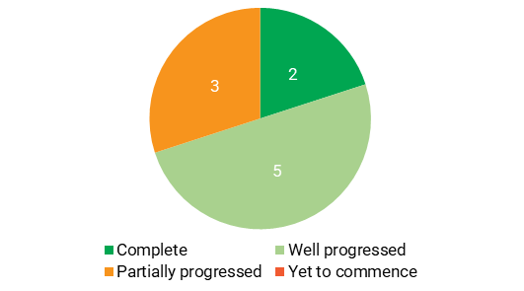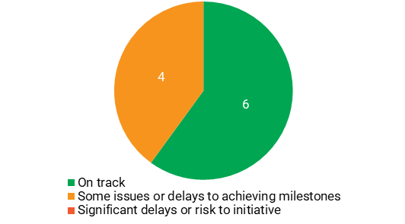

Key achievements
- The region-specific planning elements outlined in the Bilateral Schedule continue to provide a clear and sustained vision for addressing impacts on the Aboriginal and Torres Strait Islander Peoples communities while aligning with broader initiatives, such as the Closing the Gap priorities.
- Recognising the indirect effects of reform through regional planning, multiple opportunities have emerged to enhance existing service models and integrate systems more effectively.
- Safe transition of aftercare services from the Beyond Blue Way Back Support model to an Aboriginal and Torres Strait Islander Peoples-led model of service delivery in the Northern Territory that is responsible and adaptive to local needs and contexts across regions and communities.

Status of initiatives
Initiative | Progress Rating |  |  |  | Deliverables Status
Initiative |  |  |  |  | Complete | On track | Ongoing* | Delayed
Medicare Mental Health Centres (formerly Head to Health)
Medicare Mental Health Centres (formerly Head to Health) | - The Darwin Medicare Mental Health Centre continues to operate, and in 2023-24 there was a 14.7% increase in service volume from 2022-23.  - Centres in Katherine and Alice Springs are delayed but are scheduled to open in the next reporting period.  - Key Aboriginal and Torres Strait Islander Peoples stakeholders are involved in co-design to ensure services in each region meet community needs.
Investing in Child Mental Health and Social and Emotional Wellbeing
- Aboriginal and Torres Strait Islander Peoples stakeholder engagement and co-design work on the service delivery model occurred, to deliver a culturally responsive service for children and their families in Central Australia
- Services are expected to commence in 2025 and will link with the neurodevelopmental assessment clinics operated by Congress, the lead provider throughout NT.
Enhancement and Integration of headspace services (Youth Mental Health Services)
 | - Commonwealth headspace Enhancement funding was allocated to 2 existing headspace services in 2023-24 and was used to boost capacity.
Aftercare services after a suicide attempt
Aftercare services after a suicide attempt | - Aftercare service delivery for the Greater Darwin region has now commenced, with negotiations underway to begin services in 4 more hospitals.  - A Community Referrals pilot has begun in Borroloola as part of efforts to connect people who may need help to seek supports with local place-based needs.  - Commonwealth funding to support universal aftercare implementation in the Territory was executed in August 2024, leading to a ‘completed’ deliverable.
Postvention Support
Postvention Support | - NT has supported the Commonwealth in their management of the national funding agreement with Youturn Ltd trading as StandBy Support After Suicide.  - The Commonwealth is exploring funding options for services in 2025-26.
Perinatal Mental Health Screening
Perinatal Mental Health Screening | - Roll-out of the Digital Perinatal Mental Health Screening Tool continues across NT, with training for clinicians is ongoing to support increased awareness and uptake.  - Perinatal mental health care training is also occurring to improve capacity for clinicians.  - The roll-out across the state of a new Electronic Medical Records (EMR) system is being completed in gradual stages, leading to a ‘delayed’ deliverable.
Initial Assessment and Referral
Initial Assessment and Referral | - In addition to the Darwin Medicare Mental Health Centre, the IAR-DST will be implemented in the Katherine and Alice Springs services.  - Further opportunities for integration of the IAR-DST continue to be explored.
National Phone/Digital Intake Service
National Phone/Digital Intake Service | - The Phone Service was launched nationally in July 2022.  - Stakeholder engagement is ongoing to expand intake service and co-design a Territory-wide model.
Workforce
Workforce | - The NT continues to work with the Commonwealth on joint mental health workforce commitments through the National Mental Health Workforce Working Group.
Regional Planning and Commissioning
Regional Planning and Commissioning | - A Steering Committee inclusive of the NT Department of Health, the National Indigenous Australians Agency, the Aboriginal Medical Services Alliance Northern Territory and the NT Primary Health Network has been established.  - Progress continues to deliver on the outlined co-investments.

Bilateral Schedule snapshot: 2023-2024

Queensland and Commonwealth Bilateral Schedule

Overview
The initiatives under this agreement have benefited from high levels of stakeholder collaboration and engagement, resulting in several achievements over the reporting period. A high number of initiatives are well or partially progressed, one has been rated completed, and one rated yet to commence. Challenges of finding permanent locations for services have impacted implementation of several initiatives.
Progress Risk
Progress ratings across the 12 initiatives. Risk ratings across the 12 initiatives.
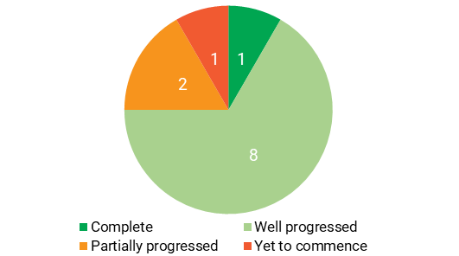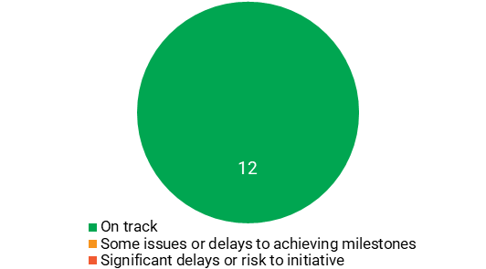

Key achievements
- Collaboration between Queensland and the Commonwealth supported effective implementation of several initiatives.
- Establishment of Head to Health Kids Queensland (H2HK-Q) Project Establishment Group to support development of two new H2HK-Q services.
- headspace Enhancement funding rolled out, boosting capacity of services and improving workforce attraction and retention.
- Data sharing with AIHW pilot commenced for the perinatal mental health screening initiative, and statewide perinatal mental health clinical guideline was completed and published.
- Safe transition of aftercare services from the Beyond Blue Way Back Support model and selection of two PHNs to establish outside hospital pathway trials.

Status of initiatives
Initiative | Progress Rating |  |  |  | Deliverables Status
Initiative |  |  |  |  | Complete |  |  | On track |  | Ongoing* | Delayed
Medicare Mental Health Centres (formerly Head to Health)
Medicare Mental Health Centres (formerly Head to Health) | - 5 of 20 planned Medicare Mental Health Centres are now operating, and in 2023-24 there was a 65.6% increase in service volume from 2022-23.  - Stakeholder consultations regarding potential co-location of services resulted in a delay to commission the Cairn’s centre, leading to a ‘delayed’ deliverable.
Investing in Child Mental Health and Social and Emotional Wellbeing
- H2HK services have commenced in Brisbane and the Gold Coast, and both centres will be fully operational in the next reporting period as recruitment and partnerships progress.
- A Project Establishment Group has been established to ensure services and specifications are aligned with the H2HK National Service Model.
Enhancement and Integration of Youth Mental Health Services
Enhancement and Integration of Youth Mental Health Services | - Commonwealth headspace Enhancement funding was allocated to 22 headspace services in Qld in 2023-24 and was used to boost capacity.  - Establishment of the new headspace centre in Caloundra has been delayed due to difficulty locating a permanent site.  - Interim service arrangements for headspace Caloundra are anticipated to commence in December 2024. The new headspace centre at Moreton Bay has contracted a Lead Agency and identified a potential site, with service commencement date to be updated following a lease being signed.  - Queensland Health funding allocated to Hospital and Health Services to employ specialist clinicians to support clinical in-reach and consultation-liaison to all headspace centres to enhance integration.
Aftercare services
Aftercare services | - Aftercare services are increasingly available across Qld, with services in the Central, South West, Townsville, and Mackay regions planned to commence in 2025.  - Planning for the Torres and Cape region has required complex co-design and is anticipated to operate in 2025.  - In 2024, 2 Expanded Referral Pathways trials were established in Brisbane and the Gold Coast.
Distress Brief Support Trial
Distress Brief Support Trial | - After experiencing some initial delay, co-design for DBS Trial sites in Ipswich and Tablelands has commenced with services anticipated to be operating in early 2025.  - The Toowoomba region has also been selected as a further trial site, to be funded by the PHN.  - PHNs are identifying and sourcing local training requirements due to the unavailability of national approach.  - The National Principles and Operational Guidance for the DBS Trial has now been finalised.
Postvention Support
Postvention Support | - Qld and the Commonwealth continue to co-fund Youturn Ltd trading as StandBy Support After Suicide to progress implementation.  - The Commonwealth is exploring funding options for services in 2025-26.
Perinatal Mental Health Screening
Perinatal Mental Health Screening | - The iCOPE screening tool has been rolled out across 112 locations, with the number of iCOPE screens in total to data is currently 10,483. A substantial number of these screens were conducted at maternity sites.  - The digital integration of iCOPE and the Qld Health electronic medical records is also progressing.
Early intervention community support programs
Early intervention community support programs | - Service arrangements with NGO providers have been completed, leading to a ‘completed’ deliverable.  - NGO providers continue to address gaps in the system and implement community-based early intervention programs.
National Phone/Digital Intake Service
National Phone/Digital Intake Service | - The Phone Service was launched nationally in July 2022.  - Work continues to explore ways to better connect this service to existing state based mental health phone services.
Initial Assessment and Referral
Initial Assessment and Referral | - Integration of the IAR is yet to commence and is under ongoing consideration for its use in government mental health alcohol and other drug services, and will be considered in connection with related work such as Enhancements to phone-based intake services.  - Head to Health Kids Hubs are awaiting the release of the child and youth assessment tool to determine whether it will be implemented into their service model.  - The Commonwealth Department of Health, Disability and Ageing released the Child (5-11 years) and Adolescent (12-17 years) aged-based IAR adaptations in early 2024 as part of the updated IAR for Mental Health Guidance - Parts B and C.
Joint Regional Mental Health and Suicide Prevention Plan
Joint Regional Mental Health and Suicide Prevention Plan | - Service needs and responses are currently being identified and prioritised across regions, in conjunction with stakeholder consultation including Aboriginal and Torres Strait Islander Peoples, lived experience groups and service providers.  - To ensure alignment with other state-based joint regional planning processes, the Commonwealth and Qld have agreed to an extension of the deliverable date.
Workforce
Workforce | - Qld continues to progress workforce initiatives with under Better Care Together: a plan for Qld state funded mental health, alcohol and other drugs services to 2027 which aligns with the National Mental Health Workforce Strategy 2022-2032.

Bilateral Schedule snapshot: 2023-2024

South Australia and Commonwealth Bilateral Schedule

Overview
The initiatives under this Agreement have seen significant achievements over the reporting period, including the expansion of mental health services and improved collaboration between stakeholders. Most initiatives are well or partially progressed with 3 rated yet to commence. However, challenges such as workforce shortages and infrastructure issues as well as delays resulting from consultation efforts have impacted the timely implementation of some initiatives.
Progress Risk
Progress ratings across the 12 initiatives. Risk ratings across the 12 initiatives.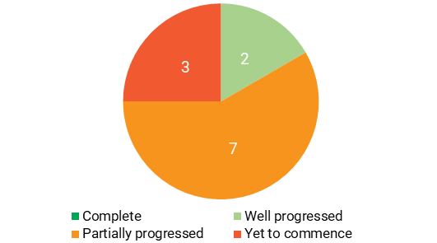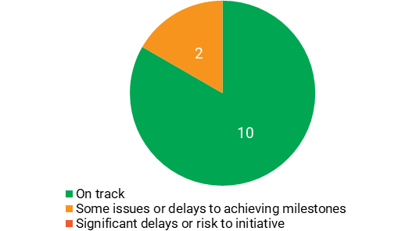

Key achievements
- Partnership and collaboration between South Australia and the PHNs improved significantly which has created opportunities for shared planning, co-design, commissioning activities and better integration of services. The Department for Health and Wellbeing and PHNs are working together and engaging with LHNs and State-wide services in the development of new Joint Regional Plans for Country South Australia and Metro Adelaide.
- Following agreement to the revised Bilateral Schedule in February 2024, the South Australia and Commonwealth suicide prevention teams have commenced planning for implementation of Universal Aftercare and the Distress Brief Support Trial.
- The South Australia Health Strategic Workforce Plan has been drafted, and the Mental Health Workforce Framework is in development.

Status of initiatives
Note: In the 2022-2023 reporting period, South Australia reported on the Preventing and Reducing Suicidal Behaviour initiative. In the 2023-2024 reporting period, this initiative became three separate initiatives: Aftercare Services; Distress Brief Support Trial; and Postvention Support. The Perinatal Mental Health Screening initiative was also added to South Australia’s Bilateral Schedule.
Initiative | Progress Rating |  |  |  | Deliverables Status
Initiative |  |  |  |  | Complete |  |  | On track | Ongoing* | Delayed
Medicare Mental Health Centre (formerly Head to Health)
Medicare Mental Health Centre (formerly Head to Health) | - The Adelaide centre continues to operate.  - Centres in Mount Gambier and Northern Adelaide are open.  - Centres in Mount Barker and Port Pirie are delayed but are expected to open in the next reporting period.
Aboriginal Mental Health and Wellbeing Centre
Aboriginal Mental Health and Wellbeing Centre | - Community engagement sessions were facilitated with Aboriginal and Torres Strait Islander Peoples communities and service providers to support the development of the Model of Care, commissioning process and implementation of the Centre.  - There were unforeseen delays in securing a suitable site for the Centre. Site considerations were informed by community consultations to ensure the centre would be fit for purpose, culturally safe and meet the needs of Aboriginal and Torres Strait Islander clients.
Child Mental Health and Social and Emotional Wellbeing
Child Mental Health and Social and Emotional Wellbeing | - Stakeholder engagement occurred throughout 2024, including establishment of SA H2HK Steering Committee.  - Lack of site location options in Bedford Park (as per election commitments) delayed establishment of the H2HK Hub, leading to a ‘delayed’ deliverable.
Enhancement and expansion of Youth Mental Health Services
Enhancement and expansion of Youth Mental Health Services | - Establishment of the new headspace centre in Gawler is underway with operation expected to commence in 2025-26.  - headspace Enhancement funding allocated to 10 headspace services in 2023-24 was used to boost capacity.  - The SA Youth Model of Care was endorsed and a draft implementation plan developed.
Aftercare services
Aftercare services | - Revised SA Bilateral Schedule agreed in February 2024, including funding for Aftercare services. Implementation discussions between the Commonwealth and SA commenced.  - Funding was provided to Adelaide PHN to continue delivery of existing service. Further site locations to be considered.
Distress Brief Support Trial
Distress Brief Support Trial | - Revised SA Bilateral Schedule agreed in February 2024, including funding for DBS trial.  - SA noted its ongoing involvement in the implementation of this initiative is dependent upon resourcing and capacity.
Postvention Support
Postvention Support | - Revised SA Bilateral Schedule agreed in February 2024, including funding for postvention services. Conversations commenced in June 2024 following the outcomes of the SA State budget.  - Commonwealth funding for 2023-24 and 2024-25 was included in Youturn Limited’s funding agreement extension, executed in October 2023, for the delivery of services in SA. SA noted its involvement in implementing this initiative is dependent upon resourcing and capacity. The Commonwealth is exploring options for funding in 2025-26.
Initial Assessment and Referral
Initial Assessment and Referral | - IAR-DST Training is being rolled out to General Practitioners (GPs) and State Mental Health Clinicians in partnership with the PHNs and Department for Health and Wellbeing. LHNs have developed draft implementation plans to support the tool’s roll out.  - Local GP pilot programs will be included in implementation plans as a key strategy to address low uptake amongst practitioners.
National Phone/Digital Intake Service
National Phone/Digital Intake Service | - The Department for Health and Wellbeing, LHNs, PHNs, the Phone Service provider and others are working to integrate the mental health phone lines in SA.  - SA engaged other states to look at different approaches to integration, e.g. the Brisbane South Metro co-located the Phone Service with Mental Health Call.  - The Phone Service was launched nationally on 1 July 2022.
Workforce
Workforce | - The SA Health Strategic Workforce Plan 2023-2033 has been drafted, and a SA Mental Health Workforce Framework is currently under development.
Regional Planning and Commissioning
Regional Planning and Commissioning | - SA and PHNs are working to facilitate the development of new Joint Regional Plans for Country South Australia and Metropolitan Adelaide, with project briefs in development and a steering committee being established.
Perinatal Mental Health Screening
Perinatal Mental Health Screening | - Roll-out of the iCOPE Screening Tool has occurred to varying degrees across state public antenatal and postnatal settings, with some LHNs using the tool for 12-18 months while others were yet to commence implementation, leading to a ‘delayed’ deliverable.  - SA noted that implementation of the tool and project support are both reliant on existing resources.
1

Bilateral Schedule snapshot: 2023-2024

Tasmania and Commonwealth Bilateral Schedule

Overview
Tasmania and the Commonwealth, including Primary Health Tasmania, are collaborating effectively to implement the initiatives under this agreement despite a range of challenges. Progress has been hampered by workforce shortages, rising infrastructure costs and limited access to leased facilities.
Progress Risk
Progress ratings across the 10 initiatives. Risk ratings across the 10 initiatives.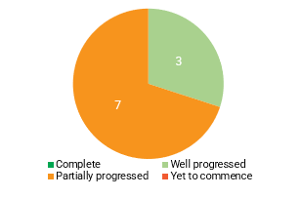 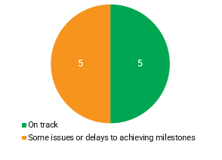

Key achievements
5
- The collaborative relationship between Tasmania, the Commonwealth and Primary Health Tasmania has supported the implementation of initiatives and collective problem solving.
- Tasmania is the first jurisdiction to establish a state-wide integrated phone service to streamline access for consumers to mental health and wellbeing supports. Interim models have now transitioned to the Central Intake and Referral Service (CIRS), which includes GP eReferral forms for mental health and alcohol and other drug services.
- The Tasmanian Eating Disorder Service day programs have commenced in interim facilities.

Status of initiatives
Initiative | Progress Rating |  |  |  | Deliverables Status
Initiative |  |  |  |  | Complete | On track | Ongoing* | Delayed
Medicare Mental Health Centres (formerly Head to Health)
Medicare Mental Health Centres (formerly Head to Health) | - The Launceston Medicare Mental Health centre continues to operate.  - Centres in Burnie, Devonport and outer Hobart have been impacted by the reduced resources available to deliver concurrent commissioning projects resulting in a ‘delayed’ deliverable.  - St John’s Park services will not commence until 2025-26 due to building permits and additional council requirements, resulting in a ‘delayed’ deliverable.
Child Mental Health and Social and Emotional Wellbeing
Child Mental Health and Social and Emotional Wellbeing | - The establishment of H2H Kids Tas is well progressed, however recruitment challenges and approval processes are causing delays.  - Further workforce planning is underway.
Enhancement and Integration of Youth Mental Health Services
Enhancement and Integration of Youth Mental Health Services | - Securing a suitable premise for headspace Eastern Shore and the headspace early psychosis program has been challenging and has resulted in a ‘delayed’ deliverable.  - headspace Enhancement funding was allocated to 2 existing headspace services in Tasmania in 2023-24 and was used to boost capacity.  - Efforts to formalise work for better integration of youth mental health services has also progressed slowly, resulting in a ‘delayed’ deliverable.
Aftercare services
Aftercare services | - Services have safely transitioned from the Beyond Blue support model.  - Primary Health Tasmania (PHT) has engaged a consultant to review the Tas aftercare system and identify the best practice elements of universal aftercare for the Tas context.  - Consultation on the expansion of referral pathways to aftercare has been included in this scope of work.
Eating Disorders Day Programs
Eating Disorders Day Programs | - Pilots have been successfully established, with services now expanding and developing beyond the clinic pilot model to deliver wider Community Based Intensive Treatment (CBIT) Program services across the state.  - An infrastructure project to deliver a purpose-built CBIT facility in Launceston is underway.
Initial Assessment and Referral
Initial Assessment and Referral | - The IAR has been embedded within the mental health eReferral form developed for the CIRS, leading to a ‘completed’ deliverable.  - Although the IAR is embedded within the mental health eReferral form, integration into GP software is being driven nationally by the IAR project team.
National Phone/Digital Intake Service
National Phone/Digital Intake Service | - The Phone Service was launched nationally on 1 July 2022. Operation transitioned into CIRS on 1 December 2023.  - The Department of Health Tasmania is collaborating with PHT to increase service reach and support options in the coming months to mitigate any community confusion around access points.
Workforce
Workforce | - The Department of Health Tasmania has established a multi-agency mental health workforce working group to identify strategies which address current and future mental health workforce needs, including innovative workforce solutions for the sector and Lived Experience.
Regional Planning and Commissioning
Regional Planning and Commissioning | - The Department of Health Tasmania, PHT and the Mental Health Council of Tasmania have continued to progress integrated planning and service delivery actions under Tas’s joint regional mental health plan, Rethink 2020: A State Plan for Mental Health in Tasmania 2020-2025.
Perinatal Mental Health Screening
Perinatal Mental Health Screening | - The technical integration work by Health ICT and the preparation of a data sharing agreement for AIHW have experienced considerable delays which has impacted progress, resulting in a ‘delayed’ deliverable.

Bilateral Schedule snapshot: 2023-2024

Victoria and Commonwealth Bilateral Schedule

Overview
Strong collaboration between the Commonwealth, the State and the PHNs has contributed towards an integrated approach across a range of initiatives. Key implementation barriers included workforce attraction, recruitment and retention. Victoria noted it remains committed to delivering the recommendations of the Royal Commission into Victoria’s Mental Health System.
Progress Risk
Progress ratings across the 11 initiatives. Risk ratings across the 11 initiatives.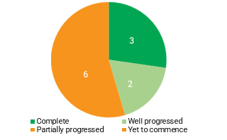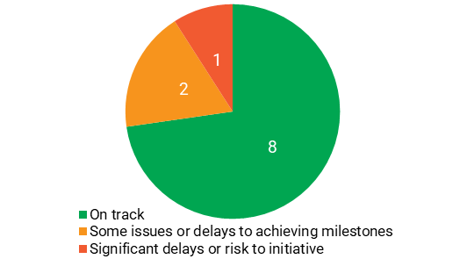

Key achievements
- The Bilateral partnership supports the Royal Commission’s call for a collaborative, long-term, and coordinated approach between Victoria and the Commonwealth to reform the mental health system.
- Eight sites for aftercare services transitioned from the Way Back Support Service model to the HOPE (Hospital Outreach Post-Suicidal Engagement) model of care. This was made possible through strengthened partnerships and close collaboration between the Commonwealth, Victorian Department of Health, Beyond Blue, PHNs and local mental health services.
- Three new Children’s Health and Wellbeing Locals opened, delivering innovative, culturally safe, wraparound care. These services offer developmentally appropriate health, mental health and wellbeing support, along with family services and parenting programs for children and families facing disadvantage and adversity.

Status of initiatives
Note: In the 2022-2023 reporting period, Victoria reported on the Universal Aftercare Services initiative and Aftercare Services – Expanded Referral Pathways Trial initiative. In the 2023-2024 reporting period, these initiatives have been combined to Aftercare Services.
Initiative | Progress Rating |  |  |  | Deliverables Status
Initiative |  |  |  |  | Complete |  |  | On track |  | Ongoing* |  | Delayed
New community-based health and wellbeing services for adults
New community-based health and wellbeing services for adults | - The Bilateral Senior Officials Groups endorsed the Transition Guidelines for Head to Health clinics to new Mental Health and Wellbeing Locals (Local Services) in December 2023.  - The guidelines outline the transition of services from decommissioning Head to Health clinics to Local Services.  - The Vic 2024-25 State Budget (delivered May 2024) announced a more gradual approach to the rollout of Local Services would be taken to provide necessary time to grow the workforce pipeline and incorporate learnings from the initial rollout into planning.  - The more gradual rollout impacted expected delivery of Local Services and decommissioning of Head to Health clinics which led to a funding shortfall in 2024-25 Vic and the Commonwealth are committed to work collaboratively to resolve the 2024-25 funding shortfall and the way forward.
New community-based health and wellbeing services for infants, children and families
- All services have been fully operational since December 2023, reaching children and families in local communities.
- Regional partnerships have been established to enhance services across rural and regional areas, with a focus on providing holistic, coordinated care.
- Vic and the Commonwealth have developed co-branding guidelines, leading to a ‘completed’ deliverable.
Enhancement and integration of Youth Mental Health Services |  |  |  |  |  |  |  |  |  |  |  |  | 
Enhancement and integration of Youth Mental Health Services | - headspace centres in Box Hill and Hamilton are now operating.  Enhancement funding has been provided to 27 existing services and was used to boost capacity.  - Vic and the Commonwealth began discussions on a work plan for an integration model between headspace services and Infant, Child and Youth Area Mental Health and Wellbeing Services.  - The Vic 2024-25 State Budget (delivered May 2024) announced a more gradual approach to mental health reforms, with enhanced integration work paused during this reporting period. However, Vic’s integration efforts across the sector continued, with directives issued to ensure that primary and secondary consultation activities with headspace centres were maintained.  - Vic’s integration efforts across the sector continued, with directives issued to ensure primary and secondary consultation activities led by Infant, Child and Youth services with headspace centres in Vic were maintained.
Perinatal mental health screening
Perinatal mental health screening | - The Review into Perinatal Mental Health Screening Approaches was completed, with key barriers identified as practice guidance, workforce training, and service system capacity.  - The Summary Report received ministerial approval and was publicly released in March 2024.  - Implementation of the recommendations is underway.
Aftercare Services
Aftercare Services | - The HOPE model of care is now established statewide, operating at 40 sites including 4 Child and Youth sites.  - Transition to the HOPE model of care has resulted in implementation delays, including for the establishment of Expanded Referral Pathway trials.  - Workforce recruitment and retention, particularly in rural and regional areas, remains a challenge.
Distress Brief Support Trial
Distress Brief Support Trial | - Implementation was initially delayed by the late execution of the Bilateral schedule, the 2022 Federal election, a change in Vic’s Mental Health Minister, and finalising trial site agreements.  - As a result, the Parties agreed to extend milestones and rephase funding in April 2024 to allow time for implementation and evaluation.  - Darebin and Greater Shepparton have been selected as the DBS trial program locations.  - The National Principles and Operational Guidance for the DBS Trial has now been finalised.
Postvention Support
Postvention Support | - Services continue to be delivered, with service enhancements agreed between the Commonwealth, Vic, and Youturn Limited.  - Vic works closely with providers to ensure services meet local needs including. Enhancement services include peer support and bereavement counselling.  - Establishing the state-level postvention steering group has been delayed due to resourcing constraints but has not impacted service delivery or performance.
National Phone/Digital Intake Service
National Phone/Digital Intake Service | - Refinement of the draft Vic mental health and wellbeing service Access and Intake policy and guidelines is underway. The documents include guidance on using the Phone Service and Digital Platform.  - The Phone Service was launched nationally on 1 July 2022.
Initial Assessment and Referral
Initial Assessment and Referral | - The IAR tool is embedded in local service models and used at intake across all Local Services, with regular reporting of assessment data.  - Staff continue to access PHN-led training to ensure all delivering IAR assessments are properly trained.
Workforce
Workforce | - Since 2021, Vic has invested over $600 million in mental health workforce initiatives to address a shortfall of 2,500 workers by 2025. This investment has driven a 25% increase in fulltime public mental health roles from 2021-24.  - Workforce challenges persist, especially in rural and regional areas where shortages are impacted by housing, education, childcare access, and job prospects for families.
Regional Planning and Commissioning
Regional Planning and Commissioning | - Vic and the Commonwealth continue to collaborate on joint regional planning, with a focus on aligning efforts with state-based reforms.  - From July 2025, Vic will establish Local Health Service Networks with regional planning aligned to these new boundaries.  - The Statewide Mental Health and Wellbeing Service and Capital Plan 2024-2037 is informing this work.

Bilateral Schedule snapshot: 2023-2024

Western Australia and Commonwealth Bilateral Schedule

Overview
The initiatives under this agreement have made strong progress during the reporting period. Productive collaboration between the Commonwealth and State supported key milestones. However, short-term funding arrangements, underestimated implementation timelines, workforce shortages, and misaligned budget cycles created challenges for service establishment and delivery.
Progress Risk
Progress ratings across the 12 initiatives. Risk ratings across the 12 initiatives.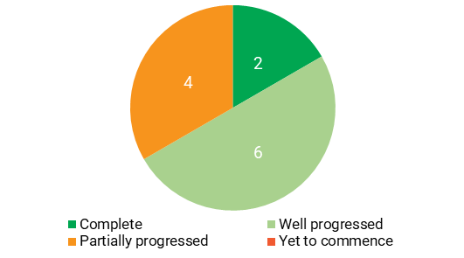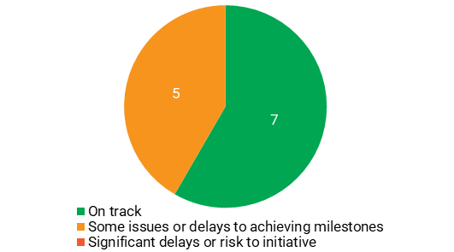

Key achievements
- The Aftercare Services Program Model of Service was developed through extensive consultation.
- The Western Australia Eating Disorders Program was launched and will provide intensive clinical monitoring, patient transition coordination and multidisciplinary outpatient services.
- A strong foundation for workforce development laid with the publication of the National Mental Health Workforce Strategy, along with the National Mental Health Workforce Working Group. These collectively demonstrate Western Australia’s commitment to improving mental health services and support.

Status of initiatives
Note, in addition to bilateral initiatives, WA provided status updates against five parallel initiatives being progressed outside of the Bilateral Schedule. These initiatives are included in the progress and risk rating totals above.
Initiative | Progress Rating |  |  |  | Deliverables Status
Initiative |  |  |  |  | Complete |  |  | On track |  | Ongoing* | Delayed
Investing in Child Mental Health and Social and Emotional Wellbeing
- Stakeholder consultation has been undertaken as part of developing the Model of Service which will be advertised for tender.
- Service provision was previously anticipated for mid-2024 but is now expected to occur in the next reporting period.
Aftercare services for people after a suicide attempt
Aftercare services for people after a suicide attempt | - The draft Model of Service has been informed by community and sector consultation, including people with Lived Experience (subject to bilateral agreement).  - Delays in finalising the Model of Service has impacted implementation, resulting in a ‘delayed’ deliverable.
Eating Disorders Program
Eating Disorders Program | - The East Metropolitan Eating Disorder Specialist Service Hub has commenced services in temporary accommodation.  - A plan for community mental health service accommodation is being developed for long term service delivery.
Initial Assessment and Referral
Initial Assessment and Referral | - Inter-departmental collaboration continues at a policy level to progress alignment of State and Commonwealth assessment and referral phone services through integrated approaches.  - All Head to Health mental health clinicians are trained in IAR-DST.
Perinatal Mental Health Screening
Perinatal Mental Health Screening | - WA has a well-established method to report screening data, therefore the iCOPE tool is not currently being used as part of the unfunded initiative under the WA Bilateral Schedule.  - The WA Mental Health Commission and the WA Department of Health are engaging in ongoing discussions about this initiative.
Regional Planning and Commissioning (including the Joint Committee)
- The final draft of the Joint Regional Planning in WA is progressing through internal agency approval requirements, resulting in a ‘delayed’ deliverable.
- The Commonwealth has provided WA with an extension to the due date for the final draft in the next reporting period.
Workforce
Workforce | - Priority areas for action have been captured in a multi-year Work Plan for the National Mental Health Workforce Working Group.  - Initiatives and training courses are being implemented to build structures and ensure successful embedding of the Lived Experience (Peer) Workforces and Aboriginal Mental Health workforce.
Parallel initiatives being progressed outside the Bilateral Schedule:
Medicare Mental Health Centres
Medicare Mental Health Centres | - Service delivery has commenced at Midland, Armadale, Mirrabooka, Gosnells and Northam, with continued increase in activity levels.
National Phone/Digital Intake Service
National Phone/Digital Intake Service | - The Phone Service was launched nationally on 1 July 2022, with increased caller volume and a focus on improving quality metrics.  - A staged approach is evolving the model to be a central entry point into WA Primary Health Alliance commissioned services.
Enhancement and expansion of headspace
Enhancement and expansion of headspace | - Planning has commenced for the procurement of a new headspace service in WA, to be announced in the next reporting period.  - Enhancement funding was allocated to 14 headspace services across the state in 2023-24 to boost capacity.
Youth and Adult Community Treatment
Youth and Adult Community Treatment | - Service provision has been operational since 2022-23 and continues with a phased implementation of expansion to service delivery to increase capacity.
Initiatives related to the ICA Taskforce
Initiatives related to the ICA Taskforce | - The key actions are not intended to be completed at a single point in time, rather to direct ongoing reform to continuously improve the experiences of infant, children, adolescents and their families and carers, leading to a ‘completed’ deliverable.

3.6.3. Perspectives of the Parties on implementation of the Agreement
In addition to providing status updates against the bilateral initiatives, the Commission asked the Parties about enablers and barriers in implementing the Agreement commitments.

What worked well
In terms of what is working well during this reporting period, some commonly reported areas included:
- Strong collaboration and partnerships between governments, PHNs, and service providers, which was also identified as a highlight in the 2022-2023 period.
- Some improvements in communication and engagement strategies, which was noted as a suggested action item in the First Report.
- Some improvements in governance and strategic planning have supported project execution and decision-making, which indicates some progress addressing the lack of clarity in roles and responsibilities among some working groups highlighted in the First Report.
- Commitment to workforce development and capacity building which has strengthened service delivery. Engagement in the National Mental Health Workforce Working Group has helped coordinate efforts to strengthen the workforce across jurisdictions, in line with the National Mental Health Workforce Strategy.
- Adaptability and responsiveness to evolving needs have played a role in refining approaches, integrating lessons learned, and enhancing service models to better support communities.

What is not working well

Despite these successes, some commonly reported issues that challenged implementation included:
Workforce shortages: Jurisdictions reported continued difficulties in attracting and retaining qualified staff, especially in rural and regional areas. These shortages are compounded by systemic barriers such as housing availability and affordability, and limited access to childcare and education. New South Wales, Victoria and Western Australia raised that short-term funding cycles further contribute to workforce instability and disrupt recruitment and long-term retention strategies. The First Report also flagged workforce shortages as a growing concern, specifically in Tasmania and Western Australia. These issues reflect ongoing national constraints despite investment in workforce development and engagement through the National Mental Health Workforce Working Group.
Data and infrastructure: The Commonwealth raised concerns of the need for improved bilateral data to enable more effective reporting and assessment of agreed performance indicators. Data systems are rolled out in gradual releases, and can experience technical issues, which impacts timelines. Limited access to building infrastructure has caused delays across multiple jurisdictions, with difficulties securing suitable premises for new or enhanced services. Challenges in accessing leased accommodation and rising infrastructure costs, also flagged in the First Report, remain a consistent concern.
Governance and communication challenges: More structured engagement at national steering group meetings could improve collaboration across jurisdictions, particularly regarding Aboriginal and Torres Strait Islander Peoples suicide prevention initiatives. Jurisdictions reported difficulties in joint planning and reporting processes due to staff turnover and changes in responsibilities. This suggests that while governance structures have become more defined, there is still work to be done in ensuring smooth coordination and clearances. South Australia reported inconsistencies in information sharing between the Commonwealth, State governments, and PHNs. The Northern Territory raised concerns aligning national advisory recommendations with its distinct regional needs. Queensland emphasised the need for greater consultation in co-funded service decisions.

Sustainable funding: Broader concerns about funding stability were raised across multiple jurisdictions. Victoria’s revised rollout schedule for Local Services has impacted decommissioning plans for Head to Health clinics, creating interim funding gaps. New South Wales and Queensland highlighted the impact of the current 3-to-4-year funding cycles on workforce and service continuity and strategic planning. Resourcing constraints in some state health departments and PHNs contributed to delays in determining implementation approaches, including site selection and service models. The challenges arising from different funding cycles between the Commonwealth and State and Territory Governments was similarly highlighted in the 2022-2023 reporting period.

Administrative challenges: The Northern Territory stressed the need for flexible timeframes to accommodate complex reform environments. Developing new models of service, rather than adapting existing programs based on the needs within jurisdictions, has also created challenges. Similarly, in the 2022-2023 period, jurisdictions acknowledged that implementation timeframes needed to reflect the realities of large-scale reform. The ongoing call for flexibility to timeframes suggests that, despite efforts to streamline processes, the complexity of system-wide change continues to challenge implementation.

Areas for improvement
To address these challenges, states and territories proposed a range of improvements to strengthen implementation. Some improvements related to administration, implementation and reporting, such as bimonthly meetings between Commonwealth and State officials, flexible implementation timelines, and national data sharing to streamline the integration of iCOPE data.

Other suggested improvements indicate a need for more long-term and strategic approaches to planning and funding such as embedding commissioning decisions within Bilateral Schedules, aligning implementation to regional planning approaches and ensuring evaluation findings inform decision making. The need to align funding and commissioning between different levels of government was similarly observed by some Parties in the 2022-2023 period. The consistency of this issue has suggested that, without structural changes to funding agreements and planning processes, coordination of service planning and delivery will remain a challenge.

Summary:
- Of the 83 initiatives under the 8 Commonwealth-State Bilateral Schedules, the Parties rated 10 as ‘complete’, 29 as ‘well progressed’, 39 as ‘partially progressed’ and 5 as ‘yet to commence’.
- Some areas that were commonly seen as supporting implementation included collaboration at the local level between those implementing initiatives, improvements in governance and strategic planning.
- Some commonly cited barriers to implementation included issues with workforce, data and infrastructure, communication between the governance and steering groups, and sustainability of funding.
- The Parties proposed a range of improvements including enhancements to implementation and reporting arrangements, as well as initiatives aimed at supporting more long-term approaches to planning and funding.

4. Enablers for measuring change and impact
While this report does not examine the outcomes of the Agreement, it does provide the opportunity to reflect on work underway to better measure outcomes and impact in the future.
In the Agreement, the Parties acknowledged that comprehensive, accurate and accessible information would be critical to successfully monitoring and achieving progress towards mental health and suicide prevention system reform. To that end, the Agreement has outlined various work to improve mental health and suicide prevention data and evaluation as the enablers for tracking progress over time.
This work has included the development of priority data and indicators, which were outlined against the Agreement’s priority outcomes, greater linking and sharing of data and the development of an evaluation framework for mental health and suicide prevention programs.

4.1. Progress on data
During this reporting period, the DGF reported that progress has been made in several areas related to data.

Priority data and indicators
A Technical Implementation Plan to guide development of priority data and indicators to measure progress against outcomes specified in the Agreement (which was due within the first year of the Agreement) was finalised and endorsed; development work on these indicators in this period resulted in an initial set of agreed indicators (see Appendix E).

Data linkage
A pilot data linkage project commenced to link State and Territory community mental health data to broader health systems data in the National Health Data Hub NHDH (previously known as the National Integrated Health Services Information Analysis Asset). Queensland and Victoria were participating in the pilot and the remaining jurisdictions were working with the Australian Institute of Health and Welfare to explore their involvement. Commonwealth data such as MBS and PBS were already included in the linkage project and the Commonwealth was working with PHNs, AIHW and headspace to enable the supply of Primary Mental Health Care data. Ethics approval for the pilot was granted and linkage has commenced.

Data sharing
Data sharing was occurring between the Department of Health and Aged Care, the AIHW, state health departments of New South Wales, Queensland, Victoria, the Australian Capital Territory and Western Australia, via the Mental Health Services Activity Monitoring System (MH SAMS). Data was being shared via the MH SAMS every 4 weeks, to a maximum of 12 times per year. Data shared included specialised mental health services (community and admitted), emergency department, and other mental health program data, as well as MBS and PBS.
In addition, work commenced on a governance framework to enable data sharing and was expected to be completed by December 2024. Further, data sharing through the MH SAMS was being overseen by a monthly meeting of participating agencies where participants discuss recent data trends, provide other contextual information to help understand trends, and provide expert advice on future analysis plans.

4.2. Progress on evaluation
The Parties to the Agreement were undertaking activities to improve the evaluation of mental health programs. During this reporting period, the EGP reported that progress in this area has included:
- A National Evaluation Framework was developed by an external consultant and informed by consultations from across the sector. The framework provided high-level guidance on priority aspects of the mental health and suicide prevention system requiring evaluation. It also included guidance on domains and measures that determined both the effectiveness and efficiency of programs consistently across mental health and suicide prevention programs (a deliverable due within the second year of the Agreement).
- The National Evaluation Framework, along with Sharing Guidelines and an approach to implementing the framework, was endorsed by MHSPSO. An extension to deliver the evaluation framework beyond the first 12 months of the Agreement (Clause 101) was granted by MHSPSO.
- Under the plans for implementing the framework, a coordinated approach to national evaluation would support more robust and consistent evaluation methodologies, support evaluation capacity building, address gaps in evaluation, and oversee a review of the framework’s Sharing Guidelines within the next iteration of the Agreement.
Summary:
- Work was underway to strengthen data and evaluation in mental health and suicide prevention activities, which was expected to enhance the monitoring of progress towards improved system effectiveness and outcomes.
- The DGF and EPG reported progress during this period in advancing data linkage and sharing, the development of national priority indicators, and the development of a National Evaluation Framework and implementation guidelines.

5. Conclusions

As they reached the half-way point of the Agreement, the Parties were making progress in implementing commitments, though significant further work will be required to realise completion by the end of the Agreement.

Overall, progress is being made
- The Parties report that the implementation of the Agreement’s outputs was largely on track with several outputs delivered or largely completed this period, such as the analysis of psychosocial support services outside the NDIS and the National Evaluation Framework. However, the further delay of the National Guidelines on Regional Planning and Commissioning this period is noteworthy and should be a priority for completion by the Parties.
- Similarly, the Parties considered almost half of the 83 initiatives under the 8 Commonwealth-State Bilateral Schedules were ‘complete’ or ‘well progressed’. Three of the 5 initiatives that were ‘yet to commence’ related to a Bilateral Schedule that Parties renegotiated during the period.

Some issues continue to challenge implementation
- While progress was being made overall, this report highlights that momentum appeared uneven across working groups. While the establishment of the LEG is a highlight this period, the convening of this group just once is disappointing. Similarly, the delays in renewing the terms of reference and work plan for the Schedule A group is noteworthy.
- This report notes some challenges to implementation have continued from the first reporting period, illustrating the enduring nature of these issues. These challenges include issues with workforce, infrastructure, administration and governance, sustainable funding and the need for implementation timelines to acknowledge the realities of large-scale reform.
- While there has been some progress on the action areas highlighted by the Commission in the First Report (e.g. finalising the remaining Joint Implementation Plans), others remain areas to address. These areas include ensuring the Schedule A working group move beyond information sharing towards collaborative cross-portfolio action and consistent and ongoing communication and engagement between the working groups.
- As outlined earlier in ‘External factors’, implementation of the Agreement is occurring alongside other complex national reforms, such as in disability support. This report highlights the potential risk of implementation of Agreement commitments being siloed from related social policy work occurring in other forums, such as NDIS reforms.

The Commission recommends the Parties undertake the following actions
- Enhance engagement with people with lived experience and Aboriginal and Torres Strait Islander Peoples – for example, through more effective collaboration with the LEG and the SEWB Policy Partnership.
- Improve the whole-of-government approach to reform – for example, renewing the Schedule A group’s work plan and ensuring it moves beyond information sharing towards cross-portfolio action.
- Explore mechanisms to support long-term approaches to planning and funding – for example, exploring the role of tools such as the National Mental Health Service Planning Framework and the national suicide prevention service planning model currently under development.
- Ensure implementation of commitments is not isolated from related policy work happening elsewhere – for example, working groups could connect with other actors driving related reforms.
- Prioritise the completion of deliverables that are delayed or at risk of delay – for example, the National Guidelines on Regional Planning and Commissioning and Bilateral Schedule initiatives rated amber or red.
- Prioritise the completion of the Joint Annual Jurisdiction Performance Reports for Years 3 and 4 to support completion of this Annual National Progress Report, which remains the primary mechanism under the Agreement for regular progress reporting to the Australian community.
The Commission thanks all stakeholders for their valuable contributions to this report.

Appendices

Appendix A

Methodology
This report is based on analysis of the following information sources that were provided to the Commission:
- Joint Annual Jurisdiction Performance Reports – providing detailed information on the status and progress implementing the initiatives under each Bilateral Schedule.
  - These reports are jointly completed by each jurisdiction and the Commonwealth.
  - For each Bilateral Schedule initiative, the reports detail the financial investment, progress and risk ratings, key risks or issues, performance indicators (detailed in the respective Bilateral Schedule) and deliverables (detailed in the respective Joint Implementation Plan).
  - The reports also include open-ended questions canvassing the Parties’ views on implementation, canvassing implementation progress, challenges and suggestions for improvement.
- Working Group Performance Reports – providing detailed information on the status and progress implementing the Outputs detailed under the Agreement.
  - These reports are completed by each of the governance and working groups established to support implementation of the Agreement. Reports were provided by MHSPSO, DGF, SQG, EPG, PPG, Schedule A Working Group and the LEG. Responses were also provided by the SEWB Policy Partnership representatives to MHSPSO.
  - These reports detail the status of deliverables and milestones and provide context for their implementation status (where relevant). They also include open-ended questions canvassing the working group’s views on the implementation of the Agreement and opportunities for improvement.
- Data on expenditure on mental health services by the AIHW.
- Update on the Priority Data and Indicators for Development (Annex B of the Agreement) provided by DGF.

Limitations
There are several limitations to this report:
- The Parties provide the primary source of information for this National Progress Report, via their completed Annual Jurisdiction Performance Reports, as per the reporting arrangements under the Agreement. Therefore, the extent that this report provides an impartial analysis of the Agreement’s implementation is limited.
- Status and risks ratings of outputs and initiatives under the agreement are assigned by the relevant working groups and parties respectively and these are not independently verified by the Commission.
- A large amount of the information provided to the Commission is qualitative or descriptive in nature, which limits the report’s ability to quantify progress in objective terms. While the Joint Annual Jurisdiction Performance Reports include Key Performance Indicators, the Commission has been unable to use these (e.g. in the Bilateral Schedule snapshots) as many were rated ‘not applicable’ by the Parties due to unavailability of data, or because the KPI was an output (e.g. an evaluation plan) rather than a traditional performance indicator.
- Delays in the Parties’ provision of completed Annual Jurisdiction Performance Reports to the Commission by the specified timeframe has delayed the completion of the Annual National Progress Report and its ultimate release to the Australian community. The final required information to enable completion of this report was provided to the Commission in May 2025. This delay has reduced the report’s currency and its utility as a mechanism for highlighting implementation barriers and supporting the Parties to act on them in a timely manner.
- As per the Agreement, this report is intended to focus on implementation progress, while the Final Review is tasked with examining the Agreement’s outcomes. Therefore, this report does not examine or comment on the merits of specific commitments or whether they are leading to desired change.

Appendix B

About the Agreement
Governance and working groups in the 2023-2024 reporting period.
To support implementation of the Agreement, the Parties established MHSPSO, comprising senior officials with responsibility for mental health and suicide prevention policy, programs and other clinical expertise as required, as well as representatives from the Closing the Gap SEWB Policy Partnership, lived experience and Aboriginal and Torres Strait Islander Peoples representatives. To progress key priority areas and assist with implementation of the Agreement, MHSPSO established several working and project groups.
Table 5. Overview of governance and working groups as at June 2024.

Group | Purpose
Mental Health and Suicide Prevention Senior Officials Group | Supporting implementation of the Agreement across jurisdictions.
Schedule A Working Group | Progressing cross-portfolio commitments under Schedule A to the Agreement.
Data Governance Forum | Overseeing and implementing data and performance measurement commitments specified in the Agreement.
Evaluation Project Group | Provide advice to MHSPSO on priority aspects of the mental health and suicide prevention system requiring evaluation.
Safety and Quality Group | Providing oversight for safety and quality matters relating to national mental health and suicide prevention reforms and services.
Psychosocial Project Group | Overseeing and facilitating the analysis of psychosocial support services outside of the National Disability Insurance Scheme.
Lived Experience Group | Providing diverse lived experience perspectives to support the governance and implementation of the Agreement.

Table 6. Other inputs as at June 2024.

Group | Purpose
Social and Emotional Wellbeing Policy Partnership | SEWB Policy Partnership makes recommendations to the Joint Council on Closing the Gap to ensure Aboriginal and Torres Strait Islander people achieve the highest attainable standard of social and emotional wellbeing. While not a working group under the Agreement, SEWB Policy Partnership has 2 representatives on MHSPSO.

Figure 7. Governance arrangements for the Agreement as at 30 June 2024.
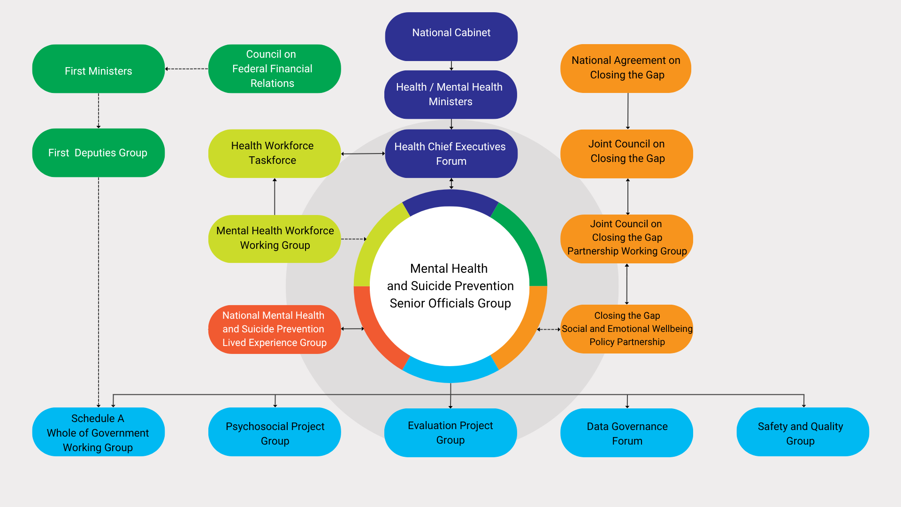

Bilateral Schedules: Implementation and reporting
The Agreement commits the Parties to develop Joint Commonwealth-Jurisdiction Implementation Plans for each Bilateral Schedule outlining governance, key deliverables, implementation approach and timeframes.

Table 7: Status of Joint Implementation Plans for Bilateral Schedules as at June 2024
Jurisdiction | Status
Victoria | The Commonwealth is seeking to renegotiate the Bilateral Schedule between the Commonwealth and Victorian Governments
South Australia | Implementation Plan commenced on 21 May 2024
Northern Territory | Implementation Plan updated on 15 May 2024
Queensland | Formally endorsed on 13 April 2023
Western Australia | Formally endorsed on 08 February 2024
New South Wales | Formally endorsed on 23 July 2023
Australian Capital Territory | Implementation Plan updated on 18 June 2024
Tasmania | Implementation Plan updated on 24 June 2024

Under the Agreement, the Parties are required to produce Joint Performance Reports against the Joint Implementation Plans by 31 August each year (Clause 76). These reports provide detailed progress information for each initiative, including funding, progress and risk ratings, key risks and mitigations, and performance indicators and the status of deliverables.

Appendix C

Status of output milestones with specified due dates
Milestone | Status: 2022-2023 | Status: 2023-2024
The Parties agree to undertake further analysis of psychosocial supports outside of the NDIS, to commence within the first twelve months from the commencement of this Agreement and be completed as soon as possible within the first two years of this Agreement – Clause 128a. | Funding sought and procurements undertaken for suppliers to undertake the unmet needs analysis. The Parties reported the First Report noted analysis work was on track for completion by March 2024. | (Health Chief Executives Forum) HCEF approved the cost-shared budget bid of $1.678 million (in 2023-24) for the unmet need project on 10 July 2023. HPA was engaged as the primary supplier, with assistance from the University of Qld.
Progress rating: |  | 
Subject to all Parties agreeing to co-contribute to the cost of its development, the national evaluation framework will be developed within the first twelve months of this Agreement – Clause 101. | Due date extended to 30 October 2023 given delays in establishing governance and to allow for broad sector engagement. Consultant was procured and framework on track to meet revised deadline. | MHSPSO endorsed the Evaluation Framework, Sharing Guidelines and proposed implementation approach. Comments from several members will be considered prior to submission of the National Evaluation Framework to HCEF for endorsement.
Progress rating:
The Parties agree to share evaluation findings: (a) Between government and with commissioning organisations, service providers and the public where appropriate. (b) According to guidelines to be developed and agreed by HSO within six months of this Agreement – Clause 99. | Consultant developing the Evaluation Sharing Guidelines by 30 October 2023, for MHSPSO endorsement by 30 November 2023. | MHSPSO endorsed the Evaluation Sharing Guidelines and proposed implementation approach.
Progress rating:
Develop national guidance on domains and measures to assess effectiveness and efficiency of programs within the second year of the Agreement – Clause 102b. | The Evaluation Framework will include guidance on domains and measures that determine both the effectiveness and efficiency of programs consistently across mental health and suicide prevention programs. | The Evaluation Framework includes guidance on domains and measures that determine effectiveness and efficiency of programs consistently across mental health and suicide prevention. The Evaluation Framework has been developed but not yet released.
Progress rating:
Parties will work together within the first twelve months of this Agreement to develop national guidelines on regional planning and commissioning – Clause 133. | Due date extended to December 2023 given the need to develop meaningful guidance that reflects jurisdictional regional planning and commissioning, and the need for sufficient consultations to take place; working group established to develop guidelines. | Timeframe was further extended to allow MHSPSO consideration of the role of the proposed Guidelines within the national context including alignment with the Reform Implementation Group workplan commissioning project under the NHRA Addendum 2020-2025. The Commonwealth continues to work with MHSPSO representatives on this deliverable.
Progress rating:
As part of development of the Workforce Strategy, Parties will work together to identify priority areas for action, by mid-2022 and work together to agree on the Workforce Strategy’s implementation, including an annual review of priorities – Clause 151. | Priorities for action were captured in a multiyear work plan for the National Mental Health Workforce Working Group established in March 2023; the draft plan was endorsed by the group in June 2023. | N/A
Progress rating: |  | N/A
The Parties will collectively develop a submission, for endorsement by Health Chief Executives, for the midpoint review of the NHRA, due to be completed by December 2023 – Clause 68. | In May 2023, MHSPSO members developed the MHSPSO submission to the NHRA mid-point review. The final MHSPSO submission was provided to NHRA Reviewers on 5 June 2023. | N/A
Progress rating: |  | N/A
Establish a governance framework and technical systems to enable data sharing, and commence agreed routine data sharing, by the end of the second year of the Agreement– Clause 88g. | DGF members have commenced work on a governance framework for data sharing. | DGF members expect to have the governance framework for data sharing complete by December 2024.
Progress rating:
The Commonwealth will ensure a subset of data for agreed priority items is supplied, linked and available to the Parties for analysis within the first 18 months of the Agreement – Clause 94a. | The Commonwealth advised it is working with PHNs, AIHW and headspace to enable the supply of Primary Mental Health Care data into the NIHSI linkage project. Commonwealth data such as MBS and PBS are included in this linkage project. | The AIHW has been working with Vic, Qld and NSW to link their mental health data into the newly named (NHDH; formerly NIHSI).
Progress rating:
Broader linked data will be available to the Parties within 30 months of this Agreement – Clause 94b. | This work is yet to commence as it relies on the completion of 94a. | No further update.
Progress rating: | 
The States will provide funding in their own jurisdiction to ensure the agreed priority items are supplied, and available to the Parties for analysis within the first twelve months of this Agreement – Clause 95. | DGF advised it was ‘not responsible for monitoring how states and territories allocate resources to meet their Agreement commitments’ and rated this milestone ‘not applicable’ to it. | Three jurisdictions are providing funding in their own jurisdiction to ensure that data is supplied for the data linkage pilot (NSW, Vic and Qld). The Commonwealth has funded the AIHW to conduct national data linkage and analysis.
Progress rating: | 
Develop a detailed technical implementation plan for the agreed KPIs within the first twelve months of this Agreement and commence reporting against KPIs in the second year of this Agreement – Clause 96d. | DGF reported a Technical Implementation Plan (TIP) to guide development of priority data and indicators was being finalised for endorsement by MHSPSO. | A technical implementation plan for agreed KPIs has been developed and endorsed by MHSPSO.
Progress rating:

Based on information provided to the Commission by the responsible working groups.

Appendix D

Bilateral Schedule Initiatives
Initiative | Description
Medicare Mental Health Centres and Satellite Network (Head to Health) | The Medicare Mental Health Centres, previously known as the ‘Head to Health Adult Mental Health Centre and Satellite Network’, provide free, immediate, short and medium-term care for adults experiencing mental health challenges. Centres are staffed by multidisciplinary teams. No appointment or referral is required.
Investing in Child Mental Health and Social and Emotional Wellbeing | A service known as Head to Health Kids, focusing on children experiencing mild to moderate developmental, emotional, relational and/or behavioural challenges, while also providing support to their families, carers and kin.
Enhancement and Integration of Youth Mental Health Services | Enhancement and integration of youth mental health services focuses on improving access, quality, and coordination of care for young people with mental health needs. This involves creating integrated service models, streamlining pathways for care, and fostering collaboration between different sectors.
Aftercare Services and expanded trial pathways | Aftercare services are designed to provide support and resources to individuals following a suicide attempt or crisis, helping them to navigate the immediate aftermath and prevent future suicidal behaviours. This also includes services for families, carers, and those affected by suicide.
Postvention Support | Postvention services aim to support individuals and communities bereaved or impacted by suicide through the grieving process, and to reduce the possibility of imitative suicidal behaviour.
Perinatal Mental Health Screening | An early intervention and prevention initiative designed to support states and territories in achieving universal perinatal mental health screening across public and postnatal care settings. The initiative aims to improve early detection, data collection and reporting of mental health concerns in expectant and new parents during pregnancy and the first year after birth.
Early Intervention Service Eating Disorders | Early intervention services focus on improving access to care and integrating services for those experiencing or at risk of an eating disorder. These services aim to minimise the severity and duration of the disorder and to reduce its broader impacts.
National Phone/Digital Intake Service | The Phone Service aims to provide a user-friendly entry point into mental health services, offering triage and warm referrals to appropriate local resources. The service shares information about existing assessment and referral systems and is intended to integrate with existing state/territory systems and services, avoiding duplication and ensuring a seamless experience for users.
Distress Brief Support Trial | The Distress Brief Support (DBS) Trial provides a framework for responding compassionately and proactively to people experiencing distress. The program will help participants develop skills to manage their distress and connect them to local services for continued support in the community.
Initial Assessment and Referral | Initial assessment and referral is designed to assist assessment and referral discussions and decisions when a person presents in the primary care system with mental health symptoms and/or psychological distress. The IAR-DST (Decision Support Tool) helps with this process, ensuring consistent and evidence-informed assessments and referrals across different settings.
Workforce | Workforce focuses on attracting, training, maximising, supporting, and retaining a workforce capable of addressing current and future needs in the mental health sector. This is supported by the National Mental Health Workforce Strategy 2022-2032.
Regional Planning and Commissioning | Regional planning and commissioning, sometimes referred to as joint commissioning, refers to the ways in which  organisations work together to commission services, to make the best use of limited resources to avoid duplication of effort and achieve better outcomes for the local communities.
Aboriginal Social and Emotional Wellbeing Centre (SA only) | The Aboriginal Social and Emotional Wellbeing Centre will deliver social and emotional wellbeing and mental health care for Aboriginal and Torres Strait Islander people and families of all ages. It will provide culturally safe and appropriate assessments and treatment, including for people experiencing distress and needing immediate support. The Centre will work in close partnership with other services including Aboriginal organisations and the broader mental health and health system to ensure that Aboriginal people receive culturally safe and appropriate care.
Infant, Child and Adolescent (ICA) Taskforce Recommendations Implementation Program (WA only) | This program outlines a whole of system plan for the public specialist infant, child and adolescent (ICA) mental health services in Western Australia to meet the mental health needs of young people, from their day of birth to their 18th birthday.
Youth and Adult Community Treatment (WA only) | This is an expansion of existing youth and adult community treatment services in Western Australia to increase service capacity. Community treatment services generally operate with multidisciplinary teams who provide outreach, transition support, relapse prevention planning and support for good general health and wellbeing.

Appendix E

Priority Data and Indicators: Summary
Indicator¹ | Description and Rationale | Latest data from this indicator shows…
Focus area: Improving health and wellbeing for Aboriginal and Torres Strait Islander Australians:
Growth in Aboriginal and Torres Strait Islander Mental Health Workers | This indicator monitors the workforce growth for specified Aboriginal and Torres Strait Islander mental health worker positions. For the purposes of this indicator, Aboriginal and Torres Strait Islander mental health workers are practitioners with recognised qualifications and/or work experience in Aboriginal and Torres Strait Islander mental health and/or health. Aboriginal and Torres Strait Islander people are identified as a priority population group in the National Agreement. Aboriginal and Torres Strait Islander mental health and suicide prevention workers are one of the professions identified as requiring immediate action by all governments to address critical shortages and promote multidisciplinary care. | - In 2022-23, 191 full-time equivalent (FTE) Aboriginal and Torres Strait Islander Mental Health Workers worked in community mental health care services in state and territory specialised mental health care facilities across Australia (compared to 196 FTE in 2021-22 and 135 FTE in 2020-21).  - In 2022-23, there were 19 FTE Aboriginal and Torres Strait Islander mental health workers working in community mental health care services per 100,000 Aboriginal and Torres Strait Islander people (compared to 20 per 100,000 in 2021-22 and 14 per 100,000 in 2020-21).
Growth and distribution of the mental health workforce | This indicator measures the rate of FTE employed mental health workers (per 100,000 population) who identify as Aboriginal and/or Torres Strait Islander. One of the agreed outputs of the Agreement is to report on progress toward increasing the number of FTE mental health professionals per 100,000 population to meet community needs. Parties of the Agreement agreed to seek opportunities to grow and support the representation of Aboriginal and Torres Strait Islander peoples in the mental health and suicide prevention workforce, in an effort to achieve population parity, through training, recruitment and retention strategies, and through supporting culturally safe workplaces. | - In 2023, the national rate of total FTE employed mental health workers (per 100,000 population) who identify as Aboriginal and/or Torres Strait Islander was:  - 35 (per 100,000) for mental health nurses  - 27 (per 100,000) for psychologists  - 3 (per 100,000) for psychiatrists  - 2 (per 100,000) for occupational therapists
Focus area: Improved service integration and continuity after self-harm:
Post-discharge community mental health care | This indicator measures the percentage of separations from state or territory public acute admitted patient mental health care service unit(s) for which a specialised community mental health service contact, in which the consumer or their carer/support person participated, was recorded in the 7 days following that separation. A responsive community support system for people who have experienced an acute psychiatric episode requiring hospitalisation is essential to maintain clinical and functional stability and to minimise the need for hospital readmission. | - In 2022-23², 76.2% of separations from public sector acute hospital services had a follow-up community care service contact, in which the consumer participated, in the 7 days after the hospital stay.
Focus area: Shared planning, commissioning and service delivery:
Progress in implementation of NGOE dataset | This indicator measures the percentage of state and territory government funding on mental health non-government organisation services (NGOs) where data on establishments, expenditure, and activity is collected under the Non-government Organisation Establishments National Best Endeavours Data Set (NGOE NBEDS). This indicator grades progress into six categories³. Non-government organisations are an integral part of the mental health system and the implementation of the NGOE NBEDS is a longstanding priority for governments. | - In 2022-23²:  - 69.6% of state and territory government funding on mental health NGO services was from states/territories at Level 6 (i.e., no work has commenced on implementing the NGOE NBEDS)  - 29.1% of state and territory government funding on mental health NGO services was from states/territories at Level 2 (i.e., NGOE NBEDS is fully implemented across the state or territory).  - 1.3% of state and territory government funding on mental health NGO services was from states/territories at Level 5 (i.e., planning has commenced but no date for implementation has been agreed)  - From 2018-19 to 2022-23 the proportion of total spending by states/territories at Level 2 has increased slightly from 26.4%, while the proportion of Level 6 services has remained relatively stable.
Focus area: Services are accessed by those who need them:
Population access to clinical mental health care⁴ | This indicator measures the percentage of the population who: (1) received one or more service from a state/territory public specialised mental health service, (2) received specialist psychiatric care in participating private hospitals with psychiatric beds, or (3) received Medicare Benefits Schedule (MBS) or Department of Veterans' Affairs (DVA) subsidised mental health services. The issue of unmet need has become prominent since the National Survey of Mental Health and Wellbeing (ABS 2008) indicated that a majority of people affected by a mental disorder do not receive treatment. Issues accessing care feature prominently in concerns expressed by consumers and carers about the mental health care, as well as the wider community. | - In 2023-24, 0.1% of the population accessed private clinical mental health care and 10.6% of the population accessed Medicare/DVA subsidised mental health services. Data is currently unavailable for access to state/territory public specialised mental health care in 2023-24.  - In 2022-23, 1.9% of the population received access to state/territory public specialised mental health care, 0.1% received access to private clinical mental health care and 10.9% accessed Medicare/DVA subsidised mental health services.
Mental health new Client Index | This indicator measures the percentage of new clients under the care of state or territory specialised mental health services, or receiving Medicare Benefits Schedule (MBS) subsidised mental health services. Access to services by people requiring care is a key issue and there is concern that the public mental health service system is inadequately responding to new people requiring care. | - In 2022-23², 41.8% of clients seen by state/territory public specialised mental health services were new clients.  - In 2023-24, 25.8% of clients receiving Medicare-subsidised mental health care were new clients.
Focus area: Responsive services:
Mental health consumer experience of service | This indicator measures the percentage of mental health consumers with an experience of service score equal to or higher than 80 using the Your Experience of Service (YES) survey. A mental health consumer is defined as a person who uses or has used a public mental health service and has responded to the YES survey. Consumer experiences of care from mental health services are vital to inform ongoing quality improvement efforts. | - In 2022-23 at least 51% of consumers, in each of the participating jurisdictions (NSW, Victoria and Queensland) reported a positive experience in admitted care, at least 74% reported a positive experience in residential care and more than 74% reported a positive experience in ambulatory care. See graph below.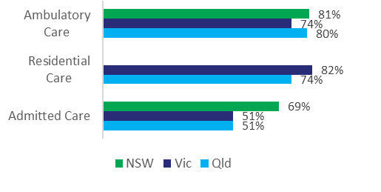
Focus area: Safe services:
Seclusion rate | Seclusion is defined as the confinement of a consumer or patient at any time of the day or night alone in a room or area from which free exit is prevented. This indicator measures the number of seclusion events per 1,000 patient days within public acute admitted patient specialised mental health service units. High levels of seclusion are widely regarded as inappropriate treatment, and may point to inadequacies in the functioning of the overall system and risks to the safety of consumers receiving mental health care. | - In 2023-24² there were 5.4 seclusion events per 1,000 bed days in public sector acute mental health hospital services nationally.
Restraint rate | Restraint involves restricting a person's freedom of movement by physical or mechanical means. This indicator measures the number of restraint events per 1,000 patient days within public acute admitted patient specialised mental health service units. Working towards the elimination of restrictive practices in mental health services has been identified as a priority. High levels of restraint may point to inadequacies in the functioning of the overall systems and risks to the safety of consumers receiving mental health care. | - In 2023-24², in acute hospital services there were:  - 8.5 physical restraint events per 1,000 bed days  - 0.4 mechanical restraint events per 1,000 bed days.
Focus area: Efficient services:
Average cost per acute mental health admitted patient day | This indicator measures the average cost of a patient day provdied by state/territory acute admitted patient mental health care service units. Efficient funtioning of public acute psychiatric inpatient units is criticial to ensure that finite funds are used effectively to deliver maximum community benefit. | - In 2022-23², $1,602 was the average cost per day for general patients in acute hospital services.
Average cost per community mental health treatment day | This indicator measures the average cost per community treatment day provided by state/territory specialised community (also known as ambulatory) mental health care service unit(s). Efficient funtioning of public community mental health services is criticial to ensure that finite funds are used effectively to deliver maximum community benefit. | - In 2022-23², $451 was the average cost per community treatment day.
Focus area: A capable, sustainable workforce:
Growth and distribution of the mental health workforce | This indicator measures the rate of FTE employed mental health workers (per 100,000 population). One of the agreed outputs of the Agreement is to report on progress toward increasing the number of FTE mental health professionals per 100,000 population to meet community needs. | - In 2023, the national rate of total FTE employed mental health workers (per 100,000 population) was:  - 15 for psychiatrists  - 98 for mental health nurses  - 110 for psychologists  - 10 for mental health occupational therapists  - In 2022-23:  - the national rate of FTE employed mental health consumer workers was 2 (per 100,000 population)  - the national rate of FTE employed mental health carer workers was 1 (per 100,000 population)  - In 2023, the national rate of total employed accredited mental health social workers was 12 (per 100,000 population)
- For several Annex B focus areas indicators are yet to be identified/developed and are therefore not reflected in this table. These focus areas are: addressing social and economic determinants, improving identification and measurement, shared planning, commissioning and service delivery, monitoring progress and outcomes through detailed regional data and closing the mortality gap for people living with mental health conditions.
- ACT data were not available at the time of publication. National calculations do not include ACT data. Caution should be exercised when conducting time series analyses.
- Level 1: NGOE NBEDS is provided to the Australian Institute of Health and Welfare for national reporting. Level 2: NGOE NBEDS is fully implemented across the state or territory. Data is available for all or most non-government organisations funded by the state or territory. Level 3: NGOE NBEDS is partially implemented and data is available for some non-government organisations funded by the state or territory. Level 4: Planning is underway and a date for implementation has been agreed. Level 5: Planning has commenced but no date for implementation has been agreed. Level 6: No work has commenced on implementing the NGOE NBEDS.
- Source: Report on Government Services 2025
Sources: State and Territory governments (unpublished), Your Experience of Service Survey Database, Report on Government Services, National Mental Health Establishments Database, National Health Workforce Dataset, Mental Health Establishments National Minimum Data Set, Australian Association of Socia Workers.

Appendix F

Acronyms and abbreviations
ABS | Australian Bureau of Statistics
ACT | Australian Capital Territory
AIHW | Australian Institute of Health and Welfare
CBIT | Community Based Intensive Treatment
CIRS | Central Intake and Referral Service
DART | Data and Regulatory Transformation
DBS | Distress Brief Support
DGF | Mental Health and Suicide Prevention Data Governance Forum
EMR | Electronic Medical Records
EPG | Evaluation Project Group
FTE | full-time equivalent
GP | General Practitioner
H2HK | Head to Health Kids
H2HK-Q | Head to Health Kids Hubs services in Queensland
HCEF | Health Chief Executives Forum
HILDA | Household, Income and Labour Dynamics in Australia
HOPE | Hospital Outreach Post-Suicidal Engagement
HPA | Health Policy Analysis
IAR | Initial Assessment and Referral Tool
IAR-DST | Initial Assessment and Referral Decision Support Tool
ICA | Infants, Children and Adolescents (Taskforce)
iCOPE | Centre of Perinatal Excellence Digital Platform
ICT | Information and Communications Technology
IT | Information Technology
KPI | Key performance indicator
LEG | Lived Experience Group
LHD | Local Health Districts
LHN | Local Health Networks
MBS | Medicare Benefits Schedule
MDMA | Methylenedioxymethamphetamine
MH SAMS | Mental Health Services Activity Monitoring System
MHSPSO | Mental Health and Suicide Prevention Senior Officials Group
MHPiP | Mental Health Pathways in Practice
MOU | Memorandum of Understanding
NDIS | National Disability Insurance Scheme
NGO | Non-Government Organisations
NHDH | National Health Data Hub
NHRA | National Health Reform Agreement
NMHC | National Mental Health Commission
NSPO | National Suicide Prevention Office
NSW | New South Wales
NT | Northern Territory
PHN | Primary Health Network
PHT | Primary Health Tasmania
PPG | Psychosocial Project Group
Qld | Queensland
SA | South Australia
SEWB Policy Partnership | Closing the Gap Social and Emotional Wellbeing Policy Partnership
SQG | Safety and Quality Group
Tas | Tasmania
TGA | Therapeutic Goods Administration
TIP | Technical Implementation Plan
Vic | Victoria
WA | Western Australia

Appendix G

Glossary
Accessible The ability of people to obtain required or available services when needed within an appropriate time. Factors include providing appropriate cultural, disability, affordability, socio economic status, and location accessibility.
Aftercare Aftercare services provide access to support for people following a suicide attempt or crisis to reduce the likelihood of further suicide attempts or deaths
Commissioning Commissioning is an evidence-based, cyclical approach to planning and purchasing services that involves assessing community needs to inform planning and designing services; selecting, overseeing and engaging with providers; managing contracts and undertaking ongoing monitoring and evaluation of delivery and outcomes (also see ‘Regional Commissioning’).
Community-based mental health services Mental illness is often treated in community and hospital-based outpatient care services provided by State and Territory Governments. Collectively, these services are referred to as community mental health care services.
Consumer A person living with mental illness who uses, has used or may use a mental health service.
Early intervention The early identification of risk factors and provision of timely treatment, care or support for people experiencing early signs and symptoms of mental illness. It aims to prevent the incidence, severity and impact of mental illness.
Lived experience Mental illness - People with lived experience are people who identify either as someone who is living with (or has lived with) mental illness or someone who is caring for or otherwise supporting (or has cared for or otherwise supported) a person who is living with (or has lived with) mental illness. People with lived experience are sometimes referred to as consumers and carers.
Suicide - People who think about suicide, people who have attempted suicide, people who care for someone with suicidal behaviour, people who are bereaved by suicide, and people who are impacted by suicide in some other way, such as a workplace incident.
Mental health The World Health Organization defines mental health as a state of wellbeing in which every person realises their own potential, can cope with the normal stresses of life, can work productively and fruitfully and is able to make a contribution to their community.
Mental health workforce Distinguishes between people who work exclusively in the mental health sector (for example Aboriginal and Torres Strait Islander mental health workers, mental health nurses, psychologists and psychiatrists) and those working in other health settings who frequently treat, interact with, care and support people experiencing suicidality, mental distress and/or ill- health (for example allied health, general practitioners and nurses). Particularly for suicide prevention, this also extends to people working in other settings who are likely to have regular contact with people experiencing suicidality, mental distress and/or ill- health as part of their role (for example aged care workers, educators, drug and alcohol workers, housing and justice services workers). Peer workers with a lived experience of mental health and suicide are also included in this definition.
Mental health and suicide prevention investment Investment as outlined in Expenditure on mental health- related services reported by the Australian Institute of Health and Welfare, noting that health expenditure is reported in terms of who incurs the expenditure rather than who ultimately provides the funding, and health funding is reported in terms of who provides the funds that are used to pay for health expenditure.
Postvention Postvention services aim to support individuals and communities bereaved or impacted by suicide through the grieving process, and to reduce the possibility of imitative suicidal behaviour.
Prevention Action taken to prevent the development of mental illness, including action to promote mental health and wellbeing and action to reduce the risk factors for mental illness.
Regional commissioning Regional commissioning (sometimes referred to as collaborative commissioning or joint commissioning) refers to the ways in which organisations work together to commission services, to make the best use of limited resources to avoid duplication of effort and achieve better outcomes for the local community.

Self-harm Deliberately hurting oneself without conscious suicidal intent.


www.mentalhealthcommission.gov.au

The Commission uses the term ‘mental health and suicide prevention system’ in this report to reflect the language used in the Agreement.
Note: 2022-2023 figures excluded 3 of the 81 initiatives given disparate progress ratings by the Parties. 2023-2024 figures include a total of 83 initiatives, due to an increase of 3 initiatives in South Australia and a decrease of 1 initiative in Victoria.
The Commission undertook a PESTEL desktop review of peer-reviewed publications, national data collections, budget papers, and media reports to identify developments in the reporting period 1 July 2023 to 30 June 2024 and assess them for potential contextual relevance. PESTEL is a scanning framework used to analyse macro-environmental factors. The above summary is not a comprehensive list.
Note: 3 outputs were assigned progress ratings for the first time in 2023-2024; Commonwealth-State implementation plans and Annual Jurisdiction Performance Reports; the Annual National Progress Report; and the Final Review. Due to a change in reporting arrangements, one milestone (83a) that had data and evaluation components was reported twice in 2022-23 but is being reported once from 2023-24 onwards.
This figure excludes spending on private health and other third-party insurers.
In addition to bilateral initiatives, WA provided status updates against 5 parallel initiatives being progressed outside of the Bilateral Schedule: Medicare Mental Health Centres, Enhancement and expansion of Headspace, Head to Health Phone Service, Youth and Adult Community Treatment and initiatives related to the ICA taskforce. These initiatives are included in the WA Bilateral Schedule snapshot on page 42 but excluded from the progress and risk rating totals presented in this section.

