Social media assets to promote opportunity

Please find below some example options of assets that you may wish to edit and post on various social media platforms.

Facebook

Post:
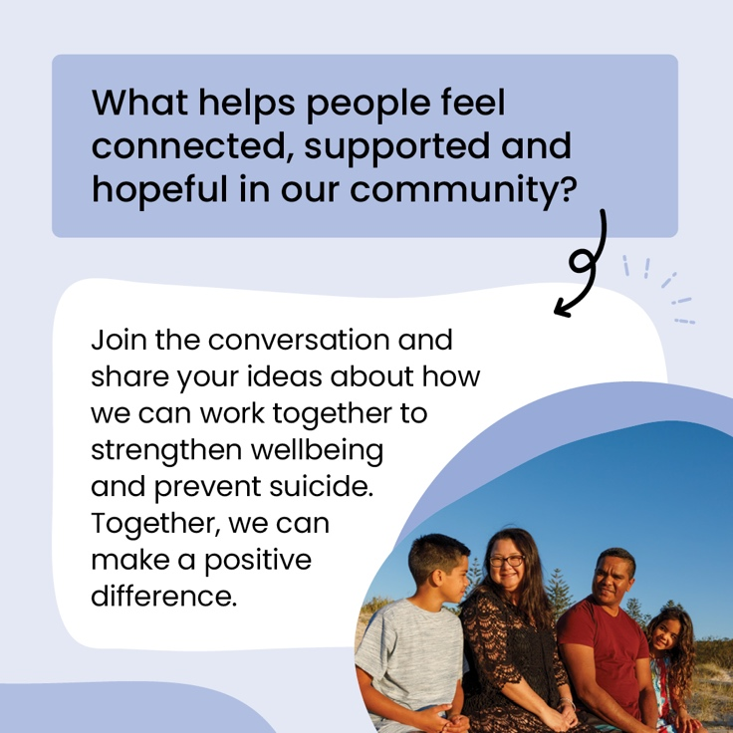

Post text:

[ORGANISATION ICON AND NAME]

You're invited to [Event Name]!
📅 [Date]
📍 [Location]

Come together to learn, connect and discuss how we can strengthen wellbeing and support suicide prevention in our community.
📩 RSVP: [Email/Contact Details]

#suicideprevention #NSPO
Edit content to suit your local context

Instagram

Post:
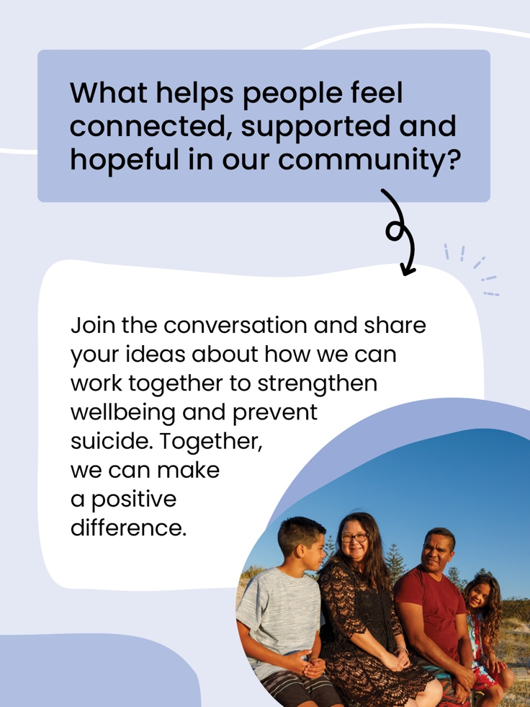

Post text:

[ORGANISATION ICON AND NAME]

You're invited to [Event Name]!
📅 [Date]
📍 [Location]

Come together to learn, connect and discuss how we can strengthen wellbeing and support suicide prevention in our community.
📩 RSVP: [Email/Contact Details]

#suicideprevention #NSPO

LinkedIn

Post:

Post text:

[ORGANISATION ICON AND NAME]

You're invited to [Event Name]!
📅 [Date]
📍 [Location]

Come together to learn, connect and discuss how we can strengthen wellbeing and support suicide prevention in our community.
📩 RSVP: [Email/Contact Details]

#suicideprevention #NSPO

X/Twitter - Post 1

Post:

Post text:

[ORGANISATION ICON AND NAME]

Join us at [Event Name] on [Date] at [Location] to learn about suicide prevention, hear about current initiatives, and explore how communities can support wellbeing, connection and local action. 💙
RSVP: [Contact Details]

#suicideprevention #NSPO

X/Twitter - Post 2 (Event reminder)

Post:
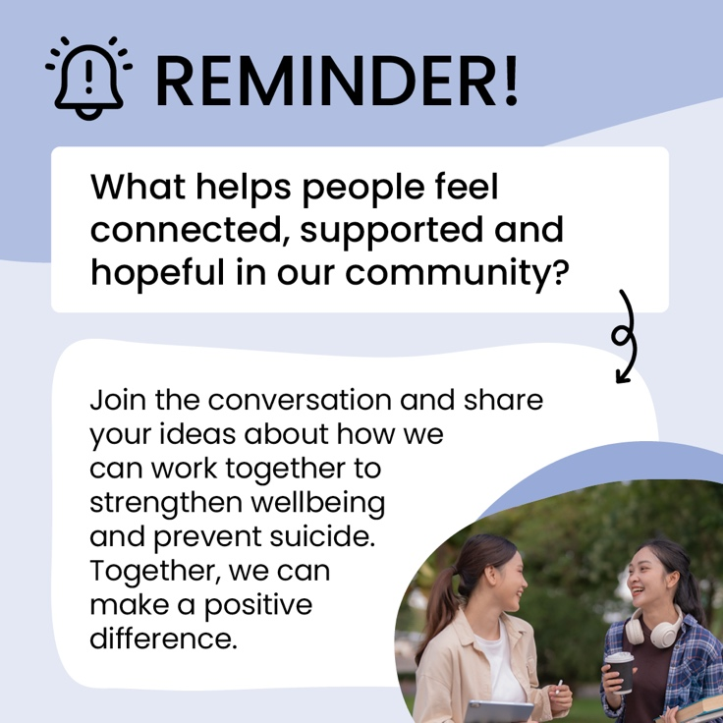

Post text:

[ORGANISATION ICON AND NAME]

Don’t forget to register for [Event Name]!
📅 [Date]
📍 [Location]

Come together to learn, connect and discuss how we can strengthen wellbeing and support suicide prevention in our community.
📩 RSVP: [Email/Contact Details]

#suicideprevention #NSPO

X/Twitter - Post 3 (Post-event thank you)

Post:
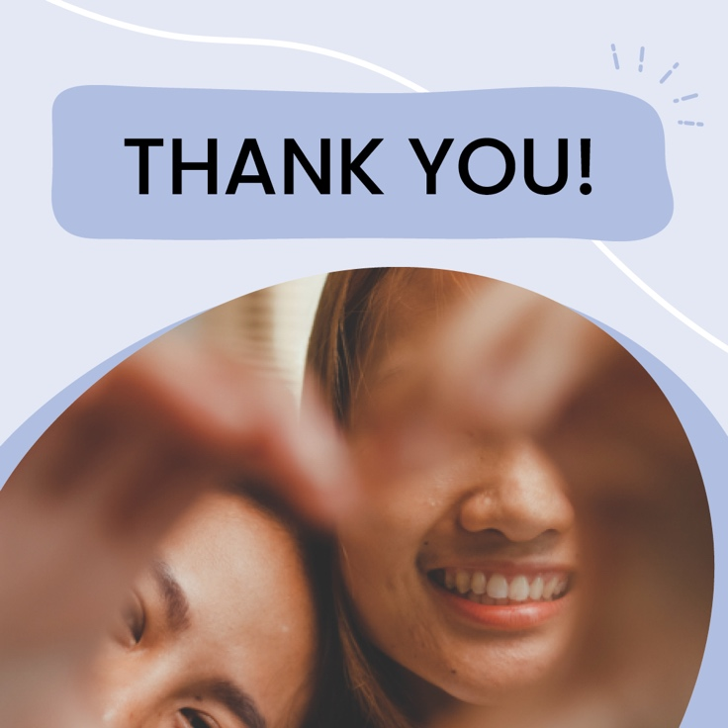

Post text:

[ORGANISATION ICON AND NAME]

💙 Thank you to everyone who joined us for [Event Name].

Every conversation helps build a more connected and supportive community.
Stay tuned for more events in the future, we hope to see you there!

#suicideprevention #NSPO

